Chapter 19 Chapter Test B
Multiple Choice
Circle the choice that best completes the statement or answers the question.
1. Waste that comes from the production of consumer goods, mining, agriculture, and petroleum extraction and refining is
A. hazardous waste.
B. municipal solid waste.
C. industrial waste.
D. compost waste.
2. In what category of waste do paint, household cleaners, medical waste, and solvents belong?
A. hazardous
B. compost
C. municipal solid
D. industrial
3. Where do most industrial nations now put much of their waste?
A. storage warehouses
B. landfills
C. rivers
D. lakes
4. Today, waste is buried in the ground or piled up in large, carefully engineered mounds called
A. incinerators.
B. material recovery facilities.
C. sanitary landfills.
D. surface impoundments.
5. What is one of the potential benefits of capturing and using the gases produced in sanitary landfills?
A. increasing the speed of biodegration of wastes
B. preventing the gases from entering the soil
C. cutting down greenhouse gases
D. providing more space for more waste
6. A number of closed landfills have been converted into
A. schools.
B. farms.
C. shopping malls.
D. recreation areas.
7. Items that are biodegradable will
A. decompose or break down naturally.
B. not be allowed into an incinerator.
C. eventually become radioactive waste.
D. take up more space in a landfill.
8. The collection of materials that can be broken down and reprocessed to make new items is
A. composting.
B. incinerating.
C. e-waste.
D. recycling.
9. Substances that can eat through or dissolve metal storage tanks and equipment are called
A. ignitable.
B. corrosive.
C. reactive.
D. toxic.
10. Natural gas, gasoline, waste oils from automotive shops and restaurants, oil–based paints, solvents (paint thinners), and alcohol are examples of which type of hazardous waste?
A. ignitable
B. toxic
C. corrosive
D. reactive
11. What form(s) may hazardous wastes take?
A. gas
B. liquid
C. solid
D. all of the above
12. What source produces the largest amounts of hazardous waste?
A. industry
B. households
C. small businesses
D. schools
13. The most common method of dealing with hazardous waste is to
A. burn it in an incinerator.
B. dump it in a specially designed landfill.
C. recycle it into new products.
D. compost it.
14. What is the largest source of radiation in the environment?
A. nuclear medicine
B. radon
C. consumer products
D. medical x-rays
15. The EPA is responsible for cleaning up the following lands, whose reuse or development are complicated by the presence of hazardous materials.
A. impoundments
B. material recovery facilities
C. brownfields
D. sanitary landfills
Modified True/False
Indicate whether the statement is true or false. If false, change the identified word or phrase to make the statement true.
16. Current solid waste disposal methods are based on modern practices of dumping, burying, or burning waste.
17. Historically, to decrease the volume of trash, the material in dumps would be removed from time to time.
18. The processes of composting and recycling both have their origins in nature.
19. Households currently are the largest source of unregulated hazardous waste.
20. Low-level radioactive wastes are more common than high-level radioactive wastes.
Completion
Complete each statement on the line provided.
21. ____________________ is any unwanted material or substance that results from a human activity or process.
22. Preventing waste generation in a way that conserves resources and reduces pollution is called ____________________.
23. ____________________ substances are harmful or fatal when inhaled, ingested, or absorbed through the skin.
24. The method of hazardous waste disposal in which the waste is pumped underground for long-term disposal is known as ____________________.
25. The federal program to clean up U.S. sites polluted with hazardous waste from past activities is called the ____________________.
Short Answer
Write the answers to the questions on the lines provided.
26. Identify the three main categories of waste.

27. What are the three basic methods of waste disposal?

28. What are the two main strategies for managing solid waste?

29. Identify at least two ways to achieve source reduction

30. What is meant by the statement that hazardous waste materials must be tracked “from cradle to grave”?

Other
Use the graph to answer the following questions.
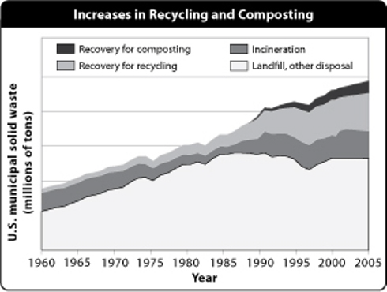
31. Where does most of the waste in the United States go?

32. According to this graph, what is the trend in the amount of waste produced in the United States?

33. What is the trend in the amount of waste that has been incinerated between 1960 and 2005?

34. Which method of handling waste came into use most recently?

35. Over time, what has happened to the percentage of all waste that ends up in landfills?

