Chapter 18 Chapter Test A
Multiple Choice
Circle the choice that best completes the statement or answers the question.
1. The use of which renewable energy source is growing at the most rapid rate?
A. the sun
B. wind
C. Earth’s heat
D. living organisms
2. When you boil water over a campfire, you are using
A. hydropower.
B. geothermal energy.
C. biomass energy.
D. solar energy.
3. Much of Iceland’s power comes from geothermal energy. What geologic features are likely to be present in large numbers in Iceland?
A. glaciers
B. waterfalls
C. geysers
D. rivers
4. A characteristic of ground source heat pumps is that
A. they use heated underground rocks.
B. underground soil temperature remains constant year-round.
C. they do not use water.
D. heat does not have to be transferred.
5. One disadvantage of hydropower is that it
A. is nonrenewable.
B. is expensive.
C. harms ecosystems.
D. releases greenhouse gases.
6. Two kinds of energy that come from oceans are ocean thermal energy and
A. tidal energy.
B. hydropower.
C. geothermal energy.
D. biomass energy.
7. What is used to absorb heat in a flat-plate solar collector?
A. a photovoltaic cell
B. glass panes
C. a heat pump
D. a metal plate
8. Which of the following is a benefit of wind power?
A. It does not cause pollution.
B. It is predictable.
C. Startup costs are low.
D. It does not harm wildlife.

9. At the present time, the most common and least expensive way to produce hydrogen fuel is by
A. the electrolysis of water.
B. the breakdown of methane.
C. nuclear fission.
D. reaction of algae.
10. What are the products of the breakdown of methane?
A. hydrogen and carbon dioxide gases
B. hydrogen and oxygen gases
C. hydrogen gas and water
D. oxygen gas and water
Modified True/False
Indicate whether the statement is true or false. If false, change the identified word or phrase to make the statement true.
11. Biodiesel is a biofuel that is used as a supplement to power gasoline engines in cars.
12. Drilling very deep wells to reach heated rocks and water so geothermal energy can be harvested can cause earthquakes.
13. A run-of-the-river approach to hydropower is most efficient when the water level in a river remains constant during all seasons.
14. A greenhouse uses active solar energy to keep plants warm in winter.
15. Hydrogen fuel is produced by the chemical breakdown of methane-containing compounds.
Completion
Complete each statement on the line provided.
16. Alternative energy sources are needed to reduce air pollution, reduce the emission of greenhouse gases, and replace ____________________.
17. In addition to providing electric power, dams can control ____________________, which destroy homes and farmland.
18. Any future ocean thermal energy facilities would probably be built in countries that are located near the imaginary line on the globe called the ____________________.
19. A photovoltaic cell creates an electric current by causing a flow of ____________________.
20. One disadvantage of wind power is that wind is not ____________________.
Short Answer
Write the answers to the questions on the lines provided.
21. What is biomass energy? Give an example of biomass.

22. How can the sun’s rays be concentrated to generate electricity?

23. How can a house that depends on electricity produced by solar energy maintain a constant energy supply through a long rainy period with little sunshine?

24. Why are offshore wind farms becoming more common compared to wind farms on land?

25. How are fuel cells used?

Other
Use the illustration to answer the following questions.
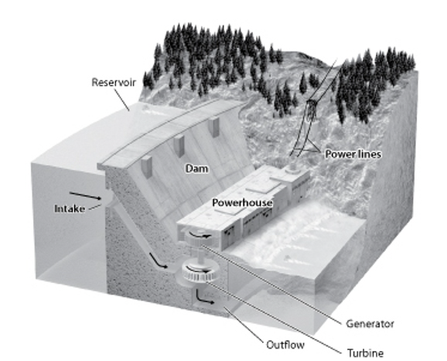
26. Electricity is produced by the ____________________ of the hydropower plant.

27. In the hydropower plant shown in the illustration, what would happen to the generation of electricity if the water level in the reservoir dropped below the opening of the intake pipe? Explain your answer.

28. What damage to the ecosystem may have occurred from constructing the dam in the illustration?

29. Where does the water released from the outflow pipe go?

30. Where in the figure does the water have the greatest potential energy?

Essay
Write the answer to each question in the space provided.
31. Explain how groundwater can sustain the generation of electricity in a geothermal power plant.

32. Why is wind power considered to be a form of solar energy?

33. Explain why solar energy is an ideal energy source for producing electricity in an isolated community.

34. Compare the way a wind turbine produces electricity with the way a turbine in a hydropower plant produces electricity.

35. Describe what happens on each side of a fuel cell. Describe any reactions that take place and give the overall reaction of the fuel cell.

