Chapter 17 Chapter Test B
Multiple Choice
Circle the choice that best completes the statement or answers the question.
1. When you eat food, your body takes in chemical energy. What kind of energy does this chemical energy convert to when you are lifting weights?
A. thermal energy
B. mechanical energy
C. electrical energy
D. electromagnetic energy
2. The energy trapped in fossil fuels came from the energy plants converted during photosynthesis. This trapped energy is
A. thermal energy.
B. potential energy.
C. mechanical energy.
D. chemical energy.
3. About half of the electricity used in the United States is generated by
A. combustion of coal.
B. combustion of natural gas.
C. combustion of crude oil.
D. nuclear fission.
4. Coal deposits that are deep underground must be extracted by subsurface mining rather than by strip-mining because strip-mining would
A. be too dangerous.
B. be too expensive.
C. have to remove large amounts of rock and soil.
D. require that removed rock and soil be put back into the hole.
5. Which of the following is derived from petrochemicals?
A. paper
B. stainless steel
C. wood
D. plastic
6. Most oil deposits are found within pores in
A. granite rock.
B. limestone and sandstone rock.
C. soil.
D. the ocean floor.
7. Secondary extraction of oil that is trapped in rocks must be used when
A. the oil is already at the surface.
B. water is not available to pump into the well.
C. the oil is no longer under pressure.
D. the oil becomes mixed with carbon dioxide.
8. Why is the use of natural gas growing faster than that of most other fossil fuels?
A. It is less expensive.
B. It is less polluting.
C. It is colorless and odorless.
D. It emits carbon dioxide.
9. Which of the following pollutants causes smog when fossil fuels are burned?
A. sulfur dioxide
B. carbon dioxide
C. hydrogen sulfide
D. methane
10. Acid drainage is a problem that is caused by
A. underground mining of coal.
B. strip mining of coal.
C. extraction of crude oil.
D. extraction of natural gas.
11. Most of the oil used in the United States is used for
A. industry.
B. transportation.
C. electric power.
D. commerce.
12. The nuclear particle that is involved in nuclear fission is a(n)
A. electron.
B. proton.
C. neutron.
D. atom.
13. The fuel used in a nuclear power plant is
A. uranium-235.
B. uranium-236
C. uranium-237
D. uranium-238
14. One of the main disadvantages of nuclear power is that it
A. pollutes the air.
B. pollutes water.
C. produces too little electricity.
D. generates radioactive waste.
15. What process occurs when the small nuclei of elements such as hydrogen are forced together under extremely high temperatures?
A. nuclear fission
B. nuclear fusion
C. nuclear meltdown
D. nuclear waste production
Modified True/False
Indicate whether the statement is true or false. If false, change the identified word or phrase to make the statement true.
16. When you burn wood in a fireplace to provide heat, you are using a renewable energy source.
17. Natural gas is composed mostly of the gas carbon dioxide.
18. Oil shale is an alternative fossil fuel that is an ice-like solid found in the ocean floor.
19. The process of combustion in power plants causes toxic mercury to be released into the air from coal.
20. Turning down a thermostat is an example of energy expenditure.
Completion
Complete each statement on the line provided.
21. A rock at the edge of a cliff has ____________________ energy before it falls.
22. Coal is formed from the remains of ancient ____________________ that were compressed under high pressure.
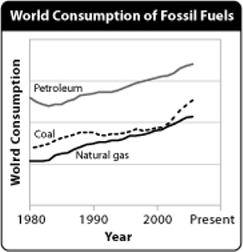
23. According to the graph, the world consumption of ____________________ from 2000 to 2006 showed the greatest increase of all fossil fuels.
24. In nuclear fission, nuclear energy is converted to ____________________ energy.
25. In a nuclear meltdown, the nuclear chain reaction becomes uncontrolled and so much heat is produced that the ____________________ melt.
Short Answer
Write the answers to the questions on the lines provided.
26. What is energy?

27. Solar panels on a rooftop trap energy from the sun. Do solar panels use a primary or a secondary energy resource? Explain.

28. Trace the various conversions of energy as coal is formed and is then burned.

29. In what way can the development of an oil field affect the habitats of wildlife?

30. How is meltdown prevented in a nuclear power plant?

Other
Use the illustration to answer the following questions.
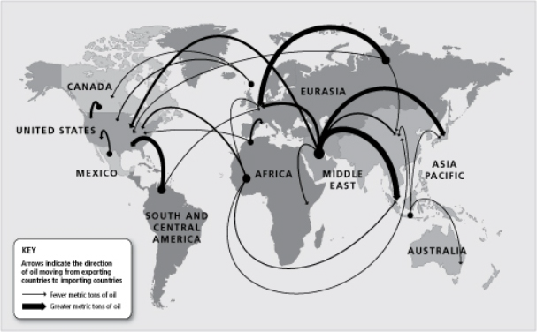
31. The United States economy would be affected to the greatest extent if the country of _____________ stopped selling us oil.

32. Assume that crude oil is moved from one country to another by tanker ships. Would you expect to find that most tanker ships filled with crude oil travel from east to west or from west to east?

33. The economy of which country would be most affected if Mexico stopped exporting oil?

34. Which region exports the most oil?

35. Is Russia a major importer of oil or a major exporter? Would you describe Russia as oil–dependent or oil–independent?

