Chapter 17 Chapter Test A
Multiple Choice
Circle the choice that best completes the statement or answers the question.
1. The energy of motion is
A. potential energy.
B. kinetic energy.
C. chemical energy.
D. electrical energy.
2. When you plug your cell phone into an electrical outlet to recharge it, you are using energy for
A. transportation.
B. industry.
C. residential use.
D. commercial use.
3. The fact that fossil fuels formed at the bottom of swamps implies that
A. most of Earth’s surface was once covered by swamps.
B. there was little or no oxygen in that environment.
C. living things once lived in all parts of Earth.
D. swamps are under large amounts of pressure.
4. In the primary extraction of oil,
A. oil rises in the well to the surface without being pumped.
B. water is pumped into the ground to force the oil to the surface.
C. chemicals are used to dissolve the oil and bring it to the surface.
D. carbon dioxide is pumped beneath oil deposits.
5. How is natural gas transported from its source to where it is used?
A. by trucks
B. by ships
C. by railroad tanker cars
D. by pipelines
6. If fossil fuels continue to be used at their current rate, which will probably be used up first?
A. coal
B. oil
C. natural gas
D. methane hydrate
7. Although acid drainage can be a natural process, it speeds up when an area is strip-mined because strip mining
A. exposes large areas of rock surface that contain sulfide minerals.
B. removes large amounts of rock.
C. releases large amounts of coal dust, which forms acid drainage.
D. exposes underground water, which combines with minerals to form acid.
8. Which country or region is coal-rich and oil-poor?
A. Middle East
B. Germany
C. Iran
D. United States

9. In a nuclear power plant, nuclear fission take place in the
A. generator.
B. cooling tower.
C. reactor vessel.
D. condenser.
10. What is the purpose of the chain reaction in a nuclear power plant?
A. to produce the heat and steam that turn the turbine
B. to produce neutrons that turn the generator
C. to cause steam to condense into liquid water
D. to reduce the temperature in the cooling tower
Modified True/False
Indicate whether the statement is true or false. If false, change the identified word or phrase to make the statement true.
11. Thermal energy travels through space in the form of waves.
12. In developed nations, most energy use provides the basic necessities of daily living.
13. About half of the electricity generated in the United States comes from coal.
14. A nation that has a large crude oil reserve is Russia.
15. The reaction that drives the release of nuclear energy in power plants is nuclear fusion.
Completion
Complete each statement on the line provided.
16. Food contains ____________________ energy, which is stored in the bonds of its molecules.
17. The process that separates crude oil into different fuels and other substances is called ____________________.
18. An alternative fossil fuel that is found in the deep ocean floor is ____________________.
19. Nuclear waste is difficult to dispose of because it is ____________________.
20. Generating energy from nuclear fusion is not yet feasible because the reaction requires an extremely high ____________________.
Short Answer
Write the answers to the questions on the lines provided.
21. A skier going downhill has kinetic energy. Where did this kinetic energy come from?

22. Which method of removing coal from the ground—strip mining or subsurface mining—do you think is less expensive? Explain why.

23. In what way is pollution from coal different from pollution from oil?

24. In what way is underground coal mining a dangerous occupation?

25. How can higher gasoline taxes result in energy conservation?

Other
Use the illustration to answer the following questions.
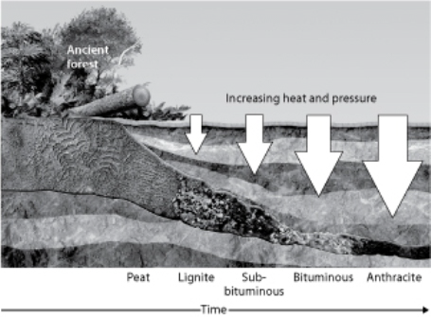
26. According to the diagram, three things that are needed to produce coal are _______________, _______________, and _______________.

27. Anthracite coal releases more energy when it is burned than lignite does. Use the diagram to explain why this statement is true.

28. Why is there more pressure on the buried ancient plants on the right side of the diagram than on the left side?

29. According to the diagram, which type of fuel is most likely to be mined by subsurface mining?

30. According to the diagram, _______________ is the fuel that forms first when the remains of plants decay.

Essay
Write the answer to each question in the space provided.
31. Explain how the temperature of an object is related to the energy the object contains. In your answer, tell what kind of energy the object contains.

32. Describe three ways fossil fuels affect air quality.

33. Explain how a buyer nation’s economy can be affected if the nation must rely on seller nations for fossil fuels.

34. “Of all nations, the United States generates the most electricity from nuclear power. However, only 20 percent of U.S. electricity comes from nuclear power.” Are these two statements contradictory? Explain why or why not.

35. Explain why the amount of energy increases with each step in the chain of fission shown in the diagram.

