Chapter 15 Chapter Test A
Multiple Choice
Circle the choice that best completes the statement or answers the question.
1. What percentage of the atmosphere is composed of oxygen?
A. 12 percent
B. 21 percent
C. 58 percent
D. 78 percent
2. A ratio that compares the amount of water vapor the air contains to the maximum amount that the air could hold at that temperature is
A. temperature inversion.
B. radiation.
C. relative humidity.
D. convection.
3. The lowest layer of Earth's atmosphere, the one directly above the ground, is called the
A. troposphere.
B. stratosphere.
C. thermosphere.
D. mesosphere.
4. What is the source of the energy that drives air movement in the troposphere and influences weather and climate?
A. ocean
B. volcanoes
C. ozone layer
D. sun
5. Carbon-containing fuels, or fossil fuels, formed millions of years ago from the remains of
A. gases in the atmosphere.
B. chlorofluorocarbons.
C. living organisms.
D. volcanic eruptions.
6. How does carbon monoxide affect human health?
A. It interferes with the body’s ability to deliver oxygen to cells.
B. It irritates the throat and air passages.
C. It helps the respiratory system function more efficiently.
D. It depletes ozone, causing greater exposure to the sun’s rays.
7. A(n) __________ can trap smog close to the surface. It happens when a layer of cool, dense air stays near the ground and under a layer of warm air.
A. temperature inversion
B. acid deposition
C. air mass
D. convection current
8. Normal precipitation has a pH of about 5.6. What pH might acid precipitation have?
A. 4.6
B. 7
C. 9.6
D. 12.6

9. Pollutants are removed or changed chemically before they leave factory smokestacks by a(n)
A. chlorofluorocarbon.
B. scrubber.
C. inversion.
D. catalytic converter.
10. Ozone depletion was caused by the following chemicals, which were used in refrigerators and aerosol spray cans.
A. catalytic converters
B. fossil fuels
C. chlorofluorocarbons
D. scrubbers
Modified True/False
Indicate whether the statement is true or false. If false, change the identified word or phrase to make the statement true.
11. In general, warm air can hold less water vapor than cooler air.
12. The ozone layer is found within the troposphere.
13. Primary pollutants are produced when air pollutants react chemically with other substances.
14. Trace amounts of some air pollutants may contribute to cancer.
15. As a result of the Clean Air Act, today, gasoline used by cars and trucks in the U.S. contains very large quantities of lead.
Completion
Complete each statement on the line provided.
16. ____________________ is the force exerted by air on the area below it.
17. ____________________ describes the pattern of atmospheric conditions in large geographic regions over long periods of time.
18. If you combine the words smoke and fog, you get the word ____________________.
19. The acids that form from pollution in the atmosphere then settle to the surface of Earth are called acid ____________________.
20. The term ____________________ was used to describe the area of lowered ozone concentration over Antarctica.
Short Answer
Write the answers to the questions on the lines provided.
21. List the four main layers of the atmosphere, from lowest to highest altitude.

22. Based on what you learned about radiation, describe what you could do to prevent your home from heating up so much as a result of radiation from the sun, and explain why it would work.

23. During which season would you expect cold fronts to occur?

24. Describe two of the effects of acid deposition.

25. Was the Montreal Protocol a success? Explain.

Other
Use the illustration to answer the following questions.
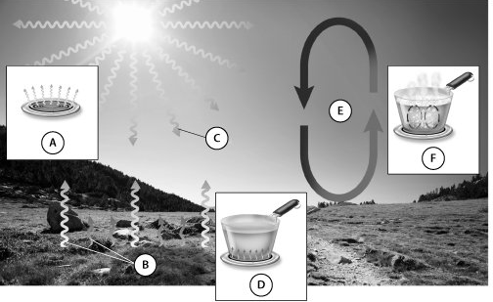
26. Identify one part of the picture that illustrates conduction.

27. What type of heat transfer is marked by letter C?

28. Which letter represents the type of heat transfer that is primarily responsible for creating winds?

29. Which letter represents a type of heat transfer that does not require direct contact?

30. Which main layer of the atmosphere is depicted in this diagram?

Essay
Write the answer to each question in the space provided.
31. Compare and contrast warm fronts and cold fronts and their effects.

32. Describe an example of how a natural process can make air pollution caused by humans even worse, and also describe an example of how human activities can make natural air pollution worse.

33. Compare and contrast primary and secondary air pollutants.

34. Explain how a temperature inversion differs from normal tropospheric conditions and how air pollution reacts differently in the two situations.

35. Has the Clean Air Act been a success? Explain.

