Chapter 14 Chapter Test B
Multiple Choice
Circle the choice that best completes the statement or answers the question.
1. As a natural resource, freshwater is
A. renewable.
B. nonrenewable.
C. unlimited.
D. unusable.
2. All of the land area that supplies water to a particular river system is included in a(n)
A. aquifer.
B. water table.
C. watershed.
D. recharge zone.
3. An impermeable layer of soil and rock
A. has many large pore spaces.
B. has few or no pores.
C. is very likely to contain pollution.
D. is usually full of water.
4. Sometimes, the water table naturally rises to the surface creating
A. aquifers.
B. wells.
C. drainage basins.
D. springs.
5. At the average American home, most water use takes place
A. during bathtime.
B. in the kitchen.
C. in the afternoon.
D. outdoors in the yard.
6. Which major category of water use would include watering grain to feed to livestock?
A. personal
B. agricultural
C. industrial
D. electrical
7. To help regulate river flow and to build a stable supply of water, engineers build
A. aquifers
B. water tables.
C. dams.
D. wells.
8. Overirrigation can result in
A. salinization.
B. water diversion.
C. recharge.
D. sediment capture.
9. Reverse osmosis is a process often used for removing the following from water.
A. oil
B. sediment
C. fish
D. salt
10. What type of system targets individual plants and introduces water directly into the soil?
A. desalination
B. reverse osmosis
C. waterlogging
D. drip irrigation
11. Which of the following is an example of nonpoint-source pollution?
A. a boat leaking motor oil
B. a pipe releasing hot water
C. rain washing salt off the roads
D. a container leaking chemicals
12. Which nutrient is usually responsible for causing eutrophication in fresh water?
A. phosphorous
B. salt
C. mercury
D. oxygen
13. Harmful algal blooms are a result of what type of pollution?
A. oil
B. nutrient
C. mercury
D. groundwater
14. What is the first step in a typical drinking water treatment process?
A. chlorination
B. filtration
C. aeration
D. settling
15. Leaky underground storage tanks are a major source of what type of pollution?
A. groundwater
B. nonpoint-source
C. biological
D. sediment
Modified True/False
Indicate whether the statement is true or false. If false, change the identified word or phrase to make the statement true.
16. Most of the time, groundwater is accessed through a spring.
17. Data indicate that our current rate of freshwater use is sustainable in much of the world.
18. Heavy water diversion can cause a river to dry up before reaching its mouth.
19. Pollution that comes from many places and spreads over a large area is called point-source pollution.
20. Chemicals break down much more quickly in aquifers than in surface water.
Completion
Complete each statement on the line provided.
21. In an aquifer, the boundary between the zone of aeration and the zone of saturation is known as the ____________________.
22. Globally, about 70 percent of our fresh water is used for ____________________.
23. A large lake that stores water for human use is called a(n) ____________________.
24. A(n) ____________________ is a sudden explosion of algal growth caused by excess nutrients.
25. ____________________ pollution occurs when water is returned to its source at a temperature that is higher than when it was taken.
Short Answer
Write the answers to the questions on the lines provided.
26. Compare the zone of aeration to the zone of saturation.

27. Identify one of the possible disadvantages of dams.

28. List two possible effects of groundwater depletion.

29. What is the difference between point-source pollution and nonpoint-source pollution.

30. What impact did the Clean Water Act have on the environment?

Other
Use the illustration to answer the following questions.
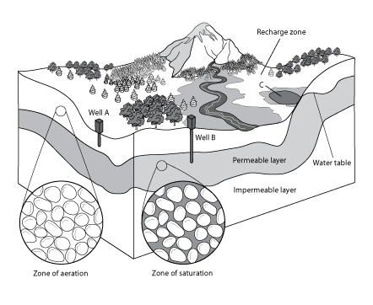
31. What would the land around the river be called?

32. What will happen to water that enters the recharge zone?

33. What is happening at point C in the diagram? What is this feature called?

34. Which well is a dry well, Well A or Well B? Explain.

35. What might happen to Well B if the water table were to drop some more?

