Chapter 12 Chapter Test A
Multiple Choice
Circle the choice that best completes the statement or answers the question.
1. After a catastrophe, soil formation is the first step in
A. primary succession.
B. secondary succession.
C. a climax community.
2. A rock containing iron turns red as its surface is exposed to air and water over time. This is an example of
A. physical weathering.
B. chemical weathering.
C. primary succession.
D. decomposition.
3. Most of the nutrients in soil come from
A. chemical weathering.
B. mechanical weathering.
C. erosion.
D. decomposition.
4. A farmer interested in raising healthy crops should look for a
A. heavy clay soil with a high pH and a dark color.
B. loamy soil with a low pH and a light color.
C. loamy, clumpy soil with a neutral pH and a dark color.
D. sandy soil with a high pH, no clumps, and a light color.
5. Deterioration of the soil’s fertility and ability to provide ecosystem services is called
A. erosion.
B. soil degradation.
C. soil pollution.
D. succession.
6. Watering crops by way of human-constructed structures is known as
A. precipitation.
B. irrigation.
C. salinization.
D. fertilization.
7. Agriculture most likely began
A. 10,000 years ago in the Middle East.
B. 200,000 years ago in Africa.
C. 15,000 years ago in China.
D. 150,000 years ago in Egypt.
8. Genetic engineering relies on placing a gene that codes for a desired trait into the __________ of a different organism from the organism where the gene was originally harvested.
A. protein
B. amino acid
C. helix
D. genome

9. Your friend tells you she’s decided not to use pesticides or synthetic chemicals on her farm; instead she’ll rely on composting and biological pest control. She is practicing
A. industrial agriculture.
B. monoculture.
C. organic agriculture.
D. sustainable agriculture.
10. Sustainable agriculture is important because while human population continues to grow, which of the following will not?
A. animal population
B. arable land
C. food production
D. GM crops
Modified True/False
Indicate whether the statement is true or false. If false, change the identified word or phrase to make the statement true.
11. Freeze-thaw cycles over several hundred years cause part of a cliff to collapse as water enters cracks in the rocks and expands. This is an example of chemical weathering.
12. Traditional agriculture is best defined by its reliance on fossil fuels and mechanization.
13. A child with a bloated belly, thin hair, and an inability to concentrate may be suffering from malnutrition.
14. Increased harvesting of wild fish may help solve the problem of creating sustainable seafood production.
15. People who want to protect land, water, and wildlife, and prevent pesticides from entering their own bodies, should buy GM food.
Completion
Complete each statement on the line provided.
16. If you wanted to farm on a steep hillside, one way to prevent soil erosion would be ____________________.
17. ____________________ is the result of a buildup of salts in the top layers of soil after excessive irrigation carries dissolved salts to the surface.
18. A farmer practicing ____________________ might use biological controls, some pesticides, and crop rotation to control harmful insects.
19. Modern crops, fruits, vegetables, and livestock are the result of ____________________.
20. Heavy reliance on ____________________ to treat animals raised for food could result in bacteria developing resistance to drugs used to treat people
Short Answer
Write the answers to the questions on the lines provided.
21. Briefly discuss some of the effects of overgrazing on rangeland, and how these might be mitigated.

22. A farmer realizes that her fields are highly saline. What are some solutions that she might try?

23. Explain some of the advantages and disadvantages of a monoculture.

24. Explain the paradox of pesticide use as it relates to pest control and pollination.

25. Briefly discuss the link between desertification and population growth.

Other
Use the charts to answer the following questions.
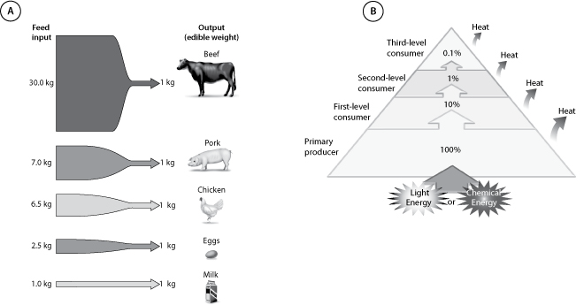
26. In Chart A, which is the most efficient source of animal protein?

27. Chart B illustrates energy transfer and trophic structure in a natural ecosystem. If this was an agriculture ecosystem, where would humans be located?

28. Ninety percent of the caloric energy available at one trophic level is lost in transfer to the next. Some people say that ‘eating at the top of the food chain’ is inefficient. Explain what this means in a culture like the United States, where people eat a large amount of meat.

29. Each year, Earth gains 75 million people. Many of the world’s most populous nations (China, India) have traditionally not included much meat in their diet, but as nations grow more prosperous, people around the world move towards a more meat-heavy diet. Predict what will happen.

30. If you were to devise a healthy, sustainable diet, what would you recommend and why?

Essay
Write the answer to each question in the space provided.
31. Recall the example of the American Dust Bowl during the 1930s. Today, in many parts of the world, there are farming areas struggling to be productive. What might happen to these areas if climate change and desertification were to worsen? Discuss both environmental and social impacts.

32. Compare and contrast national and international efforts to promote and synthesize soil conservation practices. What are the strengths and weaknesses of the different approaches?

33. A friend asks you whether you think the Green Revolution was positive or negative. How would you reply? Be sure to consider and explain the positive and negative effects, so that your friend knows that you’re aware of all sides of the story.

34. Discuss the potential costs and benefits of GM agriculture. Consider both environmental and social consequences, taking into account the relationship between agriculture and population.

35. You go to the store to buy some milk. You have a choice between buying a gallon of nonorganic milk from a generic producer with national distribution, or buying a gallon of organic milk from a small farm ten miles away. The generic milk is half the price of the local milk. Which do you choose, why, and what are the consequences of that choice?

