Chapter 11 Chapter Test B
Multiple Choice
Circle the choice that best completes the statement or answers the question.
1. A renewable resource is harvested sustainably if
A. the amount of replacement is less than the amount harvested.
B. the amount of replacement is equal to the amount harvested.
C. soil erosion is prevented.
D. replacing trees costs less than harvesting trees.
2. Most of Earth’s fresh water is used for
A. watering crops.
B. drinking.
C. washing clothes and dishes.
D. recreational purposes such as swimming pools.

3. Which of the following words best summarizes the adaptive management approach shown in the diagram?
A. rigid
B. unscientific
C. adjustable
D. simple
4. The percentage of Earth’s land surface covered by forests is
A. 15
B. 30
C. 50
D. 75
5. One disadvantage of the selection system of timber harvesting is that it
A. produces even-aged stands.
B. produces a monoculture.
C. causes soil erosion.
D. is more dangerous for loggers.
6. Deforestation is particularly harmful in arid regions because it can lead to
A. desertification.
B. a massive loss of biodiversity.
C. loss of jobs.
D. a decrease in greenhouse gases.
7. What is the role of private timber companies in national forests?
A. They plan the sale of trees that are harvested.
B. They build roads for logging.
C. They manage timber sales.
D. They receive the profits from logging.
8. The National Forest Management Act
A. requires plans for national forests that follow multiple use and maximum sustainable yield guidelines.
B. requires plans for national forests that follow multiple use and ecosystem-based management guidelines.
C. encourages prescribed burning as a means of protecting national forests.
D. promotes the removal of small trees and underbrush by timber companies.
9. The Bush administration passed regulations that
A. required maximum sustainable yield management in national forests.
B. managed wildlife and endangered species in national forests.
C. authorized programs to help plants and animals recover from near extinction.
D. allowed for the building of logging roads in national forests.
10. Which type of forest most likely contains the greatest variety of habitats?
A. old-growth forests
B. even-aged stands
C. plantations
D. monocultures
11. Smokey the Bear’s message resulted in
A. an increased number of forest fires.
B. an increase in biodiversity.
C. suppression of all forest fires.
D. a loss of lives.
12. Fire suppression can result in a(n)
A. increase in animal habitats.
B. buildup of material that fuels future fires.
C. decrease in property damage.
D. an increase in the jack pine population.
13. Prescribed burns
A. are carefully controlled.
B. cannot be controlled.
C. cause fuel buildup.
D. cause permanent damage to ecosystems.
14. The main goal of the Healthy Forests Restoration Act is to
A. prevent prescribed burning.
B. prevent erosion and soil damage.
C. prevent salvage logging.
D. promote salvage logging.
15. If a wood product is certified by the Forest Stewardship Council, it was produced
A. using sustainable methods.
B. from trees grown on a plantation.
C. from recycled materials.
D. because consumers demanded it.
Modified True/False
Indicate whether the statement is true or false. If false, change the identified word or phrase to make the statement true.
16. A renewable resource can never run out.
17. In a fish farm, the goal of maximum sustainable yield management is to keep the population of fish growing at a slow rate.
18. Providing food and medicine is an ecological value of forests.
19. Deforestation occurs when trees are removed from a forest and replaced by a housing development.
20. Trees in national forests are harvested by private timber companies.
Completion
Complete each statement on the line provided.
21. The method of timber harvesting that was most commonly used in the past was ____________________ because it was most cost-effective.
22. A Kirtland’s warbler population would be harmed both in a forest that was fire-suppressed and in a forest that was harvested by the ____________________ method.
23. Before Europeans began to colonize North America, most of the land in the ____________________half of the region was covered with old-growth forests.
24. Suppose land that was being farmed has been abandoned. Trees begin to grow. Eventually, a small forest forms. The process that has taken place is called ____________________ succession.
25. A tree plantation that has only pine trees growing on it is an example of a ____________________.
Short Answer
Write the answers to the questions on the lines provided.
26. How do forest plants prevent soil erosion?

27. Why might you expect to see a small number of animal species in an even-aged stand of trees?

28. In what way does deforestation of tropical rain forests affect global warming?

29. Who owns many of the tree plantations on which most logging in the United States takes place?

30. As a consumer, what can you do to promote sustainable harvesting practices?

Other
Use the graph to answer the following questions.
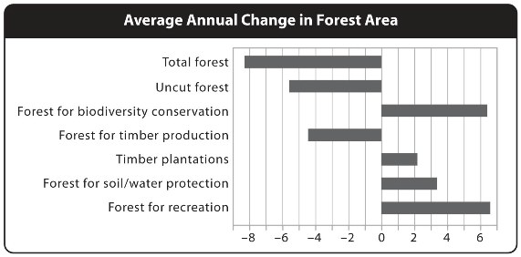
31. According to the graph, which use of forests decreased during this time period?

32. What do the numbers to the right of zero on the graph represent? Give one example.

33. According to the graph, the amount of deforestation is __________

34. Successful resource management practices will shift the bars in the graph to the right or to the left?

35. What does a negative number on the x axis on this graph represent?

