Chapter 11 Chapter Test A
Multiple Choice
Circle the choice that best completes the statement or answers the question.
1. Renewable resources include soil, fresh water, wild animals, and
A. minerals.
B. coal.
C. timber.
D. petroleum.
2. Which approach to resource management aims to harvest resources in ways that minimize impact on the ecosystem and processes that provide the resource?
A. maximum sustainable yield
B. ecosystem-based management
C. adaptive management
D. watershed management
3. In what part of a forest would you expect to find squirrel nests?
A. snag
B. understory
C. forest floor
D. subcanopy
4. Which of the following has caused an increase in the per capita land consumption?
A. They provide wood.
B. They prev ent soil erosion.
C. They regulate the water cycle.
D. They decrease flooding.
5. The clearing of a forest and its replacement by another land use is called
A. forestry.
B. clear-cutting.
C. timber-harvesting.
D. deforestation.
6. Under the National Forest Management Act, national forests
A. can be used only for recreation.
B. can be harvested only by government agencies.
C. can be harvested only where soils will not be irreversibly damaged.
D. must have roads in place wherever harvesting is done.
7. Which phrase is true for private logging operations?
A. produces a monoculture
B. produces trees of different ages
C. produces trees of different species
D. leads to high biodiversity
8. Some tree plantations resemble a natural forest that
A. has been adaptively managed.
B. contains uneven-aged stands.
C. has never been harvested.
D. has been clear-cut.

9. Prescribed burns are fires that
A. are caused by lightning.
B. are set by humans.
C. never get out of control.
D. increase the risk of injury.
10. The removal of snags following a fire is called
A. monoculture.
B. prescribed burning.
C. sustainable forestry.
D. salvage logging.
Modified True/False
Indicate whether the statement is true or false. If false, change the identified word or phrase to make the statement true.
11. The populations of many fishes have decreased because the fishing industry has become highly mechanized.
12. The goal of maximum sustainable yield management is to harvest resources in ways that minimize impact on the ecosystems and ecological processes that provide the resource.
13. Timber harvesting always results in the destruction of the forest.
14. Timber is harvested from national forests by government resource managers.
15. Wildfire suppression prevents future fires by reducing the amount of forest debris on the forest floor.
Completion
Complete each statement on the line provided.
16. A renewable resource is considered ____________________ when it can be replaced as quickly as it is harvested.
17. Forest ecosystems usually have a great biodiversity because they provide many ____________________ for organisms.
18. The national forest system was formed to set aside land to grow trees for ____________________ and to protect watersheds.
19. Suppression of forest fires causes a decrease in ____________________ because some habitats require exposure to fire.
20. A piece of lumber with an FSC logo means that it came from trees that were not harvested by the method of ____________________.
Short Answer
Write the answers to the questions on the lines provided.
21. What challenge does ecosystem-based management face?

22. Why are there so few temperate forests on Earth?

23. Why might more frequent prescribed burns be easier to control than less frequent burns?

24. Why did it take almost a decade for the Kirtland’s warbler population to begin increasing after the practice of prescribed burns began?

25. You purchase a package of paper and notice that it has an FSC logo. What does this logo tell you?

Other
Use the illustration to answer the following questions.
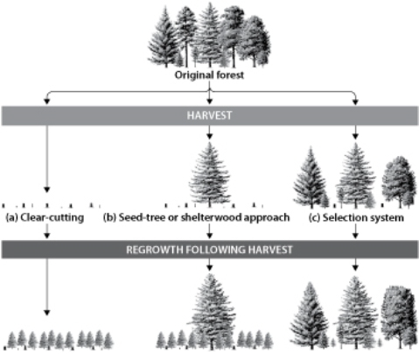
26. Which method of timber harvesting leads to the greatest uneven-aged stands of regrowth?

27. Which method of timber harvesting produces a future forest that most closely resembles the original forest in terms of biodiversity?

28. Which method of timber harvesting is likely to be most costly for a timber company? Why?

29. Which method of timber harvesting is likely to lead to a greater amount of deforestation in an area? Why?

30. A timber company plans to harvest an area of old-growth trees. How can the company control the kinds of trees that will be available for future harvesting in the area?

Essay
Write the answer to each question in the space provided.
31. Explain why resource management of topsoil is important to an ecosystem and to people.

32. Suppose a deer population was being managed for maximum sustainable yield. The number of hunted deer was regulated to keep the deer population constant. What would happen to the deer population if most of the deer that were hunted every year were young? Is the resource management successful?

33. Compare and contrast the deforestation going on now in developing nations with the deforestation that happened in the United States several hundred years ago.

34. Describe how politics can affect the timber industry. What is the role of the court system in carrying out changes to the NFMA?

35. Why might tree plantations that are monocultures be more at risk for plant diseases than tree plantations that are planted with a variety of species?

