Chapter 8 Chapter Test B
Multiple Choice
Circle the choice that best completes the statement or answers the question.
1. In what year did the human population reach 1 billion people?
A. 300
B. 1200
C. 1800
D. 2000
2. In recent years, the human population has
A. increased exponentially.
B. decreased exponentially.
C. decreased slowly.
D. increased slowly.
3. The average number of years an individual is predicted to live is called
A. carrying capacity.
B. life expectancy.
C. growth rate.
D. demography.
4. The number of organisms that an environment can support is called the
A. life expectancy.
B. demography.
C. carrying capacity.
D. growth rate.
5. Which area would have the lowest population density?
A. seacoast in Europe
B. river in China
C. tundra in Russia
D. suburb in the U.S.A.
6. The amount of people living in a given area is described as population
A. morality.
B. expectancy.
C. rate.
D. density.
7. Which factor(s) help increase total fertility rates?
A. needing extra help on farms
B. government programs supporting older adults
C. more children surviving childhood
D. one-child policies
8. What does the replacement fertility rate depend on the most?
A. population growth
B. demography
C. total fertility rate
D. death rate
9. What can be inferred about an area that has an age structure diagram with a pyramid shape?
A. The population is likely to decrease in the future.
B. There is a high proportion of older people to younger people.
C. There is a high population growth rate.
D. There is a low population growth rate.
10. What could be inferred about an area that has an age structure diagram with a “barrel” shape (thicker in the middle, narrower on the top and bottom)?
A. There is low population growth.
B. The population is likely to increase in the future.
C. There is a high proportion of young people to older people.
D. There is high population growth.
11. The number of males compared to females in a population is the
A. age structure.
B. sex ratio.
C. total fertility rate.
D. demography.
12. The model used to explain the reason that some industrialized nations have experienced a large change in birthrates and death rates is called the
A. demographic transition model.
B. replacement fertility model.
C. Industrial Revolution model.
D. life expectancy model.
13. Which stage of the demographic transition is characterized by conditions that have defined most of human history?
A. industrial
B. pre-industrial
C. post-industrial
D. transitional
14. Which stage of the demographic transition has the highest level of population growth?
A. industrial
B. transitional
C. pre-industrial
D. post-industrial
15. Which of the following regions is developed?
A. coral
B. chiton
C. kelp
D. phytoplankton
Modified True/False
Indicate whether the statement is true or false. If false, change the identified word or phrase to make the statement true.
16. The Industrial Revolution happened about 200 to 300 years ago.
17. A population with fewer younger people than older people will likely decrease in the future.
18. More people live in developing nations than live in developed nations.
19. Humans have a(n) minor impact on their environment.
20. Individuals from affluent societies tend to have smaller ecological footprints than people from poor societies.
Completion
Complete each statement on the line provided.
21. The number of babies out of 1,000 that die during their first year of life is called ____________________.

22. The study of human population statistics is called ____________________.

23. The average number of children a female member of a population has during her lifetime is the population's total ____________________.
24. The term ____________________ nation refers to nations with moderate or low income.
25. ____________________ refers to how well an individual lives.
Short Answer
Write the answers to the questions on the lines provided.
26. How did the Industrial Revolution affect agriculture?

27. List three characteristics of human population that are studied by scientists.

28. How are population size, density, and distribution like “snapshots”?

29. What is one possible evolutionary explanation for why more males are born than females?

30. What was one of the negative consequences of the Industrial Revolution?

Other
Use the graph to answer the following questions.
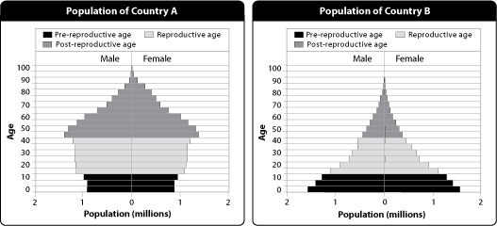
31. Which country has a greater population growth rate? How can you tell?

32. What inference can you make about Country A’s population growth?

33. Has Country B gone through the demographic transition? How can you tell from the graph?

34. Name one other country that would have a similar diagram to Country A.

35. Do you think the diagram for India would look more like the graph for Country A or Country B?

