Chapter 8 Chapter Test A
Multiple Choice
Circle the choice that best completes the statement or answers the question.
1. What event in the mid-1700s significantly changed human population growth?
A. Industrial Revolution
B. development of agriculture
C. bubonic plague
D. human settlement began
2. Which combination of factors will produce the highest rate of population growth?
A. high life expectancy and high infant mortality
B. low life expectancy and low infant mortality
C. low life expectancy and high infant mortality
D. high life expectancy and low infant mortality
3. What is a population's total fertility rate?
A. the number of births needed to keep a nation's population stable
B. the average number of children a male member of a population has each year
C. the average number of children a female member of the population has during her lifetime
D. the total number of babies born in a population each generation

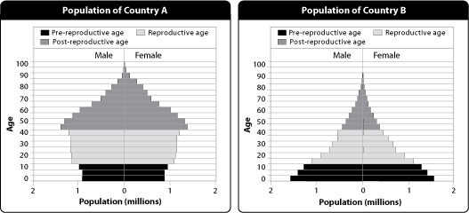

4. These graphs above are called
A. age structure diagrams.
B. life expectancy diagrams.
C. demographic diagrams.
D. infant mortality diagrams.
5. Which country does the graph on the left most likely represent?
A. China
B. Germany
C. India
D. Bangladesh
6. Which is the proper sequence of steps in the demographic transition model?
A. pre-industrial, industrial, post-industrial, transitional
B. pre-industrial, transitional, industrial, post-industrial
C. transitional, pre-industrial, industrial, post-industrial
D. post-industrial, transitional, industrial, pre-industrial
7. What happens during the transitional stage of the demographic transition?
A. Birth rates begin to fall.
B. Death rates begin to fall.
C. Birth rates increase.
D. Death rates increase.
8. Which of the following countries has yet to go through the demographic transition?
A. Japan
B. United States
C. India
D. Germany

9. In which of the following countries would individuals have the largest ecological footprints?
A. India
B. China
C. Canada
D. Thailand
10. The richest one fifth of the world's people uses what percent of the world's resources?
A. 5
B. 20
C. 43
D. 86
Modified True/False
Indicate whether the statement is true or false. If false, change the identified word or phrase to make the statement true.
11. Since the 1960s, the human population growth rate has increased.
12. In the time it took you to read this sentence, people were born and people died, but it is likely that fewer people were born than died.
13. A population with many young people compared to older people will likely experience slow population growth as the young people mature and have children.
14. As a naturally occurring phenomenon, fewer males are born around the world than females.
15. The population growth of developing nations as a whole surpasses population growth in developed nations.
Completion
Complete each statement on the line provided.
16. How a population changes in size during a specific period of time is called the ____________________.
17. The total fertility rate for a nation that would keep its population stable is called ____________________ fertility.
18. ____________________ nations are high-income nations, such as the United States.
19. The stark contrast between affluent and poor societies in today's world is often called the ____________________.
20. Many new diseases, sometimes called ____________________ diseases and which could become threats to the human population as a whole, arose because of the merging of human and animal habitats.
Short Answer
Write the answers to the questions on the lines provided.
21. Describe one positive and one negative impact of the concentration of people in cities.

22. Describe one way in which human activities skew the sex ratio one way or another.

23. What is the demographic transition?

24. Name two social factors that affect population growth.

25. What are two of the challenges presented by rapid population growth in developing regions?

Other
Use the graph to answer the following questions.
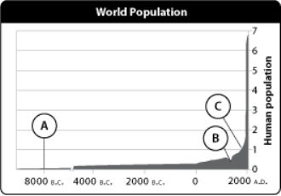
26. Describe the general trend of this graph.

27. Predict how the world's population will look beyond 2010. Explain your reasoning.

28. Which point on the graph demonstrates the highest level of population growth? What caused this to happen?

29. What happened at point B? Why?

30. How would you describe the ecological footprint of most individuals during the period of time marked by letter A? Why?

Essay
Write the answer to each question in the space provided.
31. What historical event or era had the largest impact on the size of the human population? Explain your reasoning.

32. Describe the distribution of the human population and some of its effects on the environment.

33. Compare historical and current trends in total fertility rates.

34. Compare the benefits and challenges of having a population with a high proportion of older people to younger people.

35. What stage of the demographic transition is the United States in? Explain.

