Chapter 6 Chapter Test A
Multiple Choice
Circle the choice that best completes the statement or answers the question.
1. Day-to-day conditions in Earth's atmosphere, such as “sunny and humid,” describe
A. climate.
B. climatograph.
C. weather.
D. biome.
2. Which biome would have the highest net primary production?
A. savanna
B. boreal forest
C. coral reefs
D. desert
3. In aquatic ecosystems, net primary productivity is related to
A. whether the water is fresh water or salt water.
B. the speed at which the water moves.
C. available sunlight and nutrients.
D. waves and tides.

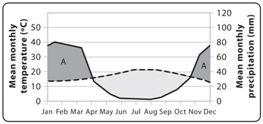
4. In the graph, the solid line represents precipitation and the dashed line represents temperature. What type of conditions are indicated by the areas of the graph labeled (A)?
A. hot
B. moist
C. dry
D. freezing
5. What percentage of Earth's surface is covered in water?
A. 75%
B. 90%
C. 25%
D. 50%
6. Which of the following describes the aphotic zone in an aquatic ecosystem?
A. the very bottom of a body of water
B. the zone where no sunlight penetrates and photosynthesis cannot occur
C. the shallow, near-shore zone
D. the uppermost layer where there is enough sunlight for photosynthesis
7. Which zone of an aquatic ecosystem tends to have more life—both producers and consumers?
A. aphotic zone
B. photic zone
C. benthic zone
D. All have roughly the same amounts of life.
8. Which ecosystems are considered standing freshwater ecosystems?
A. lakes
B. wetlands
C. ponds
D. all of the above
9. A bog is a wetland that
A. is entirely covered with thick, floating mats of vegetation.
B. has shallow water and tall, grasslike plants.
C. has shallow water and woody shrubs and trees.
D. has mostly salt water.
10. What ocean zone begins at the edge of the continental shelf and then extends outward into deeper water?
A. intertidal
B. open ocean
C. littoral
D. neritic
Modified True/False
Indicate whether the statement is true or false. If false, change the identified word or phrase to make the statement true.
11. On a biome map, patches representing the same biome tend to occur at similar longitudes.
12. Cold and dry biomes have the highest net primary production.
13. Primary consumers convert solar or chemical energy into energy stored in the bonds of organic sugars.
14. Water moves toward areas of lower salinity.
15. Ecologists tend to divide the photic zone of lakes and ponds based on distance from the bottom.
Completion
Complete each statement on the line provided.
16. A ____________________ is a group of ecosystems that share similar abiotic and biotic conditions.
17. In temperate forests, some animals avoid the winter by going into ____________________, a deep, sleeplike state that an animal enters for most of the winter.
18. The very bottom of a body of water is called the ____________________ zone.
19. ____________________ are areas of land that are flooded with water at least part of the year.
20. Areas nearest a river’s course that are flooded periodically are said to be within the river’s ____________________.
Short Answer
Write the answers to the questions on the lines provided.
21. How are biomes characterized?

22. Define net primary production in your own words.

23. List the three main criteria ecologists use to classify aquatic ecosystems.

24. List the major categories of freshwater ecosystems and provide two examples within each category.

25. What are some of the ecosystem services provided by mangrove forests?

Other
Use the graph to answer the following questions.
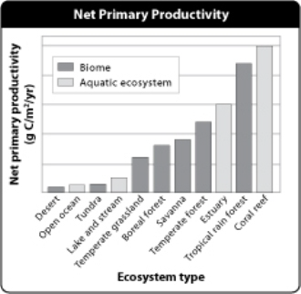
26. Why do coral reefs have such high productivity?

27. What is the general trend in this graph? What factors appear to affect productivity, and how?

28. Does the placement of the desert biome on the graph fit the general pattern? Explain why or why not.

29. Where would you place chaparral on this graph? Explain your reasoning.

30. Why might open ocean have such low productivity?

Essay
Write the answer to each question in the space provided.
31. Describe the general trend in the way net primary productivity varies throughout different biomes, and explain the reason for this trend.

32. Choose one biome and explain how organisms have adapted to the conditions of that biome.

33. Why is depth a useful characteristic for classifying aquatic ecosystems?

34. What consequences might occur in an area that loses most of its wetlands?

35. Explain the ecological importance of estuaries.

