Chapter 5 Chapter Test B
Multiple Choice
Circle the choice that best completes the statement or answers the question.
1. In the years immediately after a fire, a forest will experience
A. primary succession.
B. secondary succession.
C. tertiary succession.
D. a climax community.
2. Which of the following best describes a successful individual in evolutionary terms?
A. A successful individual possesses traits that are different from the traits of the rest of the population.
B. A successful individual produces many offspring that possess unique traits.
C. A successful individual is well adapted to its environment and produces offspring that survive to pass on genes.
D. A successful individual will be well adapted to its environment and produce a few high quality offspring.
3. Fish, cattails, frogs, water lilies, dragonflies, and all the other living things in a pond make up
A. evolution
B. speciation
C. genetic drift
D. extinction
4. Two species of finch live in the same environment. Over time, one develops a larger beak to consume larger seeds, while the other develops a narrow beak to consume more delicate seeds. This is an example of
A. resource partitioning.
B. character displacement.
C. coevolution.
D. competitive exclusion.
5. An interaction in which an individual of one species kills and consumes an individual of another is called
A. predation.
B. parasitism.
C. herbivory.
D. symbiosis.

6. In the western United States, at the southern edge of their range, moose are sometimes so severely infested with ticks that they die. The tick/moose relationship is best described as
A. predatory.
B. parasitic.
C. symbiotic.
D. mutualistic.
7. A beehive depends on pollen from flowers to survive. Flowers depend on bees to pollinate them. Humans tend bee hives, offering the bees a place to live in exchange for some of their honey. The relationship among these three sets of organisms is
A. parasitic.
B. commensalist.
C. symbiotic.
D. mutualistic.
8. The ultimate source of energy in an ecosystem in which deer eat grass and coyotes eat deer is
A. the grass.
B. the sun.
C. the deer.
D. chemosynthesis.
9. In a food web that consists of grass, mice, deer, coyotes, and hawks, which species is likely to have the greatest biomass?
A. grass
B. mice
C. coyotes
D. hawks
10. A niche restricted by competition is a
A. fundamental niche.
B. realized niche.
C. resource partitioned niche.
D. displaced niche.
11. In the history of the world, how many mass extinctions have occurred?
A. 5
B. 7
C. 10
D. 13
12. In a mass extinction, the rate of extinction exceeds
A. 99 percent.
B. 85 percent.
C. the rate of environmental change.
D. the rate of background extinction.
13. A deer browsing on a shrub is an example of
A. predation.
B. parasitism.
C. herbivory.
D. photosynthesis.
14. The first level of all food pyramids
A. consists of primary producers.
B. consist of primary consumers.
C. is chemosynthesis.
D. is photosynthesis.
15. A species with a restricted tolerance for environmental conditions is
A. a specialist.
B. a generalist.
C. highly competitive.
D. an autotroph.
Modified True/False
Indicate whether the statement is true or false. If false, change the identified word or phrase to make the statement true.
16. Two populations of a deer species are separated when a glacier forms. After the glacier melts, the two populations have become different species. This is an example of allopatric selection.
17. Communities that are powered by the sun depend on chemosynthesis for their energy.
18. A food web cascade occurs when one species has an indirect effect on species at a different level of the energy pyramid.
19. Animals gathering around a water hole in a drought prone area and establishing hierarchies of access to the water is an example of competition.
20. You have many species of bacteria living in your gut that help you with digestion. This relationship is best defined as commensalism.
Completion
Complete each statement on the line provided.
21. A species introduced to a new environment without limiting factors could become ____________________.
22. The twenty varieties of heirloom tomatoes available at your local farmers’ market are the result of ____________________.
23. ____________________ is an interaction in which an animal eats a plant.
24. The ability to perform photosynthesis or chemosynthesis defines a ____________________.
25. An organism’s ____________________ describes its use of resources and functional role in a community.
Short Answer
Write the answers to the questions on the lines provided.
26. A disaster wipes out 50 percent of a small population of birds. Prior to the disaster, about half the birds had a green wing patch and half had a blue wing patch. Several generations after the disaster, only 10% have a blue wing patch, and 90% have a green wing patch. What do you infer happened, and why?

27. Pronghorn are a species of extremely fast hooved mammal that live on the plains of western North America. They are so fast that no current North American predator can catch them. During the ice age, cheetahs occupied North America. Speculate about how pronghorn became so fast.

28. In a meadow community, you observe a high biomass of plants, a fairly high number of rodents, but only a single fox. Explain.

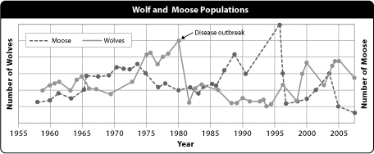
29. In the graph above, what do you think will happen between 2005 and 2010? Why?

30. Explain the advantages to producing more offspring than might survive. How is this relevant to evolution?

Other
Use the illustration to answer the following questions.
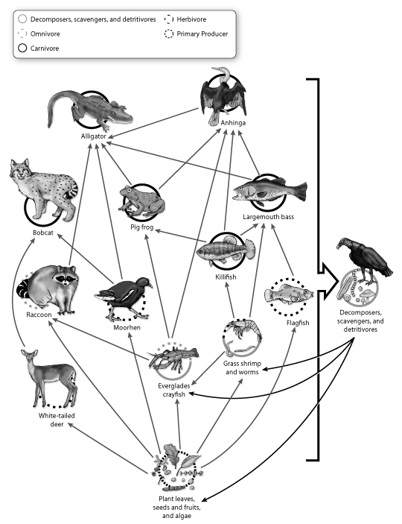
31. Identify a producer, a primary consumer, and a secondary consumer from the illustration.

32. Which populations in this ecosystem would you expect to have the fewest members, and why?

33. If an anhinga consumes a crayfish, what percentage of the energy of the crayfish’s original plant-based meal will reach the anhinga?

34. What would happen if alligators were removed from the ecosystem? Explain the effects on each level of the food web.

35. Identify two species in this web that might compete with each other, and explain which resources they compete for.

