Chapter 5 Chapter Test A
Multiple Choice
Circle the choice that best completes the statement or answers the question.
1. A landslide causes part of a mountainside to fall away, leaving bare rock. In the years immediately following the landslide, the area will experience
A. primary succession.
B. secondary succession.
C. tertiary succession.
D. a climax community.
2. If these are present in a new environment, a species is unlikely to become invasive.
A. predators, parasites, and competitors
B. cane toads, kudzu, and zebra mussels
C. exotic species
D. symbiotic and commensalist species
3. A reintroduced population of wolves in a national park is 90% grey and 10% black, consistent with the wolf population in other regions. After several generations in isolation, the national park’s wolf population is 60% grey and 40% black. The wolf population has likely experienced
A. natural selection.
B. genetic drift.
C. mutations.
D. migration.
4. In Madagascar, several species of lemur eat bamboo, but each species specializes in one part of the bamboo—one species eats mature bamboo stalks, one species eats bamboo shoots, and one species eats leaves. This is an example of
A. speciation.
B. resource partitioning.
C. competition.
D. niche partitioning.
5. In the example above, one lemur species eats only bamboo shoots. Bamboo shoots contain a high level of cyanide, a toxic chemical. This lemur species has developed a tolerance for a certain amount of cyanide. What do you think will happen over time?
A. The level of cyanide in the bamboo population will increase.
B. The level of cyanide in the bamboo population will decrease.
C. The level of cyanide in the bamboo population will remain the same.
D. The level of cyanide in the lemur population will decrease.
6. When energy is transferred between trophic levels, the amount of available energy lost is about
A. 90 percent.
B. 50 percent.
C. 25 percent.
D. 10 percent.
7. Humans are generally
A. carnivores.
B. herbivores.
C. omnivores.
D. detrivores.
8. Any being that uses the sun’s energy to create sugars is a
A. primary producer.
B. secondary producer.
C. primary consumer.
D. secondary consumer.
9. Which best describes evolutionary success?
A. A successful organism possesses adaptive traits and is able to pass those traits on to numerous offspring which then reproduce.
B. A successful organism possesses traits that are different from traits in the rest of the population and that allow the organism to compete more successfully.
C. A successful organism produces more offspring than others in the population.
D. A successful organism possess adaptive traits and produces more offspring than survive.
10. Around 65 million years ago, 95 percent of the planet’s species were wiped out, and the age of the dinosaurs ended. Which of the following best explains why we still have numerous species today?
A. The species that exist today were those that were not wiped out when the dinosaurs died.
B. The species that exist today evolved from surviving species to fill niches left vacant by the dinosaurs.
C. The species that exist today speciated due to separation among different populations.
D. The species that exist today have the potential to be as numerous as the ones that went extinct.
Modified True/False
Indicate whether the statement is true or false. If false, change the identified word or phrase to make the statement true.
11. An invasive species is a species that has been introduced to a new area and lacks limiting factors.
12. On islands off the coast of Siberia, paleontologists have found the remains of pygmy mammoths. These populations were likely separated from mainland mammoth populations and became a new type of mammoth through allopatric adaptation.
13. An organism that depends on another without killing it is a predator.
14. A nation where most of the people eat a primarily vegetarian diet will be able to support a lower population than it would if the people ate a lot of meat.
15. In a woodland, a rabbit eats grass, and a coyote eats the rabbit. The coyote is a secondary consumer.
Completion
Complete each statement on the line provided.
16. ____________________ is an accidental change in DNA.
17. You visit the state fair and see a display of 17 breeds of chicken. These chickens are the result of ____________________.
18. A species of butterfly that lives in rocky, high-altitude areas and pollinates a specific flower, which in turn is eaten by a certain bird, goes extinct. There is now a vacant ____________________ in the ecological community.
19. Chemosynthesis and photosynthesis use different energy sources, but each uses water and ____________________ to produce sugars.
20. ____________________ is a close, long-term association between two organisms.
Short Answer
Write the answers to the questions on the lines provided.
21. Explain the difference between mutualism and commensalisms, with examples.

22. Grasslands are generally considered highly productive ecosystems, and we see some of the largest and most diverse assemblages of mammal species on grasslands such as the Serengeti. Why do you think this is, as opposed to an ecosystem like a northern pine forest, for example?

23. Explain why a food web is a better representation of energy flow in a community than a food chain.

24. Wolverines are snow dependent and live in highly structured, territorial populations. At the southern edge of their range, their habitat fragments into isolated, high-altitude ‘islands’ of suitable conditions, separated by an “ocean” of lowland. Despite the fragmentation, however, wolverines have not speciated; all wolverines in North America, from the Rockies to Alaska, are one species. What might you infer about wolverine life history characteristics to explain this fact?

25. Explain how a sudden change in environment—either through a disaster or through shifts in conditions—might affect the evolution of species in the area.

Other
Use the illustration to answer questions 26–30.
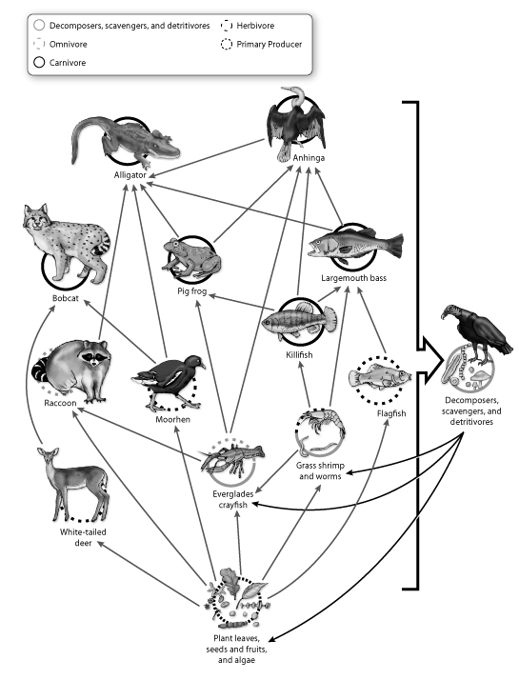
26. In the diagram, how many levels of producer and consumer are there?

27. Which animals would you expect to have the lowest relative populations in this ecosystem, and why?

28. Imagine that alligators are eliminated from the ecosystem. What might the effects be on the entire food web? Refer to specific species as you explain.

29. What does this diagram tell us about the importance of biodiversity in maintaining a functioning ecosystem?

30. In the illustration, what do the arrows represent? (aside from “This species is eaten by that one.”)

Essay
Write the answer to each question in the space provided.
31. Compare and contrast what is likely to happen to an area that has just experienced a severe forest fire, and what is likely to happen to an area that has just been exposed after centuries of glaciation. Which will regrow more quickly, and why?

32. At the end of the Pleistocene Ice Age, around 10,000 years ago, the climate changed dramatically. Using your knowledge of evolution and adaptation, explain why so many species went extinct, and speculate as to why others—such as bison, elk, and wolves—survived.

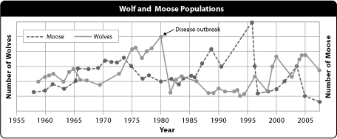
33. The graph above illustrates the population cycles of a wolf and moose population. Explain what is happening in this graph.

34. Wolves were exterminated from Yellowstone National Park in the early part of twentieth century. The elk population grew quickly once wolves were gone. Around 1950, a species of willow-nesting bird disappeared from the park. in 2005, 15 years after the reintroduction of wolves to the park, the willow-nesting bird returned. Explain what happened and how it illustrates the fact that top predators are important.

35. Explain why understanding competition and niche could be important to controlling an invasive species or predicting whether an exotic species will become invasive.

