Chapter 4 Chapter Test B
Multiple Choice
Circle the choice that best completes the statement or answers the question.
1. If 300 deer live within a 20-km² area, then 15 deer per km² is the deer ______ for that area.
A. carrying capacity
B. population density
C. limiting factor
D. survivorship curve

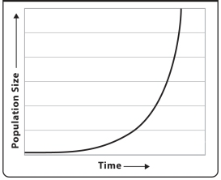
2. The graph above represents
A. exponential growth.
B. logistic growth.
C. carrying capacity.
D. limiting factors.
3. Fish, cattails, frogs, water lilies, dragonflies, and all the other living things in a pond make up
A. a population.
B. a community.
C. an ecosystem.
D. a biosphere.
4. A grassland experiences a drought that causes most of the plants to die and several watering holes to dry up. The antelope that live on the grassland experience a decrease in population because water and plants are key
A. biotic factors.
B. abiotic factors.
C. resources.
D. habitats.
5. In a population of 100 monkeys, you count 48 males and 52 females. This population has an approximately even
A. sex ratio.
B. biotic potential.
C. survivorship curve.
D. carrying capacity.


6. The daigram above would most likely display the distribution of a population of a plant that
A. has few specific resource requirements.
B. requires an exact amount of a scarce mineral.
C. establishes a boundary for itself using a chemical that poisons other plants.
D. has reached its carrying capacity.

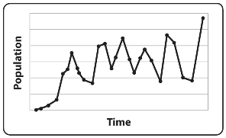
7. In the graph above, the population size is
A. increasing.
B. decreasing.
C. remaining stable.
D. undergoing cyclic change.
8. A caribou is adapted to live in cold tundra environments. It would not be able to survive in a tropical forest because the tropical forest does not provide a suitable
A. community.
B. population.
C. population structure.
D. habitat.
9. A population’s growth rate is determined by births, deaths,
A. immigration, and emigration.
B. immigration, and migration.
C. migration, and biotic potential.
D. immigration, and biotic potential.
10. An ecologist who is studying the mineral requirements and daily water intake of a plant species is studying the
A. individual.
B. plant’s population.
C. plant’s community.
D. planet’s ecosystem.
11. Which of the following has the highest population density?
A. 100 deer in 100 sq kilometers
B. 20 deer in 10 square kilometers
C. 10 deer in 10 square kilometers
D. 50 deer in 20 square kilometers
12. Every summer, Siberian cranes fly from India to Siberia, where they breed and raise their young. When winter comes, the cranes fly back to India. This is an example of
A. immigration.
B. emigration.
C. migration.
D. population control.
13. An example of a density dependent limiting factor is
A. an avalanche.
B. the amount of available food.
C. a sudden flood.
D. a decrease in water due to drought.
14. The equation for determining population growth is
A. (births + deaths) – (immigration + emigration).
B. (births + emigration) + (deaths – immigration).
C. (births + immigration) + (deaths – emigration).
D. (births + immigration) – (deaths + emigration).
15. Many bird species are territorial. In territorial birds species, what kind of population structure would you expect?
A. uniform
B. random
C. clumped
D. aging
Modified True/False
Indicate whether the statement is true or false. If false, change the identified word or phrase to make the statement true.
16. The ecosystem is the most complex level of organization that an ecologist studies.
17. A forest fire that kills a large percentage of a pine beetle population is an example of a density-dependent factor that limits population.
18. You need to count the number of trees of a certain species within a 300-km² area. Your best strategy for estimating the number of trees is sampling.
19. In year one of a study, there are 100 mice living in a field. In year two, there are 110. In year three, there are 121. In year four, there are 132. The mouse population is experiencing a logistic growth pattern.
20. A dead tree is an example of a biotic factor in a forest ecosystem.
Completion
Complete each statement on the line provided.
21. In one year, a female wolf may give birth to seven pups. In two years, a female wolverine may give birth to two kits. The wolf has a higher ____________________.
22. A sharp decline in the number of tigers throughout Asia worries many conservationists. This decrease in population size might indicate that tigers are in danger of ____________________.
23. The ____________________ includes all parts of our planet Earth that host life, with all of its organisms and environments.
24. ____________________ provide organisms with the resources needed to survive, including food, shelter, water, and mates.
25. An algae-eating snail population lives in a small pond. The amount of algae in the pond is a limiting factor that will help determine the ____________________ of the pond for the snails.
Short Answer
Write the answers to the questions on the lines provided.
26. A population of elephants with an even sex ratio contains 30 elderly elephants, 25 adult elephants, 10 juvenile elephants, and 3 baby elephants. What population trend do you predict in this population of elephants, and why?

27. A bird species requires abundant shoreline and a high population of insects within its habitat. You observe a population of these birds with a low density and adequate resources, but the population seems to be growing very slowly. What might be an explanation for the slow population growth?

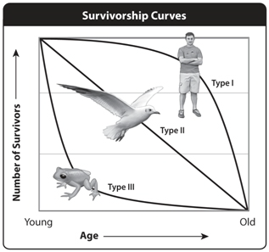
28. On a beach in Hawaii, you observe a hatching of sea turtles. Hundreds of baby turtles climb out of nests in the sand and flop towards the sea. As they cross the beach, dozens are caught by predators and eaten. What kind of survivorship curve do you think the sea turtles display, and why?

29. Ecologists are interested in studying the snow leopard population size in Nepal. Snow leopards are rare, live in difficult terrain, and are extremely hard to find. What method could the ecologists use to determine population size if they can’t find the actual snow leopards to count, and why?

30. A population of 1000 alligators has a birthrate of 400 per year. Each year, 150 alligators die, and 150 leave the population to look for new territory, but 30 alligators arrive from other territories to join the population. What is the annual population growth rate per thousand animals?

Other
Use the illustration to answer the following questions.
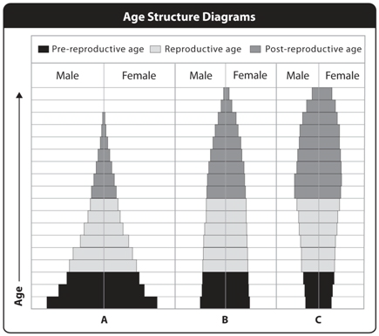
31. In which of the populations above would you expect to see a rapid increase within the next few generations?

32. Imagine that the graphs above show populations of three different species that people want to protect. Which species is likely to need the most protection and management in the near future?

33. One of these populations has a long generation time and it has been at carrying capacity for several generations, but habitat and resources are abundant and the population isn’t likely to change soon. Which population is it?

34. If population A is located in an area of limited resources and habitat, what do you predict will happen in the near future?

35. Which population has the highest proportion of reproductive individuals?

