Chapter 4 Chapter Test A
Multiple Choice
Circle the choice that best completes the statement or answers the question.
1. Giraffes, lions, zebras, hyenas, and all the other living things of the Serengeti make up a(n)
A. ecosystem.
B. population.
C. community.
D. biosphere.
2. Every spring, many species of bird travel north to the Arctic to breed, and in the fall travel south again for the winter. This is an example of
A. immigration.
B. emigration.
C. migration.
D. population growth.
3. You are studying the vegetation communities of the Mongolian grasslands in a 1000-km² area. What is your best strategy for estimating the number of individuals of different plant species growing throughout the grasslands?
A. Direct observation
B. Sampling
C. Indirect observation
D. Simply counting each one
4. Which is the highest population density of grasshoppers?
A. 35 grasshoppers/10 square meters
B. 40 grasshoppers/20 square meters
C. 1 grasshopper/1 square meter
D. 50 grasshoppers/30 square meters
5. You will be conducting a study of the interactions of vegetation, animals, mineral composition of the soil, and water levels in a saltmarsh. You are studying the
A. saltmarsh population.
B. saltmarsh biosphere.
C. saltmarsh community.
D. saltmarsh ecosystem.
6. “All the living things and their physical environment within a given area” best defines
A. a community.
B. an ecosystem.
C. the biosphere.
D. a population.
7. A population of wolves is reintroduced into Yellowstone National Park. For the first decade, the wolf population grows exponentially. Then, the population growth slows. The new pattern is known as
A. logistic growth.
B. limiting factors.
C. carrying capacity.
D. exponential growth.
8. In the example above, where wolves are reintroduced to Yellowstone National Park, the number of elk and other prey species within the park are
A. a density independent factor.
B. an example of biotic potential.
C. a density dependent factor.
D. a limiting factor.

9. Wildlife managers reintroduce a species of antelope to a park in Africa from which it had been wiped out. The habitat is ideal, and in the first year, the population grows from 50 animals to 60. If the population experiences exponential growth, what will the approximate population be at the end of five years?
A. 75
B. 90
C. 120
D. 150
10. Pandas depend on bamboo. The amount of intact bamboo forest will help determine
A. the biotic potential of the population.
B. the carrying capacity of the population.
C. the sex ratio of the population.
D. the limiting factor of the population.
Modified True/False
Indicate whether the statement is true or false. If false, change the identified word or phrase to make the statement true.
11. The community is the simplest level of organization that the ecologist studies.
12. A herd of mule deer living on a certain mountain and separated from other herds of mule deer represents a species.
13. In a population in which most of the individuals are of pre-reproductive or reproductive age, the population is likely to increase quickly in the future.
14. At the end of an ice age, you would expect to see exponential growth of species as they colonize regions left uninhabited by glaciers.


15. The diagram above shows a clumped distribution pattern.
Completion
Complete each statement on the line provided.
16. In a population of elephants in Kenya, researchers found that about 80% of the elephants were female, and only 20% were male, resulting in an unbalanced ____________________.
17. Rocks, soil, water, and oxygen are all ____________________ factors in the Sierra Nevada ecosystem of California.
18. Pikas are small mammals, related to rabbits, that are adapted to cool temperatures and life at high altitudes. In recent years, ecologists studying pikas have noticed that pika colonies at lower elevations are being abandoned, while new pika colonies are appearing at higher regions where pikas have not lived before. The movement of pikas uphill is an example of ____________________ to a new area.
19. Water, a den site, a mate, and a population of small rodents are examples of ____________________ that a fox needs to survive.
20. Wolverines have a lifespan of about 10 years. Females reach sexual maturity at around age three, and give birth to two kits every other year, if food resources are adequate. This birth rate suggests that wolverines have ____________________ biotic potential.
Short Answer
Write the answers to the questions on the lines provided.
21. In the western United States, elk populations are at an all-time high. In some states, the state government has established elk feedgrounds, where elk gather in large numbers during the winter to eat hay provided by the state. This enables more elk to survive the winter, elevating the population even further. Some people are in favor of closing the feedgrounds.
What might some of the arguments be for closing the feedgrounds? What might some be for keeping them open?

22. List the five levels of organization, from smallest to largest, that an ecologist studies.

23. You are observing a population of wolves as part of a research project. You note that wolf pups have a mortality rate of 40 percent in the first year. Adult wolves have a mortality rate of 25 percent. What type of survivorship pattern do the wolves display?

24. The male of a monogamous bird species is highly valued for its plumage, and many males are killed so that fashion designers can use their feathers on clothing and hats. The sex ratio of this species is now 89 percent female and 11 percent male. What are the long-term prospects for the species? How might this be different if the species were not monogamous?

25. In one year in a population of 100 squirrels, 12 individuals die of natural causes, and 22 are born. Seven juveniles leave the population to establish territories somewhere else, and 4 squirrels arrive from a different patch of forest. How would you calculate the growth rate of the population per 1000 individuals?

Other
Use the graph shown to answer questions 26–30.
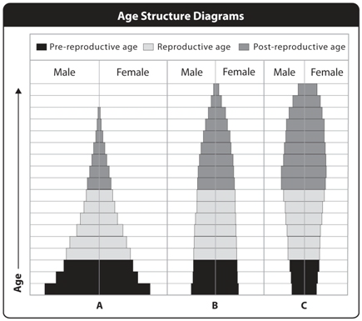

26. In the age structure diagrams, which diagram represents a population that is likely to grow rapidly in the future?

27. Imagine that the graphs above represent three populations of a rare species of deer, each protected in a separate wildlife refuge. Your goal as director of the wildlife refuge system is to make sure that the population of deer remains healthy or grows throughout the system. Which population is most likely to need attention?

28. For many years, the deer species was not present in one of the wildlife refuges, even though the habitat was good. Several years ago the deer were reintroduced into this area. Which diagram represents the population that was recently reintroduced, and why?

29. One of these populations has reached carrying capacity. Which one is it, and why?

30. In visiting the wildlife refuge where population C lives, you note the following factors:
- Approximately 70 percent of the deer have magnificent antlers.
- There are many foxes in the refuge.
- The refuge is entirely surrounded by housing developments, and is separated from the other two refuges by a superhighway.
What does this information suggest about the causes of the age structure in population C? If you were to make recommendations about how to manage this deer population in the future, with the goal of making it self-sustaining, what might you suggest? Refer to each factor.

Essay
Write the answer to each question in the space provided.
31. During the Middle Ages and throughout the Renaissance, cities in Europe suffered from outbreaks of disease that killed hundreds of thousands of people. Extrapolating from what you’ve learned in this chapter, why do you think this happened?

32. You are an ecologist working on endangered-species management. A national park approaches you because they are concerned that a species of rabbit that lives in the park is declining rapidly. At what scale or scales (individual, population, ecosystem, community, biosphere) will you study the problem, and why?

33. Explain how limiting factors and biotic potential interact to regulate the population growth of a species.

34. What are some of the benefits for humans of keeping track of the population sizes of wild species?

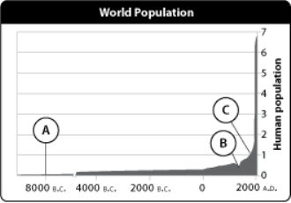
35. Above is a chart of human population growth from 8000 b.c.e. to 2000 a.d. Why do you think the population remained so stable for so long? What do you think explains the sudden spike in growth, and what do you predict will happen in the future? Why?

