Chapter 3 Chapter Test A
Multiple Choice
Circle the choice that best completes the statement or answers the question.
1. The basic units of matter, the smallest units that maintain the chemical properties of an element, are called
A. atoms.
B. lipids.
C. compounds.
D. molecules.
2. Because of their large size, proteins, nucleic acids, carbohydrates, and lipids are together called
A. solutions.
B. elements.
C. hydrocarbons.
D. macromolecules.
3. Why is water often called “the universal solvent”?
A. It can dissolve many other molecules.
B. Water can turn into a solid form.
C. Water is a type of solution.
D. It solves most of the world's environmental problems.
4. Predator prey relationships are an example of a
A. system with no feedback.
B. positive feedback loop.
C. negative feedback loop.
D. destabilizing system.
5. Which sphere of Earth is made of all the rock above and below Earth's surface?
A. lithosphere
B. geosphere
C. hydrosphere
D. atmosphere
6. The lithosphere is carried on a softer, but still firm, layer of rock called the
A. geosphere.
B. core.
C. crust.
D. asthenosphere.
7. Which sphere are humans a part of?
A. geosphere
B. hydrosphere
C. biosphere
D. atmosphere
8. A change in state in which water returns to Earth's surface and changes from a vapor to a liquid is called
A. condensation.
B. transpiration.
C. evaporation.
D. recharge.
9. Matter that organisms require for their life processes are called
A. legumes.
B. decomposers.
C. fertilizers.
D. nutrients.
10. What products are created by the process of photosynthesis?
A. the sun's light and energy
B. oxygen and carbohydrates
C. phosphorus and nitrogen
D. carbon dioxide and water

Modified True/False
Indicate whether the statement is true or false. If false, change the identified word or phrase to make the statement true.
11. A(n) compound is a chemical substance with a given set of properties that cannot be broken down into substances with other properties.
12. Because water molecules are polar, they tend to repel one another.
13. Sometimes, an output of a system is also an input for the same system.
14. Tectonic plates move apart from one another at convergent plate boundaries.
15. Producers are organisms, mainly animals, that must eat other organisms to obtain nutrients.
Completion
Complete each statement on the line provided.
16. ____________________ are polymers that consist of atoms of carbon, hydrogen, and oxygen.
17. Earth's ____________________ consists of all the planet's living or once-living things and the nonliving parts of the environment with which they interact.
18. Aquifers hold ____________________, fresh water found underground.
19. In a process called ____________________, the addition of phosphorus to bodies of water can lead to an overgrowth of producers (usually algae).
20. Nitrogen ____________________ is the conversion of nitrogen gas to ammonia.
Short Answer
Write the answers to the questions on the lines provided.
21. Define cohesion and explain why this property of water is important for life.

22. Describe how humans interact with three of Earth's spheres.

23. Explain how the processes of plate tectonics affect the types of plants and animals that can live in an area.

24. Explain why, although water covers over 70% of our planet, water shortages and conflicts over water use can occur.

25. Where you might find carbon on Earth? List four examples.

Using Science Skills
Use the illustration to answer the following questions.
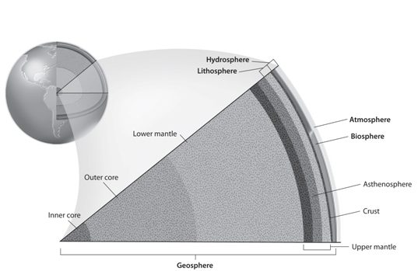

26. What is the thinnest layer of Earth's geosphere?

27. What is Earth's outermost sphere?

28. Why does the hydrosphere include both the biosphere and the atmosphere?

29. How does the size of the biosphere compare with the rest of Earth?

30. Which layer of the geosphere supports the tectonic plates?

Essay
Write the answer to each question in the space provided.
31. Compare and contrast elements and compounds.

32. Explain why negative feedback loops are more common in natural environmental systems than positive feedback loops.

33. Explain why the water cycle is so important to human life and the natural environment.

34. How do humans affect the carbon cycle? How could humans reduce their effects on the carbon cycle?

35. What consequences would occur to the nitrogen cycle if something happened that drastically reduced the population of bacteria on Earth?

