Chapter 2 Chapter Test A
Multiple Choice
Circle the choice that best completes the statement or answers the question.
1. A cost-benefit analysis is a(n)
A. study of the factors that influence that influence decisions of buyers and sellers.
B. economy in which the government decides what is made.
C. equilibrium between a product's supply and its demand.
D. comparison between what is sacrificed and gained by a specific action.
2. Which statement about the relationship between economics and the environment is true?
A. Internal and external environmental costs are usually considered equally.
B. Long-term effects often receive more weight than short-term effects.
C. Harm to the environment can harm economies.
D. The relationship usually receives serious consideration.
3. “Energy Star,” “USDA Organic,” and “Fair Trade Certified” are all examples of
A. ecosystems
B. ecolabelling
C. non-market values
D. market failure
4. In making environmental policies, government interacts with __________
A. organizations.
B. businesses.
C. citizens.
D. all of the above
5. In the U.S., laws enacted from the 1780s to the late-1800s reflected the perception that __________
A. the amount of land and natural resources in the West were endless.
B. the West's natural resources could be used up and required legal protection.
C. Americans were living amid dirtier air, dirtier water, and more waste and toxic chemicals.
D. a sustainable future should be a primary goal.
6. Most major laws in modern U.S. environmental policy were enacted in the
A. 1960s and 1970s.
B. 1980s and 1990s.
C. years between 2000–2005.
D. years between 2005–2010.
7. Headquartered in New York City, the 190 member nations of the following organization work together to promote peace and to help solve economic, social, cultural, and humanitarian problems.
A. World Trade Organization
B. European Union
C. United Nations
D. Kyoto Protocol
8. A law that prohibits dumping wastes into the ocean and punishes people who dump wastes demonstrates which approach to environmental policy?
A. green tax
B. command-and-control
C. cap-and-trade
D. subsidy
9. A power company is given free land by the government to reduce the cost of providing wind-generated electricity to rural residents. This is an example of a(n)
A. command-and-control approach
B. cap-and-trade system
C. subsidy
D. green tax
10. The first step of the environmental policy process is
A. guide the solution to law
B. identify the problem
C. get organized
D. gain access to policymakers
Modified True/False
Indicate whether the statement is true or false. If false, change the identified word or phrase to make the statement true.
11. Decision makers commonly use a method called supply and demand in which they compare what they will sacrifice and gain by a specific action.
12. All economies depend on the environment.
13. In the United States, the strength of environmental policy is constant from state to state.
14. The United Nations is a group of 27 member nations that can sign treaties and enact regulations that have the same authority as national laws in each member nation.
15. Green taxes are used widely in the United States.
Completion
Complete each statement on the line provided.
16. The amount of a product people will buy at a given price if free to do so is ____________________.
17. ____________________ consists of a formal set of general plans and principles intended to address problems and guide decision making in specific instances.
18. The laws that make up historical U.S. environmental policy can be divided into ____________________ periods.
19. The Convention on International Trade in Endangered Species of Wild Fauna and Flora (CITES) and the Kyoto Protocol are examples of ____________________ designed to protect the environment.
20. ____________________ involves efforts to influence an elected official into supporting a specific interest.
Short Answer
Write the answers to the questions on the lines provided.
21. Name an example of a “service” provided by ecological systems.

22. What were some of the costs of westward expansion in the United States?

23. How did the formation of the Environmental Protection Agency signal a new approach to environmental policy?

24. In order, from start to finish, list the steps in the environmental policy process.

25. How can people who are too young to vote make an impact on environmental policy?

Other
Use the graph shown to answer questions 26–30.
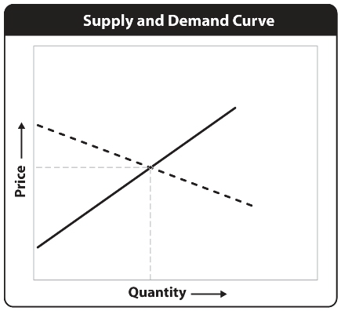

26. What is represented by the line that slopes down toward the right?

27. What is represented by the line that slopes up toward the right?

28. What is represented by the point where the two sloping lines intersect?

29. Suppose the system is at equilibrium, and then the demand curve is shifted upward. What would have to happen to the price to reach the new equilibrium point?

30. Explain why the supply curve slopes the way it does.

Essay
Write the answer to each question in the space provided.
31. People often overlook the connection between their economic activities and the environment. In terms of economic activities, how can people be more mindful of their effect on the environment? Give one example.

32. Outline the evolution of United States environmental policy from the 1780s to the late-1900s. How would you rate the progress made in U.S. environmental policy during this period?

33. What have been some of the most important developments in United States environmental policy since the 1960s? Explain the importance of these developments.

34. What type of approach to environmental policy do you think is the most effective? Explain why.

35. Choose one step of the environmental policy process and write about the consequences of omitting that particular step from the process. What would happen if that step were left out, and why?

