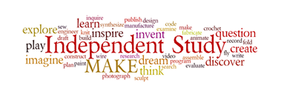

Independent Study

Adapted from Edison Public Schools

The TED Talk format has globally evolved into a way for people to share their expertise, develop their passions, and to offer radical new ideas and solutions to the world's problems.This project will give students the chance to explore what makes them special as an individual and give them a platform to share their ideas with classmates and teachers. Students will write and present a five-to-eight minute presentation using visuals and/or props. Not only will they be using the core subjects of reading, writing, and social studies (as well as math and science depending on the topic), they will also be utilizing public speaking skills and practicing self-confidence - all useful for future endeavors.

The intent of this project is to allow students to extend the core curriculum and develop his/her skills according to his/her capabilities. Therefore, the completion of this project is not for classroom extra credit and will not affect the student’s grade in any subject.

This Independent Inquiry Project packet includes:
- An Action Plan
- Project Directions
- Rubric

Action Plan

Project Topic | Date to be Completed
Step 1: Let’s Build Some Background Knowledge!
Step 2: Get Those Creative Juices Flowing: FFOE
Step 3: Using a Mind Map
Step 4: Creating a Happy Thesis Statement
Step 5: Writing the Middle of Your Speech
Step 6: Writing the End of Your Speech
Step 7: Practice, Practice, Practice
Step 8: Visual Aids
Step 9: Memorizing Your Speech
Step 10: Practice Even More!
Final Presentation Ready for the World

Possible Resources For This Project

Information Types | Possible Resources
Books, Periodicals
Websites
Interviews
Experiences

Student Signature: ___________________________ Parent Signature: _______________________

Teacher Signature: ___________________________ Date: ________________________

Project Directions
Step 1: Let’s Build Some Background Knowledge!
Research what a TED Talk is and answer the questions below.

- What is a Ted Talk?

- What is the goal/purpose of a Ted Talk?

- Watch these example Ted Talks:
- Adora Svitak: “What Adults Can Learn From Kids”

- Based on the Ted Talks you’ve already watched on your own, brainstorm a list of attributes a successful TED Talk should have and write them in the spaces provided.

Step 2: Get Those Creative Juices Flowing!
Learn the principles of FFOE (Fluency, Flexibility, Originality, Elaboration)
and brainstorm your topic. (Activities adapted from NuMinds Enrichment.)

Fluency is about turning on the faucet and letting ideas flow, without judging or critiquing them. Set a timer for five minutes. List 20 + things you could give a TED Talk on in the spaces provided. Your job right now is to brainstorm. Remember, don’t judge the ideas, just let them flow!

1) | 2) | 3)
4) | 5) | 6)
7) | 8) | 9)
10) | 11) | 12)
13) | 14) | 15)
16) | 17) | 18)
19) | 20) | 21)

Flexibility: How flexible is your thinking? To find out, we are going to see how many different categories you came up with based on the list you just created. For example, can your ideas be categorized as school topics, sports topics, etc.

How many categories do you have? _______

Why did you group your ideas into these categories? ______________________________
________________________________________________________________________

OK, now we can start judging, just a little bit. Scan your list again and pull out the TOP three ideas, in your opinion, for a TED Talk and list them below.

- ___________________________________________________________________
- ___________________________________________________________________
- ___________________________________________________________________
Originality is all about how unique your idea is. An original idea makes you say, “Brilliant, why didn’t I think of that?!” A non-original idea just blends into the background and seems “normal” because it’s been done/heard/created before!

To test the originality of your three ideas, talk with an adult. Share your ideas and get feedback. Allow them to rank your ideas 1st, 2nd, and 3rd in terms of originality. Record their ranking of your ideas below:

1st:______________________________________________________________________
2nd:_____________________________________________________________________

3rd:______________________________________________________________________

What feedback did you receive from the adult you ask? How did it help you grow?

_________________________________________________________________________
_________________________________________________________________________
_________________________________________________________________________
_________________________________________________________________________
_________________________________________________________________________

Elaboration is the last piece of FFOE, and it is about adding layers and layers of details to your most original idea. The rest of this project will help you with this last step.

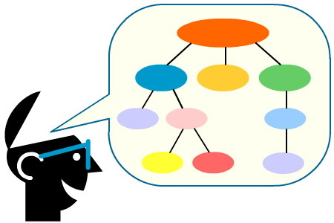
Step 3: Using a Mind Map to Elaborate on Your Original Idea

Look at the mind map example below and create one for your TED Talk topic. You may use paper and markers/colored pencils, Google Drawings, Popplet, etc.

Remember these key points:

- Have a central idea in the center represented by large text or an image.

- Show structure and hierarchy visually: text, lines, etc. should get smaller as they move out from the center.

- Use color to distinguish different “branches” of the mind map.

- Use images, doodles, and symbols to replace words and represent ideas whenever possible.

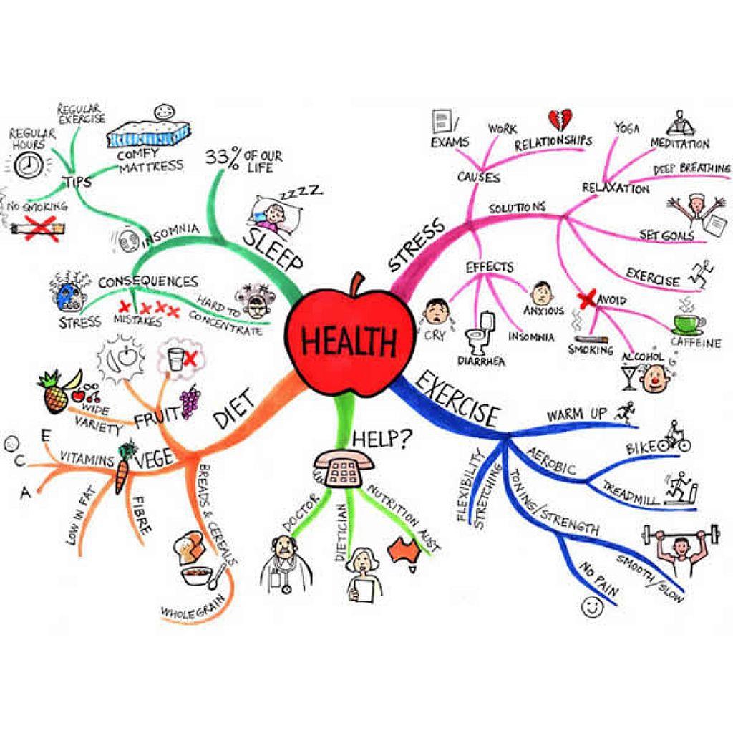

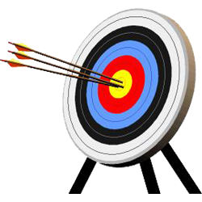
Step 4: Creating a Happy Thesis Statement
(Activities adapted from NuMinds Enrichment.)

What’s a “Happy” Thesis Statement? The main idea of your talk! A “road map” for what the talk will be about. Your opinion about the topic. This is the beginning of your speech.

What’s a “Sad” Thesis Statement? A title (Why I Love Cats), A question (Did you know that cats are awesome?), An announcement (My talk will tell you why cats are awesome.)

- Brainstorm the first sentence of your speech. Use this thesis template to strengthen its structure.

  - I believe that ________ is ________ because _______.
  - Example: I believe that cats make great pets because they are independent, loyal, and are fun to be around.
  - Write yours! ______________________________________________________________
______________________________________________________________

- Now, take off the first person and play around with the word order.

  - ___REASONS___, ___SUBJECT___ is ___CLAIM___

  - Example: Because they are independent, loyal to their owners, and fun to
be around, cats make great pets.

  - Try a few of your own! ______________________________________________________________
______________________________________________________________
______________________________________________________________
______________________________________________________________

Which is the best hook? Now that you have your thesis statement,
the beginning of your speech is complete!

Step 5: Writing the Middle of Your Speech

The middle of any speech is tricky because it can be organized in various ways. Choose the form that best fits your topic.

- Tell a story that relates to your topic.

- Include facts and research.

- Include scientific observations.

- Include personal comments and opinions.

- Address any counter arguments or doubts your audience may have.

Step 6: Writing the End of Your Speech
- Summarize your main point (making sure your ideas are clear).
- Call listeners to action (teach them how to change the world).
- Here is an example from Adora Svitak: “What Adults Can Learn From Kids”

“Adults and fellow TEDsters, you need to listen and learn from kids, and trust us and expect more from us. You must lend an ear today, because we are the leaders of tomorrow, which means we're going to take care of you when you're old and senile. No, just kidding.

No, really, we are going to be the next generation, the ones who will bring this world forward. And in case you don't think that this really has meaning for you, remember that cloning is possible, and that involves going through childhood again, in which case you'll want to be heard, just like my generation. Now, the world needs opportunities for new leaders and new ideas. Kids need opportunities to lead and succeed. Are you ready to make the match? Because the world's problems shouldn't be the human family's heirloom. Thank you.”

Step 7: Organizing Your Speech with Notecards

Once your speech is written, note cards (also known as index cards) are a great way to organize everything into smaller pieces.

Remember, the best note cards...

- Have ONE main heading or idea per card.

- Are written clearly using larger than usual font.

- Have plenty of white space around each word or phrase to help them stand out.

- Use bullet points or numbers to itemize the supporting ideas under the main heading.

- Are written on ONE side of the card only.

- Are clearly numbered so you know the order they come in.

- Are color-coded to show your main idea, supporting details, examples, and transitions or links.

- Have where props are shown.
For example: Main Idea One - Supporting Idea - Example - Show Slide 1

Step 8: Practice, Practice, Practice
Practice your speech so far with someone at home. Have your audience help you fill in each area of the charts below.

After 1st speech delivery:

Number of “ums” or “ahs”:
My pace was…
My voice volume was…
My voice inflection was…
My eye contact was…
My gestures were…
Things to Celebrate:
My goals for improvement are...

Try it again! After 2nd speech delivery:

Number of “ums” or “ahs”:
My pace was…
My voice volume was…
My voice inflection was…
My eye contact was…
My gestures were…
Things to Celebrate:
My goals for improvement are...

Step 9: Visual Aids

- Plan what visual aids you will use to enhance your presentation.

Step 10: Memorizing Your Speech
- The best TED Talks are mostly memorized so that speakers can make eye contact with the audience.

Name_______________________
Date____/______/20___

Presentation Title:______________________________________

TED Talk Rubric

 | Description | 4 Exceeding | 3 Meeting | 2 Progressing
Eye Contact with Audience | Holds attention of entire audience with the use of direct eye contact, rarely looking at notes.
Volume, Articulation, Clarity & Intonation/Inflection | Speaks with variations in volume and inflection to maintain audience interest and emphasize key points.
Body Language | “Works” the room without fidgeting or swaying. Gestures are helpful in delivering content information.
Information was well Organized | Provides clear purpose and subject; important examples, facts…; demonstrates full knowledge by answering all audience questions with explanations and elaboration (if applicable).
Content was Appropriate for the Task/Project | Presentation was on-task for the project.
Evidence of Rehearsal | The student, not the visuals, drives the talk.
Time Frame | The presentation was properly timed

Comments :

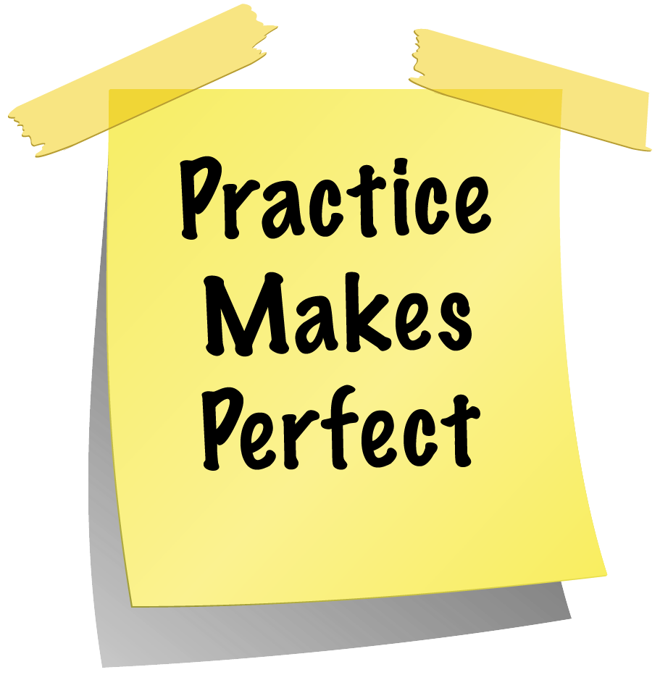
Step 11: Practice Even More!
Practice your full speech now that it is complete and use your visual aids in front of a small audience. Have your audience members help by filling out a sample rubric.

Answer these questions:

- Which rubric category did you do well on? Why? ___________________________________________________________________
___________________________________________________________________

- Which rubric category do you need to improve on? How? ___________________________________________________________________
___________________________________________________________________

- How can you make your speech even better? ___________________________________________________________________
___________________________________________________________________

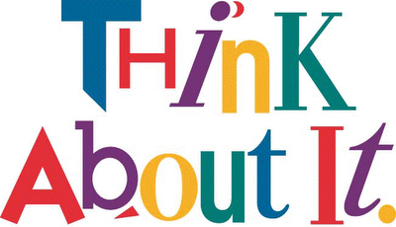
Step 12: Reflection
This step gives you the opportunity to reflect on your learning journey. Write a one paragraph reflection of this process.

Below are some guiding questions to help you:

- Why did you choose this topic?
- What is one thing that you learned that surprised you?
- What is something you hope people will take away from your presentation?
- What did you learn about yourself as you worked on this project?
- Do you have plans for a next step, such as presenting to a larger audience?
- Will you complete another talk about a similar topic or a different one?

_______________________________________________________________________________________________
_______________________________________________________________________________________________
_______________________________________________________________________________________________
_______________________________________________________________________________________________
_______________________________________________________________________________________________
_______________________________________________________________________________________________
_______________________________________________________________________________________________
_______________________________________________________________________________________________

Project Rubric

 | 4 | 3 | 2 | 1
Meaning | Thorough knowledge of content that is clearly evident throughout the piece. | Knowledge of content that is clearly evident throughout the piece. | Some knowledge of content is evident throughout the piece. | Knowledge of content is not displayed in the piece
Structure | Effectively creates a dynamic and compelling presentation that looks professional and delivers the necessary information; emphasizes visuals over text | Creates an interesting and professional looking presentation and delivers the necessary information; emphasizes visuals over text. | Creates a presentation that may deliver the necessary information; may emphasize visuals over text. | Creates a presentation that does not deliver the necessary information
Focus | FFOE elements are clearly identified and are integral to the TED Talk. TED Talk comprehensively addresses the thesis (uses evidence such as information, data, storytelling, and more). | FFOE elements are identified and are integral to the TED Talk. TED Talk addresses the thesis (uses evidence such as information, data, storytelling, and more). | FFOE elements may be identified and may be integral to the TED Talk. TED Talk may not fully address the thesis (may or may not use evidence such as information, data, storytelling, and more). | FFOE elements are not identified and are not integral to the TED Talk. TED Talk does not fully address the thesis.
Introduction and Conclusion | Introduction effectively hooks the audience, is creative and compelling.  Conclusion restates the thesis and reasons in a new and interesting way. It includes an interesting/unique call to action. | Introduction hooks the audience, is interesting and engaging.  Conclusion restates the thesis and reasons. It includes a call to action. | Introduction may hook the audience, could be more engaging.  Conclusion may restate the thesis and reasons. It may include a call to action, but it may not be fully connected to the content. | Introduction does not hook the audience.  Conclusion and call to action are not included.
Conventions in Visuals | • Effectively connected to the content.  • Little to no grammatical errors.  • Correct, fresh, vivid use of images. | • Connected to the content.  Slides/photos are incorporated.  • Some use of props | • Somewhat connected to the content.  • A few slides/photos are incorporated.  • Minimal use of props. | • Not connected to the content.  • Many grammatical errors.  • Incorrect word choice may be apparent.  • Does not use punctuation • No slides/photos are incorporated.  • No use of props

