Experiment 4: Driving an RGB LED

Introduction
You know what’s even more fun than a blinking LED? Changing colors with one LED. In this circuit, you’ll learn how to use an RGB LED to create unique color combinations. Depending on how bright each diode is, nearly any color is possible!

Parts Needed
You will need the following parts:
- 1x micro:bit
- 1x Micro B USB Cable
- 1x micro:bit Breakout (with Headers)
- 1x Breadboard
- 1x Jumper Wire
- 1x Common Cathode RGB LED
- 3x 100Ω Resistors

Introducing the Red/Green/Blue (RGB) LED
The Red/Green/Blue (RGB) LED is three LEDs in one. The RGB has four pins with each of the three shorter pins controlling an individual color: red, green or blue. The longer pin of the RGB is the common ground pin. You can create a custom-colored LED by turning different colors on and off to combine them. For example, if you turn on the red pin and green pin, the RGB will light up as yellow.
But which pin is which color? Pick up the RGB so that the longest pin (common ground) is aligned to the left as shown in the graphic below. The pins are Red, Ground, Green and Blue --- starting from the far left.
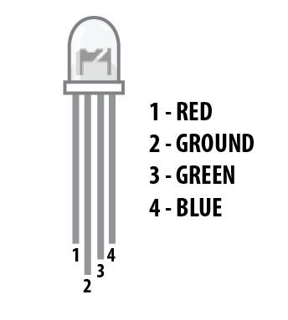
Note: When wiring the RGB, each colored pin still needs a current-limiting resistor in line with the micro:bit's I/O pin that you plan to use to control it, as with any standard LED.

Hardware Hookup
Ready to start hooking everything up? Check out the wiring diagram and hookup table below to see how everything is connected.
Polarized Components | Pay special attention to the component’s markings indicating how to place it on the breadboard. Polarized components can only be connected to a circuit in one direction.

Wiring Diagram for the Experiment
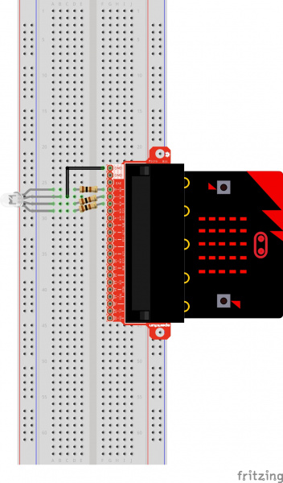
Having a hard time seeing the circuit? Click on the wiring diagram for a closer look.

Run Your Script
Either copy and paste, or re-create the following code into your own MakeCode editor by clicking the open icon in the upper right-hand corner of the editor. You can also just download this example by clicking the download button in the lower right-hand corner of the code window.
Note: You may need to disable your ad/pop-up blocker to interact with the MakeCode programming environment and simulated circuit!

Code to Note
Let's take a look at the code blocks in this experiment.
