Name: _____________________________ Period: ____________

Roundtable Discussion:

Human Populations of the World

Background:
The global human population is growing at a rate of about 90 million individuals added to the planet each year. As of the end of 2011, the global population has hit a new milestone, 7 billion people. The United Nations estimates that the global population will be approximately 9.3 billion by 2050, and more than 10 billion by 2100. Numerous studies estimate that one-third of the world’s population is under the age of 15 years old, which means billions more will be born before we reach a stable population. At the same time, advances in medical technology and increased health awareness have resulted in a global average life expectancy of 63 years. The global life expectancy in 1972 was only 50 years. The problem facing many countries is thus both dealing with an exponentially growing human population of newborns, while at the same time providing needed services for a growing elderly population. If fewer children are born, there will be less need to pay taxes for education and health care. However, there is the potential for economic strain on social services for the elderly, and pensions no longer being sufficient to support the growing retirement-age population. Given the potential economic problems associated with an aging population, some people may believe that the world needs an increased, rather than decreased, human population. However, an increased human population will inevitably result in increased environmental degradation, and this surely outweighs the economic benefits presented.
While the exact number of people who will inhabit the planet in the next 20, 50 and 100 years cannot be known for sure, there will most likely be an increase rather than decrease in population. The largest population expansions will take place in urban areas and developing nations. In an effort to combat the negative environmental effects of population growth, some governments are pursuing plans of “Smart Growth”. Smart Growth is managing population growth by conserving natural resources, decreasing emissions and maintaining sanitary conditions in a more crowded world. In order for policy makers to enact wise legislation needed for Smart Growth, we must have an accounting of how much of our natural resources remain, and when they will be completely depleted based on our current rate of consumption. Many government and private institutions are seeking to do this. There are often disagreements among experts as to how much of our resources are left, but an example of these estimates done by the United States Geological Society (USGS) can be seen in Table 1.

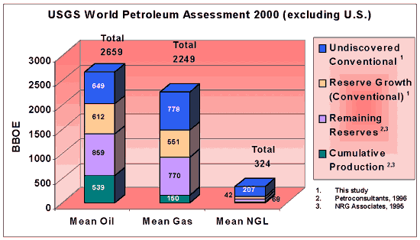

Table 1: World Petroleum Assessment (USGS)

One challenge facing developing nations is although they have lower CO2 emissions per capita, they will feel the effects of climate change and other overcrowding impacts first (see Figure 1 and Figure 2).
Globalization is the trend of govermnets forming coalitions involving trade and decreasing border security. Some controversial programs are the North American Free Trade Association (NAFTA), the European Union (EU) African Union (AU) and the Kyoto Treaty. These coalitions have both positive and negative impacts in terms of accest to natural resources and clean water, food prices and education to name a few.

In the United States, population demographics have changed dramatically over the last 200 years due to changing lifestyles, healthcare, urban sanitization, vaccinations, and more. The life expectancy of an individual born in 1960 was 70 years. This has risen to 78 years for an individual born in 2004 (U.S. National Vital Statistics Reports, 2007).
Demography is the statistical study of human populations, especially with reference to size, density, distribution and vital statistics (relating to births, deaths, marriages, health and disease, etc). In making population projections for different countries, demographers look at the profile of other countries’ residents. They ask: What are the ages of the people? How many are men? How many are women? Using this information, they construct age structure diagrams to illustrate the configuration of a country’s population as shaped by 70 to 80 years of economic, political, and natural events. These graphs can also be used to help predict future population trends. A given countries variety of reasons. population may be increasing, remaining static or decreasing.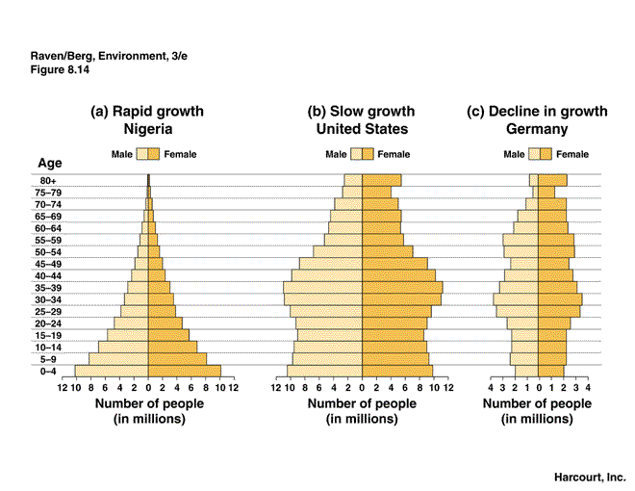
In this activity, you will be assigned to a region of the world that you are responsible for becoming an expert on. You will meet with a base group that will contain at least one expert from each region of the world. Each individual will share his or her data will the group and everyone will complete a worksheet.

Equations Needed:

Growth Rate = (birth rate- death rate) x 100
1000

Net Population Change = (birth rate – death rate + net migration rate) x 100
1000
Replacement Rate is the number of children a woman needs to give birth to in order to replace her. In developed nations it is around 2.1 children since the odds of having a girl are 50% and it is fairly certain the girl will survive to reproductive age. In developing nations the replacement rate is much higher, 6 to 14 children due to high infant mortality rates, diseases and lack of medical care.

Part One- for your assigned country:
- Use the data in table 1 to determine the percentage of the population in each age group.
- Use the information given to calculate the growth rate for your country (you can do this in excel or by hand)
- What is the median age of your country’s total population? Based on the growth rate calculated above, will this number change in the future? If so, will it increase or decrease?
- What is the average amount of years spent in school by children in your country? Do you consider this to be high or low? Is there a difference in years between males and females? If so, why do you think this is?
- What percentage of your country is living below the poverty line? Do you think this has an impact on overall quality of life in your country? If so, how?
- What percentage of your population is living in urban areas? Do you think that this number will increase or decrease in the future? Explain

Part Two- Questions for Roundtable Discussion:
- Why has the population increased so dramatically over the last century?
- Rank the regions/countries in order from highest population growth rate to lowest.
- Compare the per capita GDP of your country to that of the rest of the groups in the class. Do you consider it to be high or low? How might this number negatively impact the overall environmental health of both your country and the globe?
- Compare the infant mortality rate in your country to that of the rest of the groups in the class. Do you consider this to be high or low? How might this number negatively impact the overall environmental health of both your country and the globe?
- Compare the life expectancy in your country to that of the rest the groups in the class. Do you consider this to be high or low? How might this number negatively impact the overall environmental health of both your country and the globe?
- What is the correlation between infant mortality rates and fertility rates?
- Is there any correlation between education rates and poverty?
- What are some of the societal or cultural influences on population growth?
Class Discussion/ Presentation: Be prepared to discuss one of the following OR create your own discussion question regarding a topic related to Human Population you may feel strongly about: Remember your group will be leading the discussion so you should have several talking points to engage the other students:

- Explain how populations in another hemisphere have an impact on your life.
- Explain quality of life issues from an industrialized countries point of view.
- environmental impacts of a rising population? What specifically can be done?
- Do you think there is an ethical way to decrease the rapid growth rate in developing nations? If so, how?
- Does Globalization increase or decrease quality of life, in terms of the environment, economics, freedom, health &etc?
- Considering that agricultural production has increased due to petrochemical fertilizers, how would impoverished populations respond to “peak-oil production”?
- Natural resources are diminishing at an alarming rate, how will this affect the quality of life for impoverished people in developing countries?

References:
(Source: Laura J. Vosejpka, Northwood University. Wells, Edward. Lab Manual for Environmental Science; Wilson College, 2009.
(Source: Ernest H. Williams. Hamilton College, 1999. http://academics.hamilton.edu/biology/ewilliam/cemetery/)
(Source: Acton- Boxborough Regional HS. http://ab.mec.edu/abrhs/science/hohn/apes/activities/U5/WorldPop.pdf)
CIA World Factbook. https://www.cia.gov/library/publications/the-world-factbook/geos/br.html
Klaff, Vivian Z. 1992. “Dem-Lab: Teaching Demography Through Computers”. Prentice Hall.
U.S. National Center for Health Statistics, National Vital Statistics Reports, Vol. 55, No. 19, August 21, 2007.

World Bank World Development Report 2009. http://siteresources.worldbank.org/
INTWDR2009/Resources/4231006-1225840759068/WDR09_22_SWDIweb.pdf
http://www.ux1.eiu.edu/~cfruf/bio3002/population_age_structure.htm
http://www.un.org/esa/dsd/index.shtml?utm_source=OldRedirect&utm_medium=redirect&utm_content=dsd&utm_campaign=OldRedirect
http://articles.cnn.com/2011-10-26/world/world_world-population_1_global-population-fertility-rates-state-of-world-population?_s=PM:WORLDhttp://www.usgs.gov/newsroom/article.asp?ID=636

