Determining Soil Texture and Permeability
Purpose:_____________________________________________________________________________________________________________
__________________________________________________________
Descriptions: Examine the clay, sand, and silt and describe the samples in terms of smoothness, how gritty it is, and ability to form a ribbon and what was the ribbon length.

Clay:

Sand:

Silt:

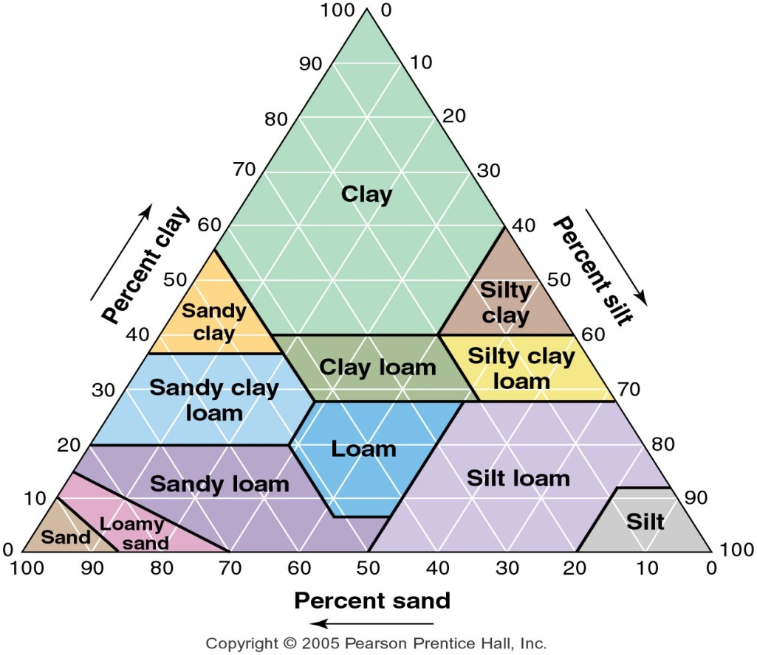
Table 2:1
Clay %: _____________
Silt %: ______________
Sand%: _____________
Soil Texture: ___________________

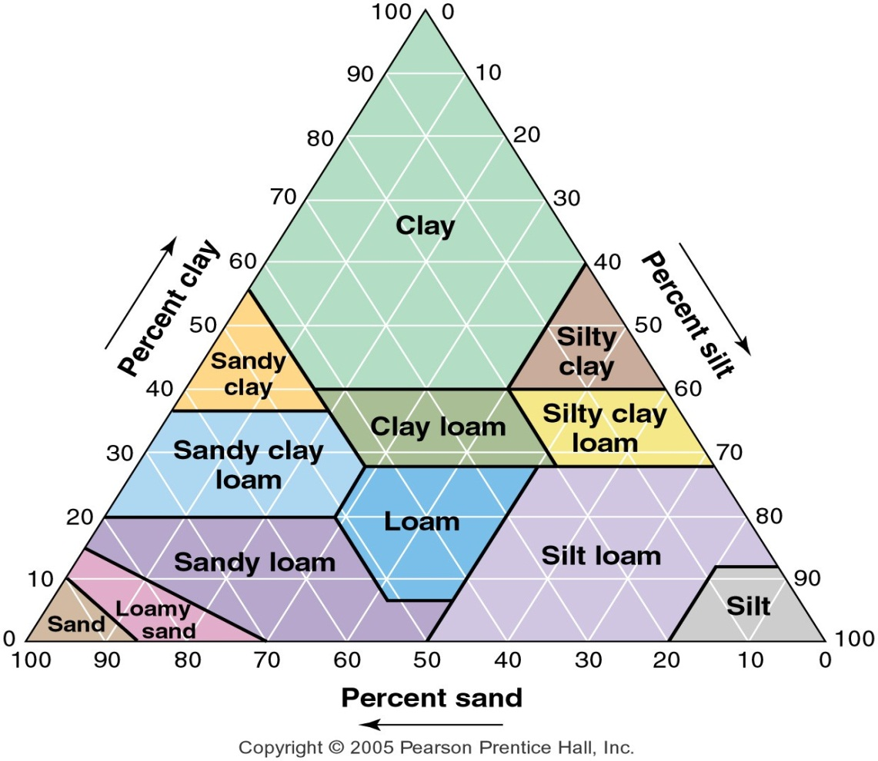
Table 2:2

Clay %: _____________
Silt %: ______________
Sand%: _____________
Soil Texture: ___________________
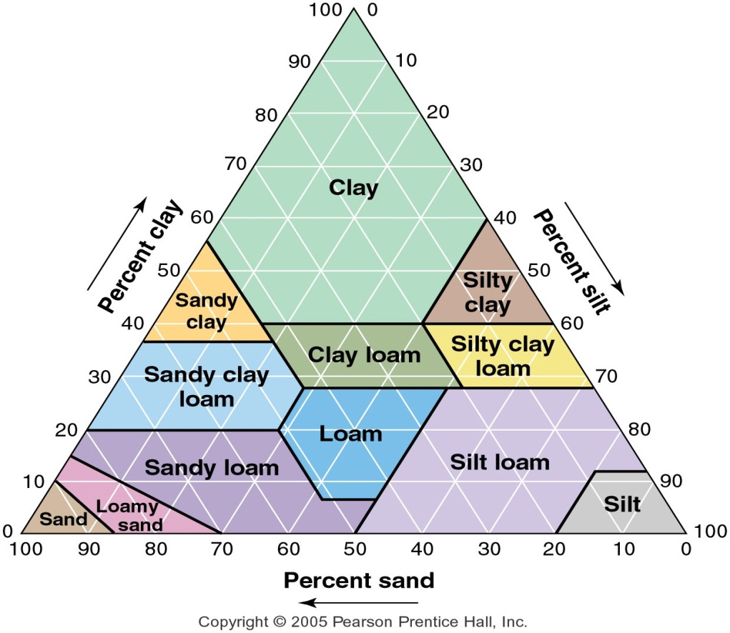
Table 2:3

Clay %: _____________
Silt %: ______________
Sand%: _____________
Soil Texture: ___________________
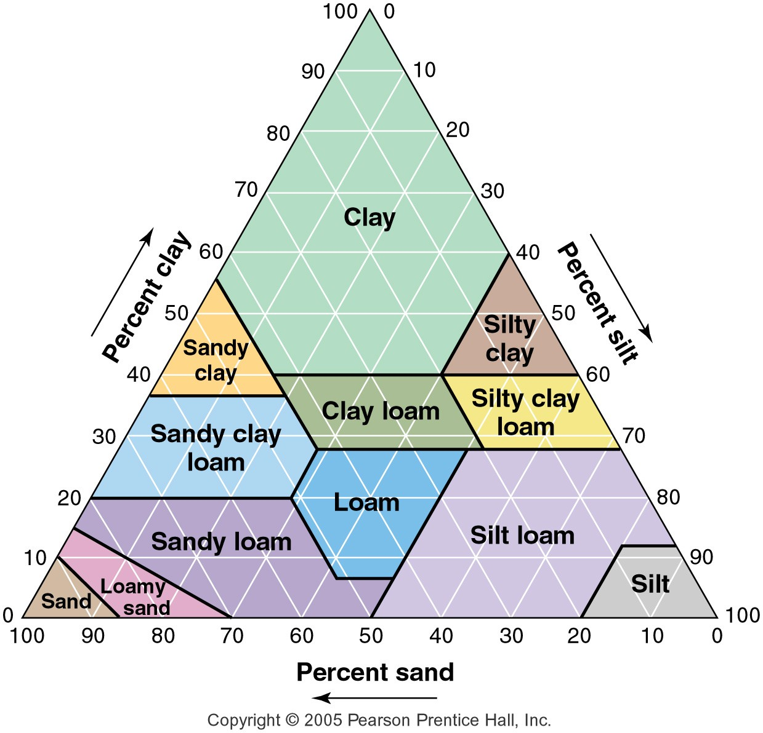
Table 2:4
Clay %: _____________
Silt %: ______________
Sand%: _____________
Soil Texture: ___________________
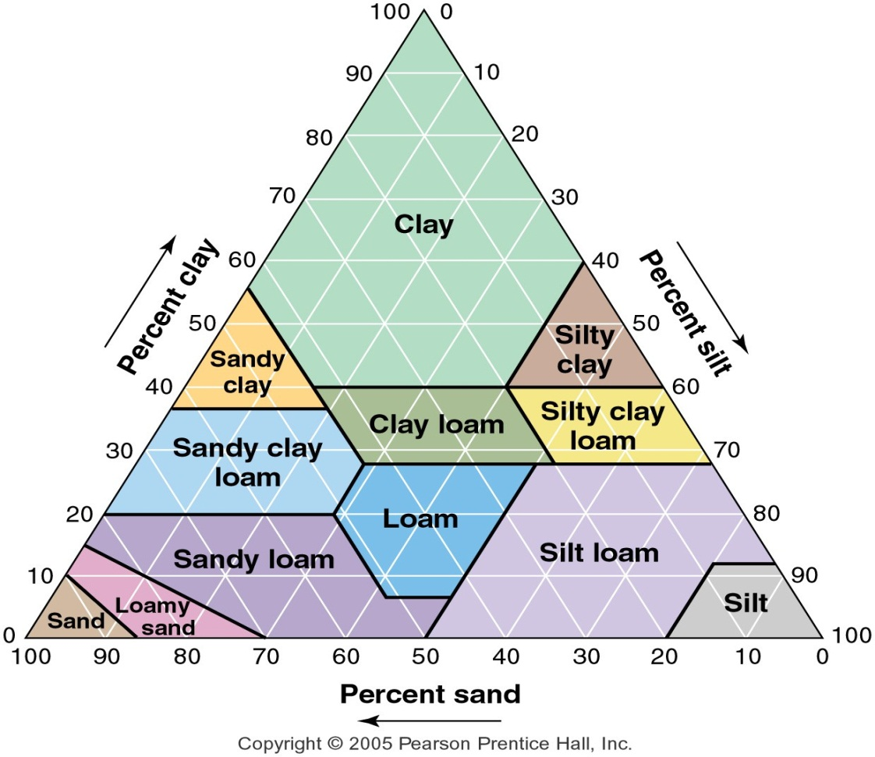
Table 2:5
Clay %: _____________
Silt %: ______________
Sand %: _____________
Soil Texture: ___________________

Determining Soil Texture by Feel
Step 1:
a.) Obtain and moisten a soil sample and place some soil (the size of an egg) in your gloved hand
b.) Moisten the soil sample until it is damp but not soaked through with water
c.) Try to form a ball, if the soil forms a ball, go to step 2, if the soil does not form a ball go to Step 5

Step 2:
- If the soil is
  - Really sticky
  - Hard to squeeze
  - Stains
  - Has a shine
  - Form a ribbon (5+ cm) without breaking
Classify as Clay and go to Step 3 – otherwise go to b -
- If the soil is
  - Somewhat sticky
  - Is somewhat hard to squeeze
  - Forms a medium ribbon (between 2-5 cm)
Classify it a clay loam and go to Step 3 otherwise go to c -
- If the soil is
  - Soft
  - Smooth
  - Easy to squeeze
  - At most slightly sticky
  - Forms a short ribbon (less than 2 cm)
Classify it as a loam and go to Step 3; otherwise go to D-
- If the soil forms a ball but does not form a ribbon go to Step 4

Step 3: refine the initial soil texture classification from Step 2 for relative amounts of sand and silt
Wet a small pinch of soil in your gloved palm and rub it with your forefinger.
e.) If the soil feels gritty, add the word sandy to the initial classification (i.e. sandy clay)
f.) If the soil feels very smooth with no gritty feeling, add the word silty to the initial classification (i.e. silty clay)
g.) If the soil is a little gritty, leave the original classification (i.e. clay)

Step 5: TEST FOR SAND
If the sand does not form a ball and instead falls apart in your hand –
Soil texture is sand
Step 4: (testing for loamy sand or silt)
If the soil: forms a ball, forms no ribbon, and is very gritty the soil texture is loamy sand
If the soil: forms a ball, forms no ribbon, and is very soft and smooth with no gritty feeling
Group # | Sample A:Clay | Sample A: Silt | Sample A: Sand | Sample B: Clay | Sample B: Silt | Sample B: Sand | Sample C: Clay | Sample C: Silt | Sample C: Sand
1

2

3

4

5

6

7

Average
Groups
1-7
Data Collection Part I: Estimating Soil Texture through Sedimentation
Calculations:
Individual Sample A:
% Sand
Sand (cm) |  | Total (cm)
(cm) sand/total (cm) x100

% Silt
Silt (cm) |  | Total (cm)
(cm) silt/total (cm) x100

% Clay
Clay (cm) |  | Total (cm)
(cm) clay/total (cm) x100

Soil Class Name
Individual Sample B:
% Sand
Sand (cm) |  | Total (cm)
(cm) sand/total (cm) x100

% Silt
Silt (cm) |  | Total (cm)
(cm) silt/total (cm) x100

% Clay
Clay (cm) |  | Total (cm)
(cm) clay/total (cm) x100

Soil Class Name

Individual Sample C:
% Sand
Sand (cm) |  | Total (cm)
(cm) sand/total (cm) x100

% Silt
Silt (cm) |  | Total (cm)
(cm) silt/total (cm) x100

% Clay
Clay (cm) |  | Total (cm)
(cm) clay/total (cm) x100

Soil Class Name

Sample | Average % Sand | Average %  Silt | Average %  Clay | Soil Class Name
A

B

C

Based on the data collected, formulate a hypothesis to predict which of the three soil samples will be the most permeable and write below:
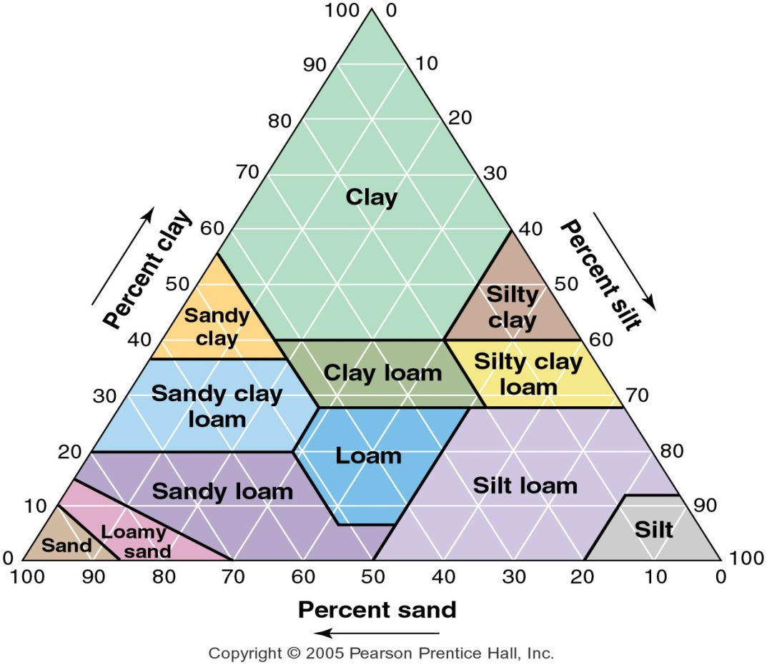
Individual Data: A
Clay %: _____________
Silt %: ______________
Sand %: _____________
Soil Texture: ___________________
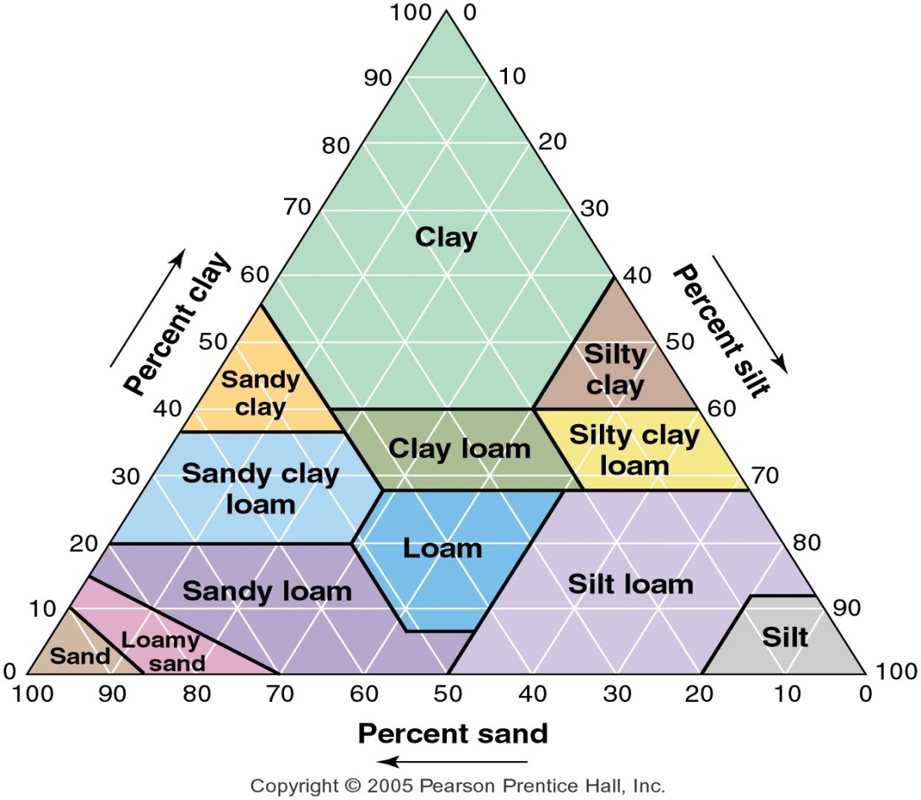
Individual Data: B
Clay %: _____________
Silt %: ______________
Sand %: _____________
Soil Texture: ___________________
Individual Data: C
Clay %: _____________
Silt %: ______________
Sand %: _____________
Soil Texture: ___________________
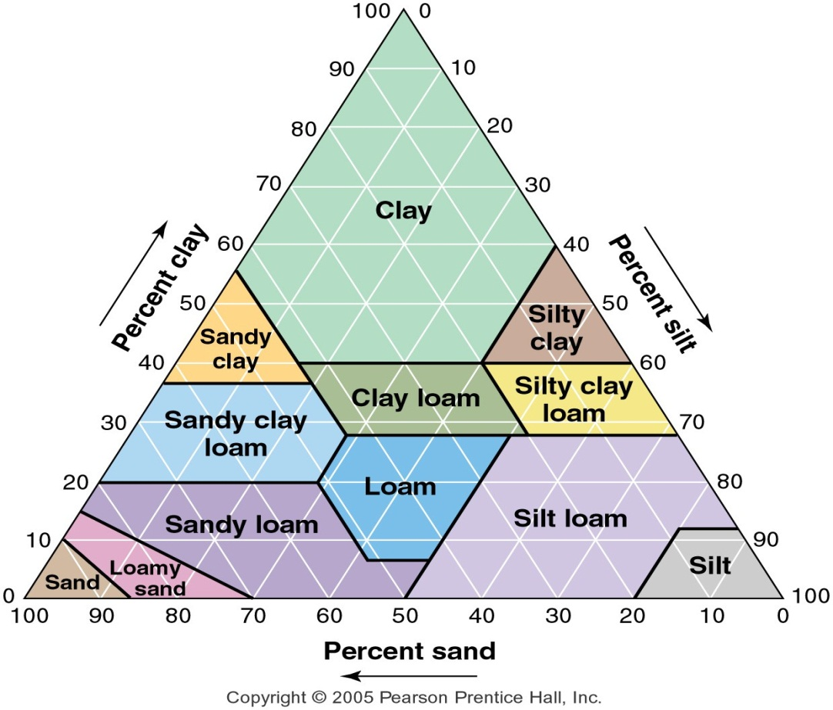
Class Data: A
Clay %: _____________
Silt %: ______________
Sand %: _____________
Soil Texture: ___________________
Class Data: B
Clay %: _____________
Silt %: ______________
Sand %: _____________
Soil Texture: ___________________

Class Data: C
Clay %: _____________
Silt %: ______________
Sand %: _____________
Soil Texture: ___________________

Group # | Sample A:  Volume (mL)  Water passed through sample | Sample A:  Volume (mL)  Water held by soil | Sample A: time (sec) time required for water to permeate | Sample A:  Volume (mL)  Water passed through sample | Sample A:  Volume (mL)  Water held by soil | Sample A: time (sec) time required for water to permeate | Sample A:  Volume (mL)  Water passed through sample | Sample A:  Volume (mL)  Water held by soil | Sample A: time (sec) time required for water to permeate
1

2

3

4

5

6

7

Average
Groups
1-7

What is your individual Group Number ___________________________ Sample with greatest permeability ______________________________

