Temperature, Precipitation, and Biome Distribution

Purpose:
The purpose of this lab is to construct and analyze a climatogram, and describe the relationship between the amount of rainfall and variance of temperature to the effect of the distribution of biomes globally.

Background:
Weather is a local area’s short-term temperature, precipitation, humidity, wind speed, cloud cover, and other physical conditions of the lower atmosphere. Climate, on the other hand, is a geographic area’s pattern of atmospheric or weather conditions over long periods of time. Average temperature and average precipitation are the two main factors determining climate, along with latitude (distance from the equator) and altitude (distance above sea level).

Biomes are large terrestrial regions characterized by similar climate, soil, plants, and animals, regardless of where they are found in the world. Biomes are closely associated with climate. You can easily associate the climate of your own locality with the biome found there. Only by extensive travel, however, can the close relationship of particular climates with particular biomes be learned on a worldwide basis. This exercise is a poor substitute for such travel; but if it is carried out thoughtfully and with frequent reference to the description of biomes in the text, it can help you understand the biological relationships that make up the diversity of the biotic communities found on land.

Below you will find six examples of climatograms, grids on which averages of precipitation and temperature at a particular location are plotted together. These climatograms show variations in only two important climatic factors during a year. Other factors may greatly affect climate, but a climatogram does give a rough idea of climate in the location from which the data were obtained.

Part 1: Identification of Temperature and Precipitation of Biomes: Using the graphs provided (these graphs also appear in your textbook) determine the monthly range of precipitation and temperature. Using the chart that appears after these graphs determine the range of average temperatures and precipitations.

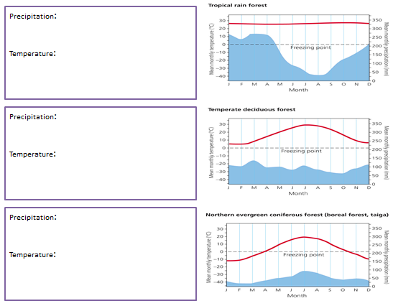
Monthly range mm/month – mm/month
Average Yearly Precipitation mm – mm

Average monthly temperature range is ◦C to C
Average Yearly Temperature is ◦C ◦C

Monthly range mm/month – mm/month
Average Yearly Precipitation mm – mm

Average monthly temperature range is ◦C to C
Average Yearly Temperature is ◦C ◦C

Monthly range 25mm/month – 100 mm/month
Average Yearly Precipitation 400 mm – 2000 mm

Average monthly temperature range is -10◦C to 20◦C
Average Yearly Temperature is -7◦C - 4◦C

Monthly range 60mm/month – 140 mm/month
Average Yearly Precipitation 700mm – 2000 mm

Average monthly temperature range is 5◦C to 30◦C
Average Yearly Temperature is 3◦C - 17◦C

Monthly range 30 mm/month- 275 mm/month
Average Yearly Precipitation= 2750-4500 mm

Average temperature is 26◦C
Average Yearly Temperature is 20◦C-30◦C
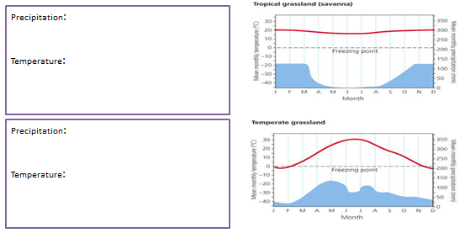
Monthly range 25 mm/month – 140 mm/month
Average Yearly Precipitation 100 mm – 1400 mm

Average monthly temperature range is -5 ◦C to 30 ◦C
Average Yearly Temperature is -7◦C to 18◦C

Monthly range 0 mm/month – 125 mm/month
Average Yearly Precipitation 500mm – 1400mm

Average monthly temperature range is 15 ◦C to 20 ◦C
Average Yearly Temperature is 17◦C to 20◦C

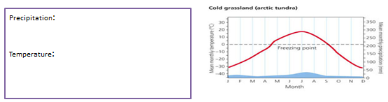
Monthly range 15 mm/month – 30 mm/month
Average Yearly Precipitation 1050 mm – 1000 mm

Average monthly temperature range is -28 ◦C to 18 ◦C
Average Yearly Temperature is -5◦C to -14◦C

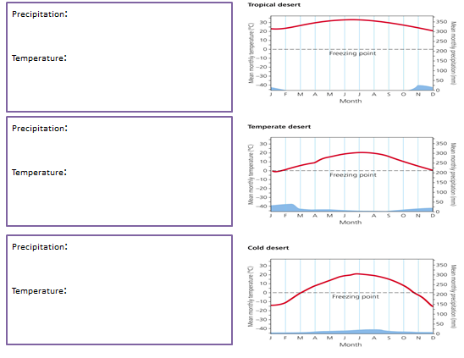
Monthly range 5 mm/month – 25 mm/month
Average Yearly Precipitation 0 mm – 500 mm

Average monthly temperature range is 0 ◦C to 20◦C
Average Yearly Temperature is -8◦C t- 18◦C

Monthly range 10 mm/month – 40 mm/month
Average Yearly Precipitation 0 mm – 400 mm

Average monthly temperature range is 0 ◦C to 20◦C
Average Yearly Temperature is 9◦C to 18◦C

Monthly range 0 mm/month – 25 mm/month
Average Yearly Precipitation 1050 mm – 1000 mm

Average monthly temperature range is 20 ◦C to 35 ◦C
Average Yearly Temperature is -5◦C to -14◦C

Part 4: Based on the attributes listed below, name which biome is best described. The graph below will assist you in this task.

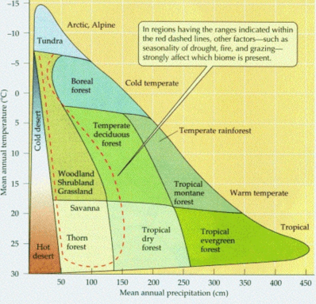

Which of the biomes has: | Biome Name:
Most Rainfall | Tropical Rain Forest
Least Rainfall | Cold Desert
Highest Average Temperature | Hot Desert
Lowest Average Temperature | Arctic Tundra
Most Consistent Year-Round Temperature | Tropical Rain Forest
Most Variable Year-Round Temperature | Arctic Tundra

Part 4: Climatographs: Create a Climatograph using Microsoft Excel
- Open a Microsoft Excel Sheet
- Type or copy the following information on three cities of the world and their biomes.

Cuiaba, Brazil: Tropical Seasonal Forest
 | J | F | M | A | M | J | J | A | S | O | N | D
P: | 24.9 | 21.1 | 21.1 | 10.2 | 5.3 | 0.8 | 0.5 | 2.8 | 5.1 | 11.4 | 15 | 20.6
T: | 27.2 | 27.2 | 27.2 | 26.6 | 25.6 | 23.9 | 24.4 | 25.6 | 27.8 | 27.8 | 27.8 | 27.2
2)
Santa Monica, California: Temperate Woodland and Shrubland
 | J | F | M | A | M | J | J | A | S | O | N | D
P: | 8.9 | 7.6 | 7.4 | 1.3 | 1.3 | 0 | 0 | 0 | 0.3 | 1.5 | 3.5 | 5.8
T: | 11.7 | 11.7 | 12.8 | 14.4 | 15.6 | 17.2 | 18.9 | 18.3 | 18.3 | 16.7 | 14.4 | 12.8
3)
Moshi, Tanganyika: Tropical Savanna
 | J | F | M | A | M | J | J | A | S | O | N | D
P: | 3.6 | 6.1 | 9.2 | 40.1 | 30.2 | 5.1 | 5.1 | 2.5 | 2 | 3 | 8.1 | 6.4
T: | 23.3 | 23.2 | 22.2 | 21.1 | 19.8 | 18.4 | 17.9 | 18.4 | 19.8 | 21.4 | 22 | 22.4

- In a Climatograph the Precipitation is a column graph and temperature is a line graph.

- Highlight data
- Insert – chart- 2D clustered column
- Right click temp on graph
- Change data series chart type to line graph
- Right click left hand scale
- Format axis- change scale (0-36)
- Right click temp
- Format data series – secondary axis
- Right click right hand scale
- Format axis – change scale (-36 to 36)
- Make sure to give the chart a title and name the x and y axis (include units of measurement)

Part 4 – In this next section, we will be examining the relationships between elevations (altitudes) and land biomes. The following Locations A, B and C are of the SAME LOCATION at DIFFERENT ALTITIDTES like on a mountain.

Location A
 | J | F | M | A | M | J | J | A | S | O | N | D
P: | 3.8 | 3.6 | 5.6 | 6.6 | 9.9 | 11.4 | 9.4 | 8.6 | 10.2 | 6.4 | 4.8 | 3.8
T: | -6.7 | -5 | 1.7 | 9.4 | 15.6 | 21.1 | 23.9 | 22.2 | 17.8 | 11.1 | 2.8 | -3.9
Location B
 | J | F | M | A | M | J | J | A | S | O | N | D
P: | 1.3 | 1.6 | 2.8 | 6.1 | 9.9 | 10.3 | 6.5 | 5.2 | 6.1 | 3 | 2.1 | 1.5
T: | -4.6 | -1.9 | 2.6 | 9.9 | 15.8 | 21.8 | 25.7 | 24.4 | 18.9 | 12.2 | 3.3 | -2.2
Location C
 | J | F | M | A | M | J | J | A | S | O | N | D
P: | 1.3 | 0.8 | 2 | 2.5 | 3.8 | 3.1 | 4.3 | 3 | 2.5 | 2.3 | 1.3 | 1.3
T: | -6.1 | -5.6 | -1.7 | 3.3 | 7.8 | 12.8 | 16.7 | 16.7 | 11.1 | 5 | -1.1 | -5.6

- Describe how altitude (elevation) influences precipitation and temperature. Your answer should include how the climate (specifically average mean temperature and precipitate) is different at the lowest and highest points of a specific area.
The higher the elevation is above sea level the lower the average mean temperature. In general the higher the elevation the lower the average mean precipitation.

- How do latitude and longitude influence precipitation and temperature. Your answer should include how the climate (specifically average mean temperature and precipitation) is different from the northernmost point of the United States to the southernmost point of the United States along with the differences in temperature from the Westernmost point of the United States to the Southernmost Points of the United States.
Examine the United States from West to East – The highest precipitation is in the West, by the Olympic Peninsula. The precipitation is lowest over the mountain ranges. After the mountainous areas of the United States, there are bands of low precipitation (rain shadow effect) with increasing precipitation the more east. Latitudinal temperature bands can be seen on the West Coast until the mountainous region of the US. Latitude

- What are the differences in precipitation and temperature between Locations A, B,C.
Location A – Temperature Range (-6.7) to 23.9 ˚C Average 9.2 ˚C
Precipitation Range (3.6) to 11.4 cm Average 7.0 cm
Location B – Temperature Range (-4.6) to 25.7 ˚C Average 10.5 ˚C
Precipitation Range 1.3 to 10.3 cm Average 4.7 cm
Location C – Temperature Range (-6.1) to 16.7 ˚C Average 2.4 ˚C
Precipitation Range 0.8 to 4.3 cm Average 4.4 cm
Lowest Precipitation = Location C Lowest Temperature = Location C
The lowest temperature and precipitation is the highest altitude
Highest Precipitation = Location A Highest Temperature = Location B
Since temperature is a greater indicator of altitude Location B is the lowest elevation

- Which of the locations is the lowest elevation? B
- Which of the locations is the highest elevation? C

Part 5 - Use the internet to find the average temperature and precipitation for your town.
a) Produce a graph summarizing this information. Got to weather.com enter zip code of your town or anywhere you like, Click monthly tab – scroll down to averages, change to table display to metric, use the mean temperature and average precipitation (change mm to cm).

b) What biome does your town belong to? Justify your answer.

You should have the students look at the maps and the abotic and biotic characteristic pages. The answer should include temperature and precipitation ranges along with naming some of the abotic and biotic characteristics of their town.

Conclusion and Discussion:
Please type your answers to all the questions below in complete sentences and hand them in with the excel graphs you generated above.

1. How are the Tundra and Desert similar? How are they different? The Tundra and Desert are similar because the mean annual precipitation is low. Both hot and cold desert have extremely low precipitation with ranges from 0-50cm per year. The Tundra has a mean average precipitation of 100 cm per year. The difference between the two biomes is the two extremes in temperature. The hot desert has a mean annual temperature of 17 – 30 ˚C while the arctic tundra us a mean temperature range of -7 to -15 ˚C.

2. How are the Tropical Rain Forest and Tropical Seasonal Forest similar? How are they different? Both the Tropical Rain Forest and Tropical Seasonal Forest have the same average temperature, but the Tropical Rain Forest has higher mean average rainfall.

3. Lawrence, Kansas and Nashville, Tennessee occupy similar latitudes. Why is one found in Temperate Grassland and the other in a Temperate Forest biome? In the United States from the northernmost states to the southern there are bands of similar average temperatures (excluding the mountainous regions which also are influenced by altitudes and the regions located beside the mountains which are affected by the rain shadow effect). Tennessee and Kansas are located in difference longitudes to which the average mean temperatures are in different isotherms. Tennessee has an average temperature range of 40-50 ˚F while Kansas has an average temperature of 30 to 40 ˚F. In addition, although these two states are in similar latitudes, in Tennessee the mean annual precipitation received ranges from 50-60 inches while in Kansas the mean annual precipitation received ranges from 16 to 20 inches (West Kansas) to 50-60 inches (East Kansas).

4. How are periods of drought reflected on a climotograph? If the climotograph reflects one year, the period of drought will be reflected by a depression in the precipitation for the months of the drought. If the climotograph reflects a greater time period, for example a period of 30 year, the drought would be reflected only if the drought lasted over the period of a year.

5. What factors can change precipitation and temperatures in an area? Climate changes have been associated with anthropogenic and natural changes to their environment. Anthropogenic changes have been attributed to the burning of fossil fuels and the rise in global carbon dioxide concentrations along with rising ozone levels in the lower atmosphere. These changes have caused a rise in average annual global temperatures and changes in weather patterns across the globe. Natural precipitation and temperature changes can be do with the fluctuations in the sea surface patterns and atmospheric pressure referred to as ENSO. These fluctuations cause periods of vast temperature and precipitation changes all over the world.

