Kamyla Fonseca
AP Environmental Science P. 1-2
October 4, 2013, 8:00 AM
Belleville High School front yard
Emily Ramos, Cindy Narvaez, Fernando Mendez

Plant Species Richness: An Ecological Investigation of

Biotic and Abiotic Factors in an Ecosystem

Purpose:
The purpose of this study is to explore field experiment design, to gain observation skills and to compare plant species richness through sampling and sample means.

Background
All processes within ecosystems involve interactions between biotic (living) and abiotic (nonliving) factors. These factors impact what plants grow in an area and how well they grow there. The richness or biodiversity of species in a given area depends on specific habitat characteristics such as available sunlight, precipitation, temperature, soil composition, hydrology and disturbance. Competition from other plants also impacts growth in an area. Species richness can be measured through various sampling techniques and statistics. This study is an introduction to hypothesis construction, experimental sampling in disturbed and undisturbed habitats and sample comparisons to determine relative biodiversity in three different areas.

Methodology

Each group will be working in two sites with different abiotic conditions: a Mowed Area Shaded, and a Mowed Area Full Sun. Before going out to one’s respected field, he must create a hypotheses relating to the possible effects of various abiotic and biotic factors between the two sites. The next set of actions is to create transacts for sampling the two sites 12 times each with your quadrat. Use the included random number tables to get 48 pairs of random numbers. Random Number Table 0-3 is meant to determine how many meters off the transect line you will place your quadrat. Random Number Table 0-33, however, is to determine at what foot along the transect you will place your quadrat. Write each set of random numbers in the appropriate spaces on your datasheets. Begin your sampling by placing the quadrat at the appropriate position determined by the first set of random numbers and counting the number of different species of plants within the quadrat. Record this on the datasheet. The name of a species may be included if you know it. At least 2 people within each group should be counting the number of species in your quadrat so that you get them all. Repeat this for 12 samples in the Mowed Area Shaded, and the Mowed Area Full Sun. Special Note: Stay within the area determined by your Learning Assistant. We have tried to keep you as far away from Poison Ivy as possible, but cannot guarantee its absolute absence in the sampling area. Do not touch any plant with three leaves!

Plant Species Richness Hypotheses Sheet

Team Hypothesis

H₁- We hypothesize that the area covered in sunlight will provide several variations of different plant species.

H₂- The hypothesis regarding the mowed area that is shaded is that due to the lack of sunlight, it will have a
very little mount of different plant species.

Null Hypotheses

Mowed Area: Shaded

Sample  Number | Meters from  Transect | Foot on  Transect | Number of Plant Species Counted
1 | 2 | 7 | 3
2 | 3 | 31 | 3
3 | 3 | 2 | 4
4 | 2 | 2 | 3
5 | 3 | 31 | 3
6 | 1 | 9 | 2
7 | 3 | 2 | 1
8 | 2 | 6 | 3
9 | 1 | 23 | 4
10 | 3 | 15 | 3
11 | 3 | 25 | 4
12 | 2 | 27 | 4

Total number counted: 37
Number of individual plant species found in area: 5
Plant species found:
Vescue | Goose Grass | Smart Weed
Buckhorn | White clovers

Mowed Area: Full Sun

Sample  Number | Meters from  Transect | Foot on  Transect | Number of Plant Species Counted
1 | 1 | 2 | 2
2 | 2 | 13 | 5
3 | 1 | 6 | 4
4 | 3 | 1 | 3
5 | 2 | 22 | 6
6 | 2 | 1 | 2
7 | 2 | 15 | 3
8 | 3 | 7 | 4
9 | 3 | 32 | 6
10 | 3 | 22 | 5
11 | 2 | 3 | 2
12 | 2 | 9 | 4

Total number counted: 46
Number of individual plant species found in area: 11

Plant species found:
Kentucky Blue | White Clovers | Plain Tane | St Augustine | Bull Thistle | Crab Grass
Fascue | Rye | Speed Well | Buffalo Grass | Bermuda

Need a table with the average number of species

Analysis

During the lab period on October 4, 2013 at 8:00 AM, plant species in different areas were studied to investigate – remember a hypothesis is either supported or negated - prove the hypothesis that a greater variation of plants existed on areas with sunlight rather than shaded areas. In a group consisting of four students, we used the random number table to randomly select sampling area - depict how many meters and feet off the transect line we would place the quadrat. Then, the amount of different plant species counted within the quadrat was recorded into the datasheet. For the lab conducted (this statement doesn’t make sense) to compare plant species richness in a field experiment design, we hypothesized that the mowed area covered in sunlight would be rich with variations of different plant species Why. We also hypothesized that the shaded mowed area would have less plant species than the area covered in sunlight. Why The total amount of plant species counted in the mowed area covered in sunlight was 46. However, the total amount of plant species counted in the shaded mowed area was only 37. he names of the identified species were recorded for further analysis. What was your analysis - The data showcases that for the area covered in sunlight, a total number of 46 plant species were counted and 11 different types of plant species were identified. The data for the shaded mowed area, on the other hand, demonstrate that only 37 plant species were counted and only 5 different plant species were identified. Therefore, the data strongly supported the hypothesis that the sunlight mowed area provide a richer variation in plant species than the shaded mowed area The analysis therefore is that sunlight allows more plants to grow. Plants need sunlight in order for photosynthesis to occur. An area with a lot of sunlight would be more habitable than a shaded area. Only a limited amount of plants can live with a minimal amount of sunlight. That is why the shaded area only had five different plant species.

Abotic and Biotic Factors effecting Terestial Biomes 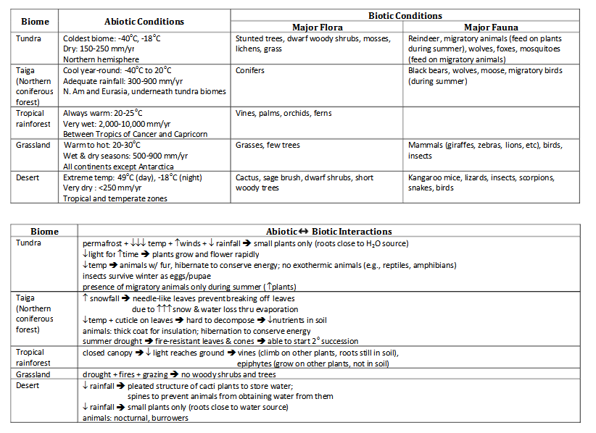l

Rubric: Plant Species Richness