NChO 2006
ANNOTATED ANSWERS

1. | D HCl  H₂ and CH₄ are nonpolar and will dissolve very little in polar water. CO is polar and will dissolve OK, but HCl is very polar and dissolves amazingly well in water. Note: HCl and NH₃ both dissolve extremely well in water.
2. | C buret  Beakers only have approximate markings. Volumetric pipets and volumetric flasks are only good for measuring exactly 25.0 mL. Here is a picture of a volumetric pipet.  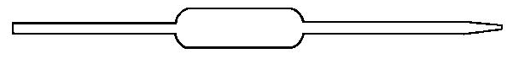
3. | B Dehydrating Agent  We did this in class (on the balcony). Sugar’s empirical formula is CH₂O. Concentrated H₂SO₄ removes the H₂O leaving C(s). Here is a great movie of the process:  http://cwx.prenhall.com/petrucci/medialib/media_portfolio/text_images/060_DehydratSugar.MOV
4. | C HCl + HNO₃  Gold is a noble metal and does not react with acids, even the oxidizing acids. However, HCl + HNO₃ form Cl₂ in solution which oxidizes the Au → Au³⁺ and forms the AuCl₄⁻ complex ion.
5. | A 12 g  Read graph carefully. At 80°C solubility = 90 g/100 mL; at 20°C solubility = 60 g/100 mL.  Difference = 30 g/100 mL which is 12 g/40 mL
6. | B too low  An example of a hydrated salt is CuSO₄·5H₂O. Not heating enough means not all the H₂O is driven off the hydrate. ∴the mass before heating is fine, but he mass after heating is too large. The mass of H₂O calculated will be too small and the degree of hydration calculated will be too low.
7. | D 2Ag⁺ + S²⁻ → Ag₂S(s)  molecular: 2AgNO₃ + Na₂S → Ag₂S(s) + 2NaNO₃  ionic: 2Ag⁺ + 2NO₃⁻ + 2Na⁺ + S²⁻ → Ag₂S(s) + 2Na⁺ + 2NO₃⁻  net ionic: 2Ag⁺ + S²⁻ → Ag₂S(s)  Answer is unbalanced, but shows the correct species.
8. | B 1:2  iron(II) oxide = FeO; iron(III) oxide = Fe₂O₃; the mixed oxide, Fe₃O₄ = FeO + Fe₂O₃.  This is one Fe²⁺ and two Fe³⁺
9. | D 10.2 g  Mass of the products = mass of the reactants. We know C₃H₈, so calculate O₂ reacted and add.  2.20 g C₃H₈ x$\frac{{\text{1 mole C}}_{3}H_{8}}{\text{44}\text{.}{\text{11 g C}}_{3}H_{8}}$x$\frac{{\text{5 mol O}}_{2}}{{\text{1 mol C}}_{3}H_{8}}$x$\frac{\text{32}\text{.}{\text{00 g O}}_{2}}{{\text{1 mol O}}_{2}}$= 7.98 g O2; 2.20 g + 7.98 g = 10.18 g
10. | D 139 mL  Dilution formula: V_{before}·M_{before} = V_{after}·M_{after} ; x (18.0 M) = (25.00 mL) (1.00 M) x = 138.889 mL
11. | C 5.11%  6.40 mL AgNO3 x$\frac{\text{1 L}}{\text{1000 mL}}$x$\frac{0\text{.}{\text{200 mol AgNO}}_{3}}{\text{1 L}}$x$\frac{{\text{1 mol Br}}^{−}}{{\text{1 mol AgNO}}_{3}}$x$\frac{\text{79}\text{.}{\text{9 g Br}}^{−}}{{\text{1 mole Br}}^{−}}$= 0.102272 g Br⁻  $\frac{0\text{.}{\text{102272 g Br}}^{−}}{2\text{.}\text{00 g sample}}$x 100 = 5.11%
12. | B high P/low T  Gases dissolve best at high pressures (Henry’s Law) and low temperatures (de-emphasize entropy). Entropy favors gaseous state (very random, spread out) rather than dissolved state.
13. | A HF only  Hydrogen bonding occurs when H is bonded to F, H with N, and H with O.
14. | C 50.0 g/mol  Molar Mass = grams/moles; 10.00 grams is given. Use PV=nRT to find moles or the fact that this problem is at STP, so 1 mole gas = 22.4 L ∴4.48 L = 0.200 moles.  Molar mass = $\frac{\text{10}\text{.}\text{00 g}}{0\text{.}\text{200 moles}}$= 50.0 g/mol
15. | A breaking the O-H bond  Evaporating, melting, and subliming are all phase changes. Chemical change (breaking bonds) requires more energy than overcoming intermolecular forces of attraction.
16. | B  Melting is an orderly lattice becoming less orderly, but still with atoms touching each other.  Note: (A) would be evaporation; (C) would be a solid; (D) would be a solid split into pieces.
17. | D CCl₄  Since the differences in electronegativity between C (2.5) & Cl (3.0) and C (2.5) & H (2.1) are small, these molecules are all non-polar. London forces play the strongest role in determining the boiling temperature. CCl₄ has the largest atoms and the most polarizable electron clouds, ∴ highest BP.
18. | B  Know how to label the phases in a phase diagram.  As you increase pressure, the substance changes from liquid to solid. ∴solid is more dense than liquid.
19. | A K_{p}  The only thing that changes K is temperature.
20. | A I only (combustion of charcoal)  Which situation gets more random, more disordered, more spread-out.  I-yes; II-no (gas → liquid); III-no (dissolved ions → solid)
21. | C -40 kJ  D + A → 4C desired equation  A → 2B OK as is ΔH = 40 kJ  2B → 2C ΔH x 2 ΔH = -100 kJ  D → 2C reverse equation ∴change sign ΔH = +20; 40 + (-100) + 20 = -40 kJ
22. | C 98 kJ  Bond energies of the reactant bonds – bond energies of the product bonds  N≡N + 2 H—H → N—N + 4 N—H  941 + 2(436) – [159 + 4(389)] = 1813 – 1715 = 98 kJ
23. | B 8.63 g  heat lost by hot water = -(heat gained by melting ice + heat gained by ice water warming up)  q = mCΔT mass x ΔHfus q = mCΔT; let x = mass of ice  (265g)(4.18)(-3.3°C) = -[ x·333 + (x)(4.18)(21.70°C)  -3655.41 = - (333x + 90.7x)  x = 8.627 g
24. | B exothermic reaction with an increase in entropy  Two driving forces, decrease in potential energy (exothermic, ΔH<0) and increase in entropy (ΔS>0)
25. | D adding 150 mL acid instead of 100 mL acid  Adding more acid does not change the concentration of the acid and will not increase the contact between the solution and the solid CaCO₃.  (A) increases rate by increasing concentration of the acid  (B) increases rate by increasing the temperature of the mixture  (C) increases rate by increasing surface area (important when there are two different phases involved)
26. | C 0.18 mol·L⁻¹·min⁻¹  Faster rate by a ratio of $\frac{{\text{3 mol N}}_{2}}{{\text{2 mol N}}_{2}H_{4}}$
27. | B Rate = k[A]²[B]  Expt 1 & 3: [A] constant, [B] doubles, Rate doubles ∴[B]¹ (first order with respect to B)  Expt 1 & 2: [B] constant, [A] doubles, Rate x 4 ∴[A]² (second order with respect to A)
28. | D 100 kJ  Draw a picture of the situation.  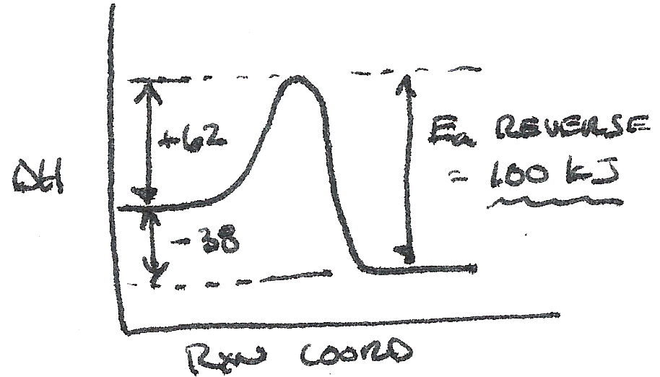
29. | C second Note: know how to derive the units for these cases and maybe memorize  Zero order 1st order 2nd order  Rate = k Rate = k[A] Rate = k[A]²  k = Rate = mol·L⁻¹·s⁻¹ k = $\frac{\text{Rate}}{[A]}$= s⁻¹ Rate = $\frac{\text{Rate}}{[A]^{2}}$= L·mol⁻¹·s⁻¹
30. | A catalyst provides a pathway with a lower activation energy  (B) only temperature changes the equilibrium constant, K  (C) increasing temperature increases kinetic energy, not a catalyst  (D) the catalyst interacts with the reactants. While it may be true that it interacts with the products, that is not its role.
31. | A liquids are not included in the equilibrium expression (their concentrations do not change)
32. | C increasing the volume of the container  Look for a change that shifts the equilibrium toward the products. When the stress is too much room, the equilibrium shifts to the side that takes up more room. The products contain more moles of gas so they take up more room.  (A) catalyst speeds up both the forward and reverse reaction so you get to the same equilibrium.  (B) endothermic means heat is a reactant. Decreasing the temperature shifts reaction toward the left.  (D) slows down both the forward and reverse reaction so you get the same equilibrium.
33. | A smallest K_{a} Note: Be careful of negative exponents. 10⁻⁵ < 10⁻⁴ and 1.8 < 5.5
34. | D pH = 6.30 Note: this question can be a calculation problem or a conceptual problem.  This is an ICE box problem with initial values for both HA and A- (common ion effect)  You might also notice that this is a buffer. If [HA] = [A⁻] then pH = pK_{a} = 6  Since there is some excess conjugate base (A⁻), the buffer’s pH will be a little more basic, 6.30.
35. | B NH₄Br  pH less than 7 means acidic. Look for an acid or the conjugate acid of a weak base.  (A) neutral (B) conjugate acid of NH₃ (C) conjugate base of HF (D) conjugate base of HC₂H₃O₂
36. | D 6.4 x 10⁻⁷M  This is an ICE box problem with an initial value for F⁻.  K_{sp} = [Mg²⁺][F⁻]² = (x) (0.l0 + 2x) = 6.4 x 10⁻⁹  2x << 0.10 ∴(0.10 + 2x) ≈ (0.10)  ∴(x) (0.10) = 6.4 x 10⁻⁹; x = 6.4 x 10⁻⁷
37. | B VO²⁺ → VO₃⁻  (A) N(+3) → N(0) reduction (B) V(+4) → V(+5) oxidation  (C) Cl(+1) → Cl(-1) reduction (D) Cr(+6) → Cr(+6) no redox change
38. | D +6  MoO₂Cl₂ Think of this as an algebra problem: x + 2(-2) + 2(-1) = 0 ∴x = +6
39. | B 4H⁺  Notice that this is a half-reaction: 2H₂O + S²⁻ → SO₂ + 4H⁺ + 6e⁻
40. | B +0.426 V  reduction E° - oxidation E° = -762 – (-.336) = +0.426 V  Note: There is no need to double the Tl E° even though you double the equation when you combine the oxidation and reduction reactions. This is because each half cell was compared to the standard H₂ half cell. The differences in electrons involved has already been taken into account.
41. | A E° +; ΔG° −; spontaneous  A spontaneous electrochemical cell has a + E° value. A spontaneous reaction has a − ΔG° value.
42. | C O₂  Anode means oxidation. For electrolysis, either the H₂SO₄ can change or the H₂O will change.  Eliminate (A) because 2H⁺ + 2e− → H₂ this is reduction… it would occur only at the cathode.  Either H₂O is oxidized: 2H₂O → O₂ + 4H⁺ + 4e⁻ (memorize this equation)  or SO₄²⁻ is oxidized: S in SO₄²⁻ is already as oxidized as it can be. The water will change.
43. | D Cs  Cs is a member of the alkali metal family, the most reactive metallic family. Cs is the most reactive of the alkali metals. (Fr would be the most reactive if there were any of it around.)
44. | C N  N has the most protons in its row and is the smallest atom ∴the strongest ionization energy.
45. | A 3f  The first f-orbitals are 4f.
46. | B 9  Draw the orbital diagram: 1s² 2s² 2p_{x}² 2p_{y}² 2p_{z}² 3s² 3p_{x}² 3p_{y}¹ 3p_{z}¹
47. | B II only  n determine energy; l determines the shape (type of orbital); m_{l} determines the orientation
48. | C lanthanides  lanthanides: the 4f orbitals are being filled actinides: the 5f orbitals are being filled  transition metals: the d orbitals are being filled
49. | A NaF  Small lattice energy, look for large size and small charge. Na⁺ and F⁻
50. | A I only (NO)  Draw the Lewis dot structures. NO has 11 electrons, the N atom has 7 electrons.  SF₂, all single bonds, each atom has an octet. PF₄⁺, four single bonds, each atom has an octet.
51. | D CH₃CN  Draw the Lewis dot structures. Shortest CN bond is the triple bond in CH₃CN.
52. | D NO₂⁻  Draw the Lewis dot structures. NO₂⁻ has two resonance structures and a lone pair on the N atom.
53. | C C₁ – sp³, C₂ – sp²  SN = steric number (# of bonded atoms + # lone pairs); C₁ SN=4 sp³; C₂ SN=3 sp²
54. | D II. & III only (COCl₂ & CH₂Cl₂)  Draw the Lewis dot structures. CO₂ is linear and non-polar.  COCl₂ and CH₂Cl₂ are not symmetrical and polar.
55. | B benzene  This is just a definition: benzene compounds are called aromatic compounds.
56. | D 1,2-dichloroethene  Geometric isomers mean cis-/trans- isomers. Look for a double bond (-ene) with groups on the two carbons of the double bond.
57. | B CH₃COOH (carboxylic acid)  You need to recognize that an acidified solution of Cr₂O₇²⁻ is a strong oxidizer.  An alcohol can be oxidized into an aldehyde and then further oxidized into a carboxylic acid.
58. | A -O-H  Simple sugars have the empirical formula CH₂O. Glucose is shown.  The -O-H bonds allow hydrogen bonding and solubility in H₂O.  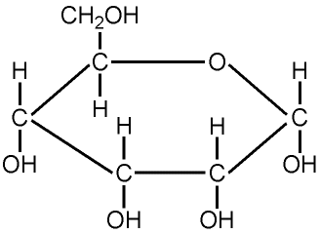  Source: http://www2.glos.ac.uk/GDN/origins/images/sugar.gif
59. | C esters  Esters are used for flavorings and fragrances.  A standard high school lab is making Oil of Wintergreen from methyl alcohol and salicylic acid.
60. | B nitrogen  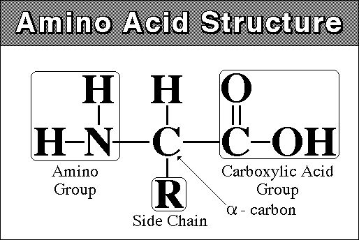  Source: http://www.hcc.mnscu.edu/programs/dept/chem/V.27/amino_acid_structure_2.jpg

