Advanced Placement Chemistry,

EXAMINATION
REVIEW

Memorization!

Table of Ionic Charges

CATIONS (positive ions)
+1 | +2 | +3 | +4
GROUP IA ELEMENTS (Alkali Metals): Li⁺, Na⁺, K⁺, etc.  SILVER, Ag⁺  AMMONIUM, NH₄⁺ | GROUP IIA  ELEMENTS (Alkaline  Earth Metals): Mg²⁺, Ca²⁺, etc.  MOST TRANSITION METALS FORM IONS WITH +2 CHARGES  LEAD(II), Pb²⁺  TIN(II), Sn²⁺ | IONS OF CERTAIN GROUP IIIA ELEMENTS, including Al³⁺ & B³⁺  IRON(III), Fe³⁺ | TIN(IV), Sn⁴⁺  LEAD(IV), Pb⁴⁺
 | ANIONS (negative ions)
-1 | -2 | -3 | -4
GROUP VIIA ELEMENTS (the Halogens): F⁻, Cℓ⁻, Br⁻, I⁻  ACETATE, CH₃COO⁻  BICARBONATE, HCO₃⁻  (hydrogen carbonate)  BISULPHATE, HSO₄⁻  (hydrogen sulphate)  CHLORATE, CℓO₃⁻  CYANIDE, CN⁻  CYANATE, OCN⁻  HYDROXIDE, OH⁻  NITRATE, NO₃⁻  PERCHLORATE, CℓO₄⁻  PERMANGANATE, MnO₄⁻  THIOCYANATE, SCN⁻ | GROUP VIA ELEMENTS: O²⁻, S²⁻, etc.  CARBONATE, CO₃²⁻  CHROMATE, CrO₄²⁻  DICHROMATE, Cr₂O₇²⁻  OXALATE, (COO)₂²⁻  PEROXIDE, O₂²⁻  SULPHATE, SO₄²⁻  SULPHITE, SO₃²⁻  THIOSULPHATE, S₂O₃²⁻ | GROUP VA  ELEMENTS, including N³⁻  PHOSPHATE, PO₄³⁻

Nonmetals

- You should know that the following nonmetals are diatomic: H₂, N₂, O₂, F₂, Cl₂, Br₂ & I₂.
- Phosphorus exists as P₄; phosphorus oxide can exist either as P₄O₁₀ (most likely) or as P₄O₆.
- Sulphur normally exists as S₈ molecules.

Atomic Structure

SUMMARY OF THE THREE MAIN SUBATOMIC PARTICLES
 | SYMBOL | RELATIVE  CHARGE | MASS (u)
ELECTRON | e⁻ | -1 | ¹/₂₀₀₀
PROTON | p | +1 | 1.00
NEUTRON | n | 0 | 1.00

In any (uncharged) atom:
THE NUMBER OF PROTONS = THE ATOMIC NUMBER OF THE ATOM
THE NUMBER OF ELECTRONS = THE NUMBER OF PROTONS
THE NUMBER OF NEUTRONS = THE MASS NUMBER - THE ATOMIC NUMBER

Isotopes are atoms of the same element containing different numbers of neutrons and therefore having different masses.

Gases

Volume is always measured in litres (L), millilitres (mL) or cubic centimetres (cm³).
1 L = 1000 mL = 1000 cm³

DENSITY OF A GAS = MOLAR MASS OF THE GAS (g/mol)
(g/L) MOLAR VOLUME OF THE GAS (L/mol)

The five principal assumptions of the kinetic molecular theory of gases are as follows:
☑ Gases consist of molecules whose volumes are negligible compared with the volume occupied by the gas.
☑ Since the molecules of a gas are far apart, the forces of attraction between them are negligible.
☑ The molecules of a gas are in continual, random, and rapid motion.
☑ The average kinetic energy of gas molecules depends only on the gas temperature, and can be expressed by E_{K} α T.
☑ Gas molecules collide with each other and with the walls of their container, but they do so without loss of energy (The collisions are said, by scientists, to be "perfectly elastic").

Real Gases versus Ideal Gases
The Gas Laws work for “Ideal Gases”. However, there is no such thing as an Ideal Gas!

- Real Gases deviate most from ideal behaviour at high pressures.
- Real Gases deviate most from ideal behaviour at low temperatures.
- At a given temperature and pressure, the greater the intermolecular forces, the greater will be the deviation from ideal behaviour.

- At high pressures and low temperatures, the greater the size of the gas molecules, the greater will be the deviation from ideal behaviour.
Quantum Numbers

Quantum Number | Symbol | Allowable Values | What the quantum number is responsible for
Principal | n | 1, 2, 3, 4, 5, 6, 7, .. | determining the energy of the electron and the size of the orbital.
Secondary (Azimuthal) | ℓ | 0 to (n-1) | determining the shape of the orbital.
Magnetic | m_{ℓ} | +ℓ to -ℓ | determining the spatial orientation of the orbital relative to the other orbitals in the atom.
Spin | m_{s} | +½ or -½ | determining the spin of the electron within the orbital.

Electron Configurations

The following “rules” govern the electron configuration of atoms:

The Aufbau Principle: This simply states that the lowest energy level orbitals are filled first.

The Pauli Exclusion Principle: This states that no two electrons in an atom can have the same set of four quantum numbers.

Hund’s Rule: This states that the most stable arrangement of electrons is that with the maximum number of unpaired electrons, all with the same spin direction.

The maximum number of electrons in the various subshells is:

subshell | maximum number of electrons
s |  | 2
p |  | 6
d |  | 10
f |  | 14

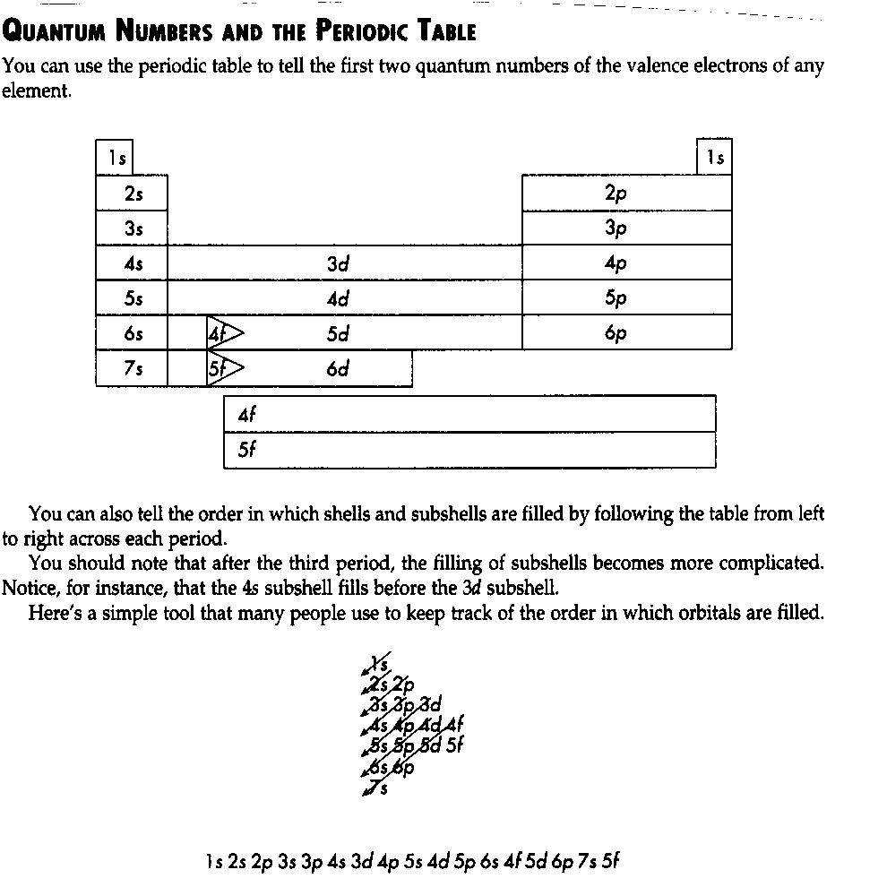

Filled subshells, particularly in the valence shell, lead to stable, unreactive, elements. Additionally, there is stability associated with half-filled valence subshells.

The Noble Gases are, of course, the most stable of all the elements.
Nitrogen, phosphorus and arsenic have unusually stable properties due to the fact that their valence shells consists of filled s orbitals and half-filled p orbitals.

Periodic Trends: Sizes of Atoms, Ionization Energies, Electronegativity

- Within each column (group), the atomic radius tends to increase as we proceed from top to bottom.
- Within each row (period), the atomic radius tends to decrease as we move from left to right.

The ionization energy of an atom or ion is the minimum energy required to remove an electron from the ground state of the isolated gaseous atom or ion. The first ionization energy, I₁, is the energy needed to remove the first electron from a neutral atom. For example, the first ionization energy for the sodium atom is the energy required for the process, Na(g) → Na⁺(g) + e⁻
The second ionization energy, I₂, is the energy needed to remove the second electron, and so forth, for successive removals of additional electrons.

- Within each group, ionization energy generally decreases with increasing atomic number as you proceed down the group.
- Within each row, ionization energy generally increases with increasing atomic number as you proceed from left to right. There are slight irregularities in this trend, however.

Electronegativity is the ability of an atom in a molecule to attract electrons to itself.
Electronegativities generally decrease as you proceed down a group and increase as you proceed from left to right across a period. Fluorine is the most electronegative element.

Ionic Bonding & Ions
An ionic bond is formed when one electron, or more, is/are transferred from one atom to another.
Positive ions are referred to as cations; negative ions are referred to as anions.

Lattice energy is governed by the formula, $E∝\frac{Q_{1}Q_{2}}{d}$
(where Q₁ and Q₂ are the charges and d is the distance between them).

The most common ionic charge of the fourth row transition elements, from scandium to zinc, is 2+ (e.g. Ti²⁺ & Fe²⁺). When such ions are formed, the transition metal atom loses its two 4s electrons (3d electrons are not lost). (In fact, whenever a positive ion is formed from an atom, electrons are always lost first from the subshell having the largest value of n). Thus, in forming ions, transition metals lose the valence-shell s electrons first, then as many d electrons as are required to reach the charge of the ion.

Relative Sizes of Ions

- For the Representative (s-block and p-block) Elements that form positive ions (cations), the radius of the positive ion will always be smaller than the radius of the corresponding atom. This is due primarily to the fact that when these elements form ions the outermost shell (highest value of n) is lost in its entirety.
- For the Representative Elements that form negative ions (anions), the radius of the negative ion will always be larger than the radius of the corresponding atom.
- For all of the Representative Elements, as you go down a group the radii of ions of equal charge increase. This is due primarily to the fact that as you go down the group the outermost electrons have a larger value of n.

Lewis Structures for Covalent Molecules

☑ | Ensure that each atom ends up with the “correct” number of valence electrons.  - Most elements end up with eight valence electrons (the “octet rule”).  - Hydrogen ends up with two valence electrons.  - Boron and beryllium usually end up with fewer than eight valence electrons.  - Some elements from periods 3, and higher, end up with more than eight valence electrons. These elements include sulphur, phosphorus, arsenic, selenium and xenon. They are said to form “expanded octets”.

The formal charge of an atom equals the number of valence electrons in the isolated atom, minus the number of electrons assigned to the atom in the Lewis structure: the most likely Lewis structure is one in which the formal charges on the atoms are a minimum.

How to calculate formal charges
① For each atom count all the nonbonding electrons (i.e. “lone pairs” of electrons).
② Count exactly half of the electrons that the atoms uses to bond with other atoms.
③ Add steps ① and ② to obtain the electrons assigned to that atom.
④ Subtract the assigned electrons from the atom's valence electrons to obtain the formal charge of the atom.

BOND LENGTH IS THE DISTANCE BETWEEN THE NUCLEI OF THE BONDED ATOMS, AND BOND ENERGY IS THE ENERGY REQUIRED TO SEPARATE THE BONDED ATOMS TO GIVE NEUTRAL PARTICLES.
A DOUBLE BOND IS BOTH SHORTER AND STRONGER THAN A SINGLE BOND.
Similarly, a triple bond is both shorter and stronger than a double bond.

Enthalpy

Exothermic reactions have negative ΔH values; endothermic reactions have positive ΔH values.

ΔHº represents an enthalpy change occurring at standard conditions, which are 25 ºC and
101.3 kPa.

ΔH_{f}° represents the enthalpy change for a special type of reaction known as a formation reaction. A formation reaction is one in which one mole of a compound is made (or "formed") from its elements, with all the chemicals in their standard states.
ΔH_{c} represents the enthalpy change for a special type of reaction known as a combustion
reaction. It is also sometimes referred to as the heat of combustion.

Rate Laws

For the general (hypothetical) rate determining step,
a A + b B → products
the Rate Law (Expression) is,
r α [A]ª [B]^{b} or r = k [A]ª [B]^{b}

Units of Rate Constants
Overall Reaction Order | Units of Rate Constant, k
0 | M.s⁻¹
1 | s⁻¹
2 | M⁻¹.s⁻¹
3 | M⁻².s⁻¹

Integrated Rate Laws
For First Order Reactions, $\text{ln}\frac{[A]_{t}}{[A]_{0}}=−\text{kt} \text{or} \text{ln}[A]_{t}−\text{ln}[A]_{0}=−\text{kt}$

(The second equation is given on the data sheet but you need to know that it works for First Order Reactions)
 | Thus, for a first order reaction,  - A graph of ln[A]_{t} versus time gives a straight line.  - The slope of the line is equal to -k .  - The y-intercept is equal to ln[A]₀.

Half-life, t_{½}, is the time required for a reactant to reach exactly half of its original concentration.

$t_{\frac{1}{2}}=\frac{\text{ln}2}{k}=\frac{0\text{.}\text{693}}{k}$ (This formula is not given on the data sheet!)
$\frac{1}{[A]_{t}}−\frac{1}{[A]_{0}}=\text{kt}$
For Second Order Reactions,

(This equation is given on the data sheet but you need to know that it works for Second Order Reactions)
 | Thus, for a second order reaction,  - A graph of 1/[A]_{t} versus time gives a straight line.  - The slope of the line is equal to +k .  - The y-intercept is equal to 1/[A]₀.

 | Thus, for a zero order reaction,  - A graph of [A]_{t} versus time gives a straight line.  - The slope of the line is equal to -k .  - The y-intercept is equal to [A]₀.

Activation Energy & Catalysis

The minimum energy required to initiate a chemical reaction is called the activation energy, E_{a}.

A catalyst is a substance which increases the rate of a chemical reaction without undergoing a permanent chemical change itself in the process.

Homogeneous catalysts are in the same phase as the reactants; heterogeneous catalysts are in a different phase from that of the reactants.

Nuclear Reactions
The most common isotope of hydrogen, ${}_{1}^{1}{}H$, has a nucleus consisting of a single proton. This isotope comprises 99.9844 percent (but don’t memorize the actual percentage!) of naturally occurring hydrogen. Two other isotopes are known: ${}_{1}^{2}{}H$, whose nucleus contains a proton and a neutron, and ${}_{1}^{3}H,$whose nucleus contains a proton and two neutrons. The ${}_{1}^{2}{}H$isotope, called deuterium whereas the third isotope, ${}_{1}^{3}H,$is known as tritium.

TYPES OF RADIOACTIVE DECAY
 | ATOMIC NUMBER | MASS NUMBER
alpha decay | decreases by 2 | decreases by 4
beta decay | increases by 1 | remains unchanged
positron emission | decreases by 1 | remains unchanged
electron capture | decreases by 1 | remains unchanged

Particle | Symbol | Charge | Mass (u) | Approx. speed  (x speed of light) | Penetrating  ability
alpha | $${}_{2}^{4}{}\text{He}$$ | +2 | 4 | 0.1 | Low
beta | β or ${}_{−1}^{0}{}e$ | -1 | $$\frac{1}{\text{2000}}$$ | 0.9 | Higher
gamma radiation | γ | 0 | 0 | speed of  light | Very high
proton | $${}_{1}^{1}{}p$$ | +1
neutron | $${}_{0}^{1}{}n$$ | 0
positron | $${}_{+1}^{0}{}e$$ | +1
Radioactive Decay

Radioactive decay is a first-order kinetics process.

The half-life of a radioactive isotope (radioisotope) is defined as the time it takes for exactly one-half of the nuclei in a given sample of the isotope to decay.
$N_{t}\text{ = }N_{o}\text{ x }2^{−\frac{t}{h}}$
where......
N_{t} = the amount of radioisotope at time = t
N₀ = the amount of radioisotope present initially (time, t = 0)
h = half-life
t = time during which the radioisotope has decayed

Also, for radioactive decay:
$$\text{ln}\frac{N_{t}}{N_{0}}=−\text{kt}$$
where......
N_{t} = the amount of radioisotope at time = t
N₀ = the amount of radioisotope present initially (time, t = 0)
k = the rate constant
t = the time during which the radioisotope has decayed

Nuclear Fission
- nuclear fission is the splitting of a large nucleus into two, or more, smaller nuclei
- a typical fission reaction is:
${}_{0}^{1}{}n+{}_{\text{92}}^{\text{235}}{}U→{}_{\text{56}}^{\text{142}}{}\text{Ba}+\underline{}\underline{}\underline{}+3{}_{0}^{1}{}n$
- ${}_{\text{92}}^{\text{235}}{}U$ is the fissionable isotope of uranium
- less than 1% of the atoms present in naturally-occurring uranium are ${}_{\text{92}}^{\text{235}}{}U$ atoms and that the vast majority are ${}_{\text{92}}^{\text{238}}{}U$
- a nuclear fission reaction is a chain reaction since one neutron or more are produced
- that the critical mass of ${}_{\text{92}}^{\text{235}}{}U$is approx. 1 kg
- that the moderator in a nuclear reactor slows down the fast moving neutrons so that they can be more readily captured by the ${}_{\text{92}}^{\text{235}}{}U$atoms

Nuclear Fusion
- nuclear fusion is the joining together of two, or more, lighter nuclei to form a heavier one
- a typical fusion reactions are:
${}_{1}^{1}{}H+{}_{1}^{1}{}H→{}_{1}^{2}{}H+\underline{}\underline{}$ & ${}_{1}^{1}{}H+{}_{1}^{2}{}H→\underline{}\underline{}\underline{}$
- nuclear fusion usually involved hydrogen and helium isotopes
- nuclear fusion reactions occurs in stars, including our Sun
- nuclear fusion reactions take large amounts of energy, and temperatures of around 40,000,000 K, to initiate.

Molecular Shapes Summary
NUMBER  OF  ELECTRON  PAIRS  AROUND  CENTRAL ATOM | NUMBER  OF LONE PAIRS AROUND CENTRAL ATOM | EXAMPLE | MOLECULAR SHAPE |  | IS THE  MOLECULE SYMMETR-  ICAL? | WILL THE  MOLECULE BE POLAR IF IT CONTAINS POLAR BONDS? | TYPE OF HYBRI-  DIZATION
NUMBER  OF  ELECTRON  PAIRS  AROUND  CENTRAL ATOM | NUMBER  OF LONE PAIRS AROUND CENTRAL ATOM | EXAMPLE | BOND ANGLES | NAME OF SHAPE | IS THE  MOLECULE SYMMETR-  ICAL? | WILL THE  MOLECULE BE POLAR IF IT CONTAINS POLAR BONDS? | TYPE OF HYBRI-  DIZATION
2 | 0 | BeCℓ₂ |  | LINEAR
3 | 0 | BCℓ₃ |  | TRIGONAL PLANAR
4 | 0 | CH₄ |  | TETRAHEDRAL
4 | 1 | NH₃ |  | TRIGONAL  PYRAMIDAL
4 | 2 | H₂O |  | BENT
5 | 0 | PCℓ₅ |  | TRIGONAL  BIPYRAMIDAL
5 | 1 | SF₄ |  | SEESAW
5 | 2 | ClF₃ |  | T-SHAPED
5 | 3 | XeF₂ |  | LINEAR
6 | 0 | SF₆ |  | OCTAHEDRAL
6 | 1 | BrF₅ |  | SQUARE PYRAMIDAL
6 | 2 | XeF₄ |  | SQUARE PLANAR
Sigma and Pi Covalent Bonds

The first bond between any two atoms is a strong sigma (σ) bond.
To describe multiple (double and triple) bonding we must consider a second kind of bond that results from the overlap between two p orbitals oriented perpendicular to the inter-nuclear axis, as illustrated below:
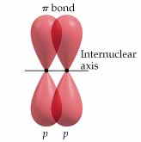
This sideways overlap of p orbitals produces a pi () bond. π bonds are generally weaker than bonds.

Bonding in Alkanes, Alkenes, Alkynes and Aromatic Hydrocarbons

ALKANES ARE SATURATED HYDROCARBONS IN WHICH THE CARBON ATOMS ARE JOINED BY SINGLE COVALENT BONDS ONLY. ALL ALKANES HAVE 109.5° BOND ANGLES AND EXHIBIT sp³ HYBRIDIZATION. ALL OF THE COVALENT BONDS PRESENT IN ALKANES ARE STRONG SIGMA (σ) BONDS.

ALKENES ARE UNSATURATED HYDROCARBONS CONTAINING AT LEAST ONE DOUBLE C=C BOND. ALL ALKANES HAVE 120° BOND ANGLES AND sp² HYBRIDIZATION AROUND THE CARBON ATOMS JOINED BY THE DOUBLE BOND. THE DOUBLE BOND CONSISTS OF ONE STRONG SIGMA (σ) BOND AND ONE WEAKER PI (π) BOND.

ALKYENES ARE UNSATURATED HYDROCARBONS CONTAINING AT LEAST ONE TRIPLE C=C BOND. ALL ALKYNES HAVE 180° BOND ANGLES AND sp HYBRIDIZATION AROUND THE CARBON ATOMS JOINED BY THE TRIPLE BOND. THE TRIPLE BOND CONSISTS OF ONE STRONG SIGMA (σ) BOND AND TWO WEAKER PI (π) BONDS.

BENZENE IS AN AROMATIC HYDROCARBON WITH THE FORMULA C₆H₆ AND WITH THE SIX CARBON ATOMS IN A RING STRUCTURE. It is often represented as follows:
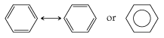

Equilibrium Constants

For the general reaction,
aA(g) + bB(g) ↔ pP(g) + qQ(g) ,
$$K_{c}=\frac{[P]^{p}[Q]^{q}}{[A]^{a}[B]^{b}}$$
This relationship is called the equilibrium law (expression) for the reaction. The subscript c indicates that concentrations (measured in mol/L, molarity) are used.
When the reactants and products in a chemical equation are gases, we can formulate the equilibrium law expression in terms of partial pressures instead of molar concentrations. When partial pressures in atmospheres are used in the equilibrium-constant expression, we denote the equilibrium constant as K_{p} . So, for the general reaction:
aA(g) + bB(g) ↔ pP(g) + qQ(g)
$K_{P}=\frac{(P_{P})^{p}(P_{Q})^{q}}{(P_{A})^{a}(P_{B})^{b}}$

SINCE THE CONCENTRATIONS OF PURE SOLIDS AND PURE LIQUIDS CANNOT EASILY BE ALTERED, THEY ARE ALWAYS OMITTED FROM EQUILIBRIUM LAW EXPRESSIONS.

Reversing a chemical equation will cause the value of the equilibrium constant to
become the reciprocal, doubling an equation will cause the value of an equilibrium constant to square, halving an equation will cause the value of the equilibrium constant to become the square root, etc.

If two equations (with equilibrium constants K₁ and K₂ ) are added together, then the equilibrium constant for the overall equation, K_{overall}, is given by:
K_{overall} = K₁ x K₂

Le Châtelier’s Principle

WHEN A STRESS IS APPLIED TO A SYSTEM AT EQUILIBRIUM, THE EQUILIBRIUM WILL READJUST SO AS TO RELIEVE THE STRESS.

WHEN A SYSTEM “SHIFTS” TO RELIEVE A STRESS, THE SYSTEM NEVER TOTALLY COMPENSATES.

YOU ONLY TAKE GASES INTO ACCOUNT WHEN DETERMINING THE EFFECT OF VOLUME CHANGES ON A CHEMICAL EQUILIBRIUM.

WHEN THE VOLUME OF THE CONTAINER IS DECREASED, THE SYSTEM WILL COMPENSATE BY MAKING FEWER GAS MOLECULES; WHEN THE VOLUME IS INCREASED IT WILL COMPENSATE BY MAKING MORE GAS MOLECULES TO FILL THE AVAILABLE SPACE.

Solubility & Solubility Product

Solubility is the maximum amount of solute which will dissolve in a given amount of solvent to form a saturated solution at a given temperature. Solubility is normally measured in g/L, although molar solubility is, obviously, measured in mol/L. The equation for the saturated solution is written with the solid on the left – e.g.:
MgF₂(s)  Mg²⁺(aq) + 2 F⁻(aq)
The equilibrium constant for an equilibrium of this sort is referred to as the solubility product, and it is given the symbol K_{SP}. In this example:
K_{SP} = [Mg²⁺] [F⁻]²

It should be noted that the K_{SP} of a salt increases as its solubility .

Intermolecular Forces
In general, as the strength of the inter-molecular forces increases,
- Melting points increase.
- Boiling points increase.
- Solubility decreases.
- Viscosity increases.

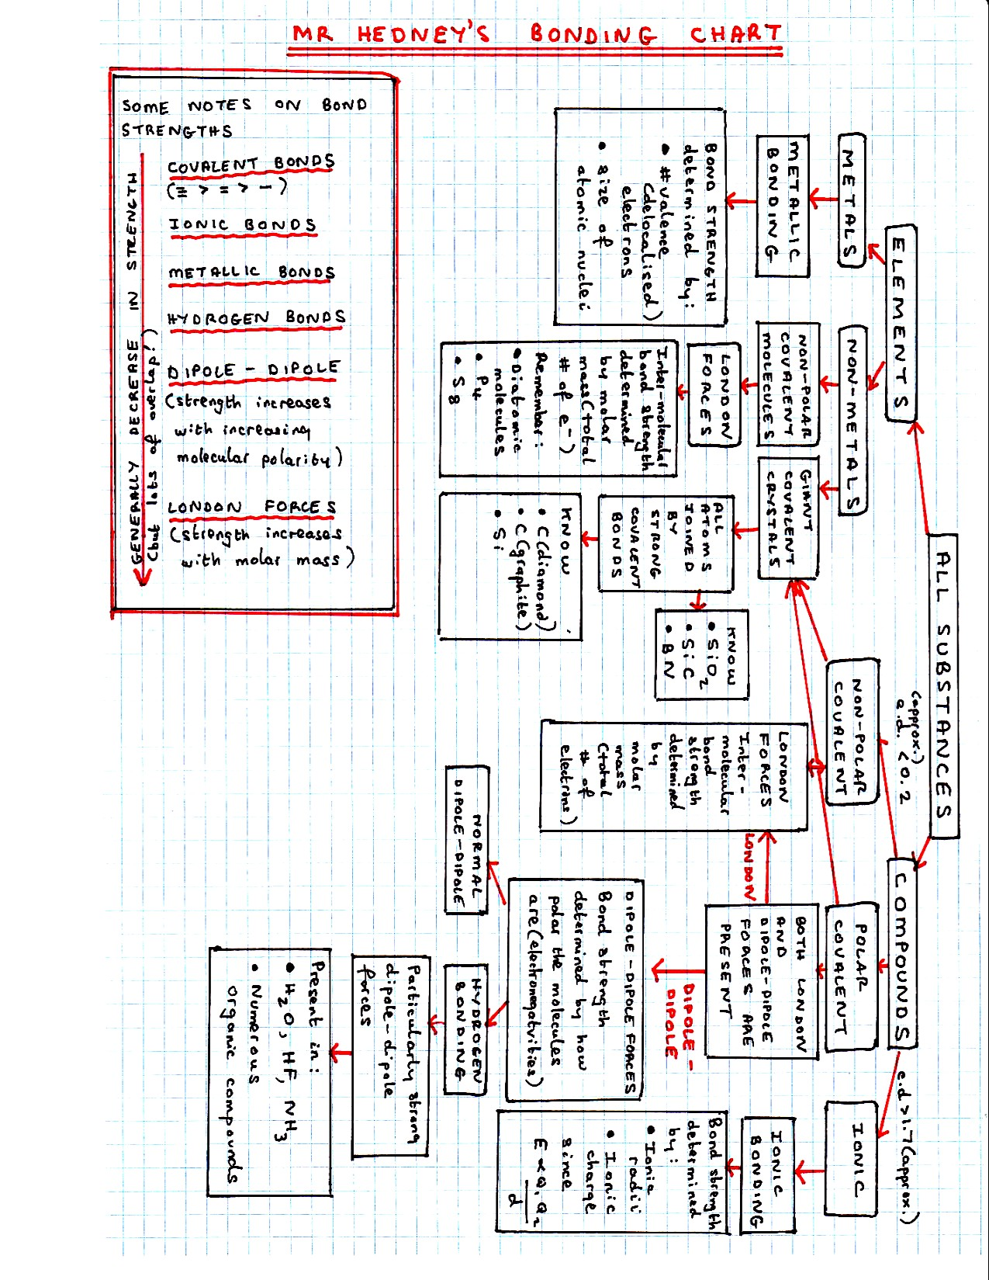

Phase Diagrams

Typical phase diagram…….

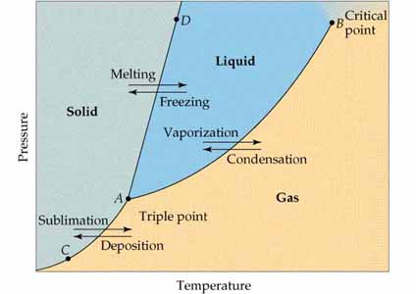

The critical point is the temperature above which a vapour cannot be liquefied by pressure alone.

The phase diagram for H₂O is ‘odd’……

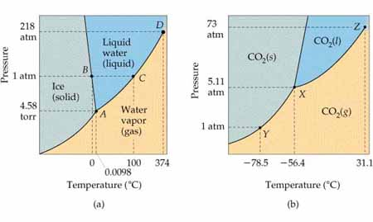

Solubility Rules

SALTS | MOST ARE | EXCEPTIONS
NITRATES (NO₃⁻)  ACETATES (CH₃COO⁻)  CHLORATES (ClO₃⁻) | SOLUBLE | None
SULPHATES (SO₄²⁻) | SOLUBLE | The sulphates of Ag⁺, Ba²⁺, Ca²⁺, Hg²⁺, Hg₂²⁺, Pb²⁺ and Sr²⁺ are all insoluble.
BROMIDES (Br⁻)  CHLORIDES (Cl⁻)  IODIDES (I⁻) | SOLUBLE | The bromides, chlorides and iodides  of Ag⁺, Hg²⁺, Hg₂²⁺ and Pb²⁺ are all  insoluble
CHROMATES (CrO₄²⁻)  DICHROMATES (Cr₂O₇²⁻) | SOLUBLE | The chromates of Ag⁺, Ba²⁺ and Pb²⁺ are all insoluble.
HYDROXIDES (OH⁻)  OXIDES (O²⁻) | INSOLUBLE | The alkali metal hydroxides and oxides are all soluble.  The hydroxides and oxides of Ba²⁺, Ca²⁺ and Sr²⁺ are moderately soluble.
CARBONATES  PHOSPHATES | INSOLUBLE | The alkali metal carbonates and phosphates are, of course, all soluble.
SULPHIDES | INSOLUBLE | The alkali metal sulphides, along  with BaS, CaS, MgS, (NH₄)₂S and  SrS are all soluble.
NOTES
ALL ALKALI METAL SALTS, AND ALL AMMONIUM SALTS ARE SOLUBLE.
THE SALTS OF MOST COMMON “HEAVY” METALS (silver, lead, mercury, for example) TEND TO BE INSOLUBLE (except, of course, their nitrates, acetates and chlorates).

Diluting Solutions

When solvent (usually water) is added to dilute a solution, the number of moles of solute remains unchanged. Therefore:
(Initial molarity)(initial volume) = (final molarity)(final volume)
M_{i} x V_{i} = M_{f} x V_{f}

Acid-Base Definitions

Arrhenius Definitions of Acids and Bases: Acids are substances that, when dissolved in water, increase the concentration of H⁺ ions. Likewise, bases are substances that, when dissolved in water, increase the concentration of OH– ions.

Bronsted-Lowry Definitions of Acids and Bases: Acids are substances (molecules or ions) that can transfer a proton to another substance. Likewise, bases are substances that can accept a proton.
Lewis Acids and Bases: Lewis acids are defined as electron-pair acceptors; Lewis bases are defined as electron-pair donors.

Conjugate Acid-Base Pairs: An acid differs from its conjugate base (and vica versa) by H⁺. (Every acid has a conjugate base formed by the removal of a proton from the acid, and every base has associated with it a conjugate acid formed by the addition of a proton to the base.)

Naming Acids

- The “ic” ending is used for the acid with the higher oxidation state; the “ous” ending is used for the acid with the lower oxidation state.
- The prefix “hypo” is used when the oxidation state is “really low”; the “per” prefix is used when the oxidation state is “really high”.
- For example:
HClO (hypochlorous acid) Cl has an oxidation state of +1.
HClO₂ (chlorous acid) Cl has an oxidation state of +3.
HClO₃ (chloric acid) Cl has an oxidation state of +5.
HClO₄ (perchloric acid) Cl has an oxidation state of +7.

Strong and Weak Acids and Bases

Strong acids are completely ionized in aqueous solution, weak acids are not.
The “Big Six” Strong Acids
HClO₄ (perchloric acid)
HNO₃ (nitric acid)
HCl, HBr, HI (hydrochloric, hydrobromic, and hydroiodic acids)
H₂SO₄ (sulphuric acid)

Two common examples of “moderate acids” that you should know are:
H₃PO₄ (phosphoric acid)
(COOH)₂ (oxalic acid)

Soluble hydroxides form Strong Bases. Learn the following strong bases:

LiOH, NaOH, KOH, Ba(OH)₂, Sr(OH)₂

Weak Monoprotic Acids

If we represent a general weak monoprotic cid as HA, we can write the equation for its ionization reaction in either of the following ways, depending on whether the hydrated proton is represented as H₃O⁺(aq) or H⁺(aq):
either: HA_{(aq)} + H₂O_{(l)} ↔ H₃O⁺_{(aq)} + A⁻_{(aq)}
or: HA ↔ H⁺ + A⁻
Because [H₂O] is omitted from equilibrium constant expressions in aqueous solutions, the form of the equilibrium-constant expression is the same in either case:
K_{a} = [H₃O⁺_{(aq)}] [A⁻_{(aq)}] or K_{a} = [H⁺] [A⁻]
[HA_{(aq)}] [HA]

K_{a} is called the acid dissociation constant (or acid ionization constant).

Weak Bases

If we generalize a weak base as B(aq), then the equilibrium for the weak base:
B(aq) + H₂ O(l) <----> BH⁺(aq) + OH⁻(aq)

The equilibrium constant, symbolized by K_{b}, for such a reaction is called the base ionization constant, and the equilibrium law expression is:
K_{b} = [BH⁺] [OH⁻]
[B]

The weak base you will most frequently encounter is an aqueous solution of ammonia, NH₃(aq), and it ionizes as follows:
NH₃(aq) + H₂O(l) <----> NH₄⁺(aq) + OH⁻(aq)
(NH₃(aq) is “ammonia” and NH₄⁺(aq) is the ammonium ion)

Relative Strength of Acids and Bases

The stronger an acid, the weaker is its conjugate base; the stronger a base, the weaker is its conjugate acid.
The product of the acid-dissociation constant for an acid, K_{a}, and the base-dissociation constant, K_{b}, for its conjugate base is the ion-product constant for water, K_{w}.
Thus, K_{a} x K_{b} = K_{w} = 1.0 x 10⁻¹⁴.

pK_{a} & pK_{b}
(In AP Chemistry, it is safe to assume that p(anything) = -log(anything)!)
pK_{a} = -logK_{a}
pK_{b} = -logK_{b}

Acid – Base Salts

THE SALTS FORMED FROM....
STRONG ACIDS  and  STRONG BASES | will be....  NEUTRAL | WEAK ACIDS  and  STRONG BASES | will be....  BASIC
STRONG ACIDS  and  WEAK BASES | will be....  ACIDIC | WEAK ACIDS  and  WEAK BASES | could be slightly acidic or slightly basic - depending on the respective K_{a} and K_{b} values

Buffers
BUFFERS ARE SOLUTIONS THAT RESIST CHANGES IN pH ON ADDITION OF ACID OR BASE.
Buffer solutions consist of:
EITHER ➔ a solution of a weak acid in the presence of one of its salts
[e.g. ethanoic (acetic) acid and sodium ethanoate (acetate)]
OR ➔ a solution of a weak base in the presence of one of its salts
[e.g. ammonia solution, NH_{3 (aq)}, and ammonium chloride]

Oxidation Numbers
1. The oxidation number of an element in the free, or un-combined, state is zero.

2. The oxidation number of a monatomic ion is equal to its charge.

3. In all compounds containing Group IA alkali metals, the oxidation number of the Group IA ion is +1.

4. In all compounds containing Group IIA metals, the oxidation number of the Group IIA ion is +2.

5. In most compounds containing oxygen, the oxidation number of oxygen is almost always -2.

6. In most compounds containing hydrogen, the oxidation number of hydrogen is almost always +1.

7. The algebraic sum of the oxidation numbers of all the atoms in the formula of a compound is zero.

8. The algebraic sum of the oxidation numbers of all the atoms in the formula of a polyatomic ion is equal to the charge on the ion.

Oxidation – Reduction Definitions
- A substance is said to be oxidised if it gains oxygen or loses hydrogen. Likewise, a substance is said to be reduced if it loses oxygen or gains hydrogen.

- The substance which brings about the oxidation is said to be the oxidising agent, and the substance which brings about the reduction is the reducing agent.

- Oxidation is a chemical change in which a substance loses electrons and reduction is a chemical change in which a substance gains electrons. Remember, OIL RIG !
- A substance is said to be oxidised during a chemical reaction if its oxidation number increases and a substance is said to be reduced if its oxidation number goes down.

Balancing Redox Equations in Acid and Basic Solutions

IN ACID SOLUTION | IN BASIC SOLUTION
Both H⁺(aq) & H₂O present | Both OH⁻(aq) & H₂O present
If you require an additional H atom, add H⁺ to the side where you require it. | If you require an additional H atom, add H₂O to the side where you require it, and add OH⁻ to the other side.
If you require an additional O atom, add H₂O to the side where you require it, and add 2H⁺ to the other side. | If you require an additional O atom, add 2OH⁻ to the side where you require it, and add H₂O to the other side.

Voltaic Cells
- Oxidation occurs at the anode and reduction occurs at the cathode.

- Electrons always flow through the wires, in the external circuit, from the anode to the cathode.

Standard Reduction Potentials

The chart is supplied; the other information needs to be memorized!

 | Fluorine has the greatest attraction for electrons
  - With fluorine, the forward reaction is far more likely to occur than the reverse reaction.  - Fluorine is the most easily reduced  - Fluorine is the best oxidizing agent | F₂ (g) + 2e⁻ ➔ 2F⁻ 2.87  Co³⁺ + e⁻ ➔ Co²⁺ 1.82  Au³⁺ + 3e⁻ ➔ Au(s) 1.50  Cl₂ (g) + 2e⁻ ➔ 2Cl⁻ 1.36  O₂ (g) + 4H⁺ +4e⁻ ➔ 2H₂O(l) 1.23  Br₂ (l) + 2e⁻ ➔ 2Br⁻ 1.07  2Hg²⁺ + 2e⁻ ➔ Hg₂²⁺ 0.92  Hg²⁺ + 2e⁻ ➔ Hg(l) 0.85  Ag+ + e⁻ ➔ Ag(s) 0.80  Hg₂²⁺ + 2e⁻ ➔ 2Hg(l) 0.79  Fe³⁺ + e⁻ ➔ Fe²⁺ 0.77  I₂ (s) + 2e⁻ ➔ 2I⁻ 0.53  Cu⁺ + e⁻ ➔ Cu(s) 0.52  Cu²⁺ + 2e⁻ ➔ Cu(s) 0.34  Cu²⁺ + e⁻ ➔ Cu⁺ 0.15  Sn⁴⁺ + 2e⁻ ➔ Sn²⁺ 0.15  S (s) + 2H⁺ + 2e⁻ ➔ H₂S(g) 0.14  2H⁺ + 2e⁻ ➔ H₂(g) 0.00  Pb²⁺ + 2e⁻ ➔ Pb(s) -0.13  Sn²⁺ + 2e⁻ ➔ Sn(s) -0.14  Ni²⁺ + 2e⁻ ➔ Ni(s) -0.25  Co²⁺ + 2e⁻ ➔ Co(s) -0.28  Tl⁺ + e⁻ ➔ Tl(s) -0.34  Cd²⁺ + 2e⁻ ➔ Cd(s) -0.40  Cr³⁺ + e⁻ ➔ Cr²⁺ -0.41  Fe²⁺ + 2e⁻ ➔ Fe(s) -0.44  Cr³⁺ + 3e⁻ ➔ Cr(s) -0.74  Zn²⁺ + 2e⁻ ➔ Zn(s) -0.76  Mn²⁺ + 2e⁻ ➔ Mn(s) -1.18  Al³⁺ + 3e⁻ ➔ Al(s) -1.66  Be²⁺ + 2e⁻ ➔ Be(s) -1.70  Mg²⁺ + 2e⁻ ➔ Mg(s) -2.37  Na⁺ + e⁻ ➔ Na(s) -2.71  Ca²⁺ + 2e⁻ ➔ Ca(s) -2.87  Sr²⁺ + 2e⁻ ➔ Sr(s) -2.89  Ba²⁺ + 2e⁻ ➔ Ba(s) -2.90  Rb⁺ + e⁻ ➔ Rb(s) -2.92  K⁺ + e⁻ ➔ K(s) -2.92  Cs⁺ + e⁻ ➔ Cs(s) -2.92  Li⁺ + e⁻ ➔ Li(s) -3.05 | - With lithium, the reverse reaction is far more likely to occur than the forward reaction.  - Lithium is the most easily oxidized.  - Lithium is the best reducing agent.  
 | Lithium has the least attraction for electrons

Spontaneity of REDOX Reactions

EMF and Free-Energy Change
For a reaction to be spontaneous, ΔG° must be negative and Eº_{CELL} must be positive.

When using the equation, ΔG° = -n. ℑ.E° (supplied), remember that:

ΔG° = standard free energy change (measured in J/mol) ⇐ N.B.!!
n = the number of moles of electrons transferred (for the equation as written)
ℑ = the faraday constant (96,500 C/mol)
Eº = standard cell potential (25°C and 101.3kPa)

The Nernst Equation (for Calculating Non-Standard Cell Potentials)

$E_{\text{cell}}=E_{\text{cell}}^{o}−\frac{\text{RT}}{nℑ}\text{ln}Q = E_{\text{cell}}^{o}−\frac{0\text{.}\text{0592}}{n}\text{log}Q$ (at 25 ºC)
where........ E_{CELL} = non-standard cell potential (in volts)
Eº_{CELL} = standard (all concentrations = 1 mol/L) cell potential (in volts)
n = the number of moles of electrons transferred
Q = the reaction quotient for the reaction
ℑ = the faraday constant (96,500 C/mol)
R = 8.314 J/mol.K

Common Oxidising Agents
Whenever you come across reactions involving either permanganate or dichromate, it is safe to assume that they will be redox reactions, and that the MnO₄⁻ or Cr₂O₇²⁻ ions will be reduced. The reduction half-equations in acidic solution are as follows:
MnO₄⁻(aq) + H⁺(aq) + e⁻ → Mn²⁺(aq) + H₂O
(PURPLE) (LIGHT PINK)
Cr₂O₇²⁻(aq) + H⁺(aq) + e⁻ → 2Cr³⁺(aq) + H₂O
(ORANGE) (GREEN)

Common Oxidation Half-Equations worth Knowing

2 I⁻ ----> I₂ + 2e⁻ (Note: I₂ is purple in colour)
2 Br⁻ ----> Br₂ + 2e⁻ (Note: Br₂ is orange/brown in colour)
C₂O₄²⁻ ----> 2 CO₂ + 2e⁻
H₂O₂ ----> O₂ + 2 H⁺ + 2e⁻

The Chromate (CrO₄²⁻) – Dichromate (Cr₂O₇²⁻) Equilibrium

2 CrO₄²⁻(aq) + 2 H+ ↔ Cr₂O₇²⁻(aq) + H2O

Which Substances Conduct Electricity?

SOLIDS
Electrical Conductors | Non-conductors (insulators)
All metallic elements.  All alloys.  One non-metallic element - the graphite allotrope of carbon. | All non-metallic elements except graphite.  All compounds.
LIQUIDS
Electrical Conductors | Non-conductors (insulators)
All metallic elements  All alloys  Molten ionic compounds. These electrical conductors are also electrolytes. | Non-metallic elements  All covalently-bonded compounds
AQUEOUS SOLUTIONS
Electrical Conductors (Electrolytes) | Non-electrolytes
Aqueous solutions of acids, bases and salts (ionic compounds ). These electrical conductors are also electrolytes. | Aqueous solutions of covalent compounds do not conduct electricity and are, therefore, non-electrolytes

Predicting the sign of ΔS for physical and chemical changes

- For a given substance, the solid state will have a lower entropy than the liquid which, in turn, will have a lower entropy than the gas.
- When the temperature is increased without a change of state occurring, the entropy
increases.

- When a solid dissolves in water, the entropy of the system will increase.

- When simpler molecules are combined into more complex molecules the molecular complexity increases and the entropy decreases.

Gibbs Free Energy
A CHANGE CAN ONLY BE SPONTANEOUS IF IT IS ACCOMPANIED BY A DECREASE IN GIBBS FREE ENERGY.
If, at constant temperature, ΔG is negative, the process is spontaneous.
If, at constant temperature, ΔG is positive, the process is not spontaneous (or spontaneous in the reverse direction.
If, at constant temperature, ΔG = 0, the system is at equilibrium.

Since ΔG° = ΔH° - TΔS° (given),

ΔH | ΔS | ΔG | spontaneous at which temperatures
- | + | - | ALL
+ | - | + | NONE
+ | + | + or - | HIGH
- | - | + or - | LOW

Non-Standard Gibbs Free Energy Changes
Using the equation, ΔG = ΔGº + RTlnQ (or ΔG = ΔGº + 2.303RTlogQ) (both given),
- ΔG and ΔGº values are always given/calculated in kJ/mol.
- The Universal Gas Constant, R, must be used as 8.314 J/mol-K.
- You will need to divide RTlnQ (since it is in joules) by 1000 before adding it to ΔGº (which is in kJ)
- T must be in Kelvin.
ΔG and K
Since ΔGº = -RTlnK (or ΔGº = -2.303RTlogK) (given), it follows that:
ΔGº negative | K > 1 | spontaneous reaction (in forward direction)
ΔGº = zero | K = 1 | Spontaneous in neither direction
ΔGº positive | K < 1 | reverse reaction is spontaneous
You should be able to re-arrange the equation to find K:
$K=e^{\frac{−{ΔG}^{o}}{\text{RT}}}$
and, remember that:
- ΔGº values are always given / calculated in kJ/mol.
- The Universal Gas Constant, R, must be used as 8.314 J/mol.K.
- Remember that RT is in joules; whereas ΔGº is in kJ!
- Gas pressures must be in atm; solution concentrations must be in mol/L (molarity); the concentrations of pure solids and pure liquids are to be taken as equal to 1.
- T must be in Kelvin.
- For reactions involving gases, K_{p} is to be used; for reactions involving aqueous solutions, solids and liquids, K_{c} is to be used.

Organic Chemistry
Organic Chemistry is essentially all memorization. Refer to Unit in your notes!

Naming Complexes

When naming a complex ion, first give the name(s) of the ligand(s), in alphabetical order, followed by the name of the metal.

Note the following:

- If a ligand is an anion whose name ends in -ite or -ate, the final e is changed to o. (E.g. change sulphate to sulphato and change nitrite to nitrito).
- If the ligand is an anion whose name ends in -ide, the ending is changed from -ide to -o. (E.g. change chloride to chloro and cyanide to cyano).
- If the ligand is a neutral molecule, its common name is used. The important exceptions to this, however, are that water is called aqua, ammonia is called ammine, and CO is called carbonyl.
- When there is more than one of a particular ligand, the number of ligands is designated by the appropriate Greek prefix: di-, tri-, tetra-, penta-, hexa-, hepta-, etc.
- If the complex ion is an anion, the suffix -ate is added to the metal name. The Latin name is often used for the metal in this case. For example, ferro rather than iron and cupro rather than copper.
- Following the name of the metal, the oxidation number of the metal is given using Roman numerals.

