Name___________________________________________ Date______________________
Solar System Test
Match each term with the correct definition
______1. Solar System a. A force that keeps planets in orbit

______2. Gravity b. Consists of eight planets, their moons, and the Sun

______3. Star c. Made out of dust and particles

______4. Sun d. Center of our solar system

______5. Axis e. Our Earth rotates on this

Fill-in each sentence using the correct term from the word bank.
mass orbit gravitational pull weight moons float

The sun has the largest _____________________________________. It holds planets and other objects in the solar system and allows for the planets to _________________________________. The planets also have gravity and they hold their ____________________________________ in orbit. Without gravity everything will ________________________________ into space. If you were to travel to space your ______________________________ would change depending on how gravity pull on you. But your ______________________________ would stay the same.
What planet am I?
- I am the smallest planet. It takes me three months to revolve around the Sun.
_____________________________
- I am the largest planet and have a set of rings that are barely visible in natural light.
_____________________________
- I have a ring system made of ice and rock fragments.
_____________________________
- My axis is tilted way over on my side so my poles can take turns pointing toward the Sun.
_____________________________
- I have four seasons and I am the largest inner planet.
_____________________________
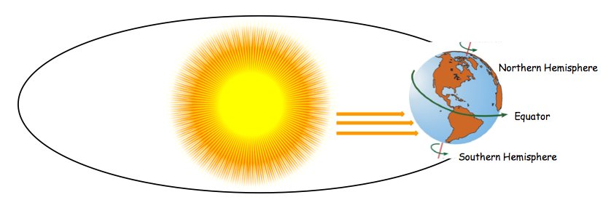
Explain what is going on in the picture below.

The sun shines directly on the ______________________ hemisphere and it shines indirectly on the _________________________ hemisphere. So this means that in the summer is going on ____________________of the equator and winter is going on ____________________ of the equator.
Multiple Choice. Circle the correct answer. Then write the letter on the line.
_______1. The sun provides this for the Earth. If not, the Earth would be a lifeless ball of ice and rock.
  - Heat
  - Energy
  - All of the above
________2. Rotation determines:
- Night and day
- A year
- A century
- A decade
________3. Where does a comet live?
- Kuiper Belt
- Oort Cloud
- Earth
- Both A and B
_______4. Where are asteroids found?
- Oort Cloud
- Earth
- Asteroid Belt
- Mars
________5. What develops a tail as it starts to melt?
- Dust
- Meteor
- Planet
- Comet
_________6. What does a meteor turn into if it hits Earth’s surface?
- Meteorite
- Meteor
- Planet
- A star

Essay
Explain the difference between rotation and revolution. You must use these key terms within your essay: Sun Seasons Earth Axis Day Night Year Revolves Rotates
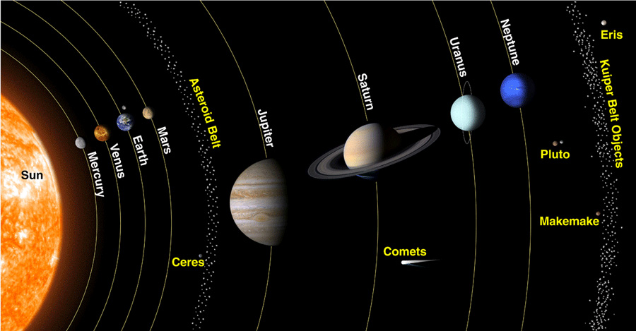
______________________________________________________________________________________________________________________________________________________________________________________________________________________________________________________________________________________________________________________________________________________________________________________________________________________________________________________________________________________________________________________________________________________________________________________________________________________________________________________________________________________________________________________________________________________________________________________________________________________________________________________________________________________________________________________________________________________________________________________________________________________________________________________________________________________________________________________________________________________________________________________________________________________________________________________________________________________________________________________________________________________________________________________________________________________________________________________________________________________________________________________________________________________________________________________________________________________________________________________________________________________________________________________________________________________________________________________________________________________________________________________________________________________________________________________________________________

10.___________________________
9.___________________________

8.___________________________

7.___________________________

6.___________________________

5.___________________________
4._____________________________
3._____________________________
2._____________________________
1._____________________________

