SCHOOL LETTERHEAD

To the Parents of <student first name> <student last name>:

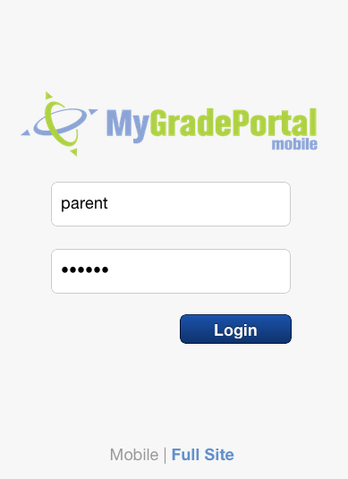Education doesn’t only happen in the classroom, but also at home and in our communities. Our district strives to give families as many opportunities as possible to support their student’s educational career. With that in mind, we are excited to introduce a new web service called the **OnCourse MyGradePortal**.  
  
This secure website allows parents to securely access their child’s attendance, homework, grades, discipline incidents, classroom websites, and teacher messages. It is simple to use, and can be accessed from any Internet-connected computer, or even your smartphone or tablet device, like and iPhones, iPads, Androids! Your student will also have an account, and can stay informed about grades and homework from their own computer or mobile device.   
  
Each family/authorized guardian will receive a secure username and password to access this system. To login, follow these steps:

**From a laptop or desktop computer:**

1. Open your web browser and visit [www.mygradeportal.com](http://www.mygradeportal.com)
2. Login with your username/password
3. Explore! If you need help, click the ***User Guide*** link in the top-left corner of the screen.

**From your smartphone or tablet:**

1. Open the device’s web browser (Safari, Chrome) and visit [**http://mobile.MyGradePortal.com**](http://mobile.MyGradePortal.com)
2. Login with your username/password
3. Tap one of **3 icons** at the bottom of the screen to view the **Welcome Screen, Teacher Messages**, or information about your **Students**, such as absences, grades, discipline, etc.

Parental involvement is a critical factor in student success, and we hope that you will take advantage of this new service to stay informed about your student’s progress throughout the year.

If you need any further help or information regarding this resource, please contact ________________ at ( ) - or email . Thank you for your continued support and involvement in your children’s education. Only with our continued cooperation can your children be successful for the future.

Sincerely,

<Superintendent of Schools>