**The pegword method**

Pegwords can be used when numbered or ordered information needs to be remembered. Pegwords are rhyming words for numbers and include the following:

|  |  |
| --- | --- |
| One is bun | six is sticks |
| two is shoe | seven is heaven |
| three is tree | eight is gate |
| four is door | nine is vine |
| five is hive | ten is hen |

Pegwords are substituted for the number to be remembered and associated with the other information. For instance, to remember that insects have six legs whereas spiders have eight legs, create a picture of insects on sticks (see Figure 2) and another picture of a spider on a gate. To remember Newton's first law of motion (objects at rest tend to remain at rest unless acted on by another force), create a picture of a bun (pegword for one) resting. To remember that a garden rake is an example of a third-class lever, create a picture of a rake leaning against a tree (pegword for three, or third).

Pegwords can also be combined with keywords. To teach that crocoite is a mineral that is number 2 on the Mohs hardness scale, create a picture of crocodiles (key-word for crocoite) wearing shoes (pegword for 2). To remember that the mineral wolframite is hardness number 4, black in color, and used in making filaments for lightbulbs, create a picture of a black wolf (keyword for wolframite), looking in a door (pegword for 4), and turning on a lightbulb. Research has shown that elaborate strategies such as this are very effective, and that color, appropriately encoded, can also be easily remembered (Scruggs, Mastropieri, Levin, & Gaffney, 1985). That is, a picture of a black wolf is much more likely to be remembered than a picture of wolframite colored black.

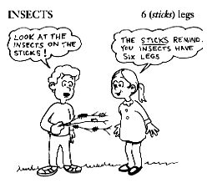

Figure 2. Mnemonic representation of insects having six legs. (Copyright 1993 by M. A. Mastropieri and T.E. Scruggs.)

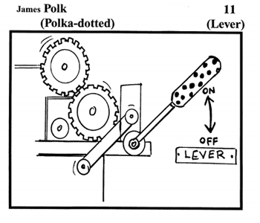

Figure 3. Mnemonic representation of Polk as the 11th U.S. president (Copyright 1993 by M.A. Mastropieri and T.E. Scruggs.)

Pegwords can also be extended beyond the number 10 (11 is lever, 12 is elf, etc.). For instance, to remember that the 19 th amendment of the U.S. Constitution guaranteed women the right to vote, create a picture of a woman dressed as a knight (19 = knighting) riding to a voting booth. To remember that James K. Polk was the 11th American president, create a picture of a polka-dotted (keyword for Polk) lever (pegword for 11) as shown in Figure 3 (Mastropieri, Scruggs, & Whedon, 1997).

Pegwords can also be extended beyond the number 19, by using, for example, twenty is twin-ty (twins), thirty is thirsty, forty is party, and fifty is "gifty," or gift-wrapped. For example, to remember the math fact, 7 x 8 = 56, create a picture and practice the pegword phrase, "Heaven's (7) gate (8) holds gifty sticks" (pegword for 56). To remember that Taft was the 27th president, create a picture of a taffy (keyword for Taft), being pulled between twin heavens (pegword for 27).

**Letter strategies**

Letter strategies, which involve using letter prompts to remember lists of things, are the most familiar to students. Most former students remember using the acronym HOMES to remember the names of the Great Lakes and FACE to remember the notes represented in the spaces of the treble clef, from bottom to top. Except for the FACE strategy, however, most acronyms assume that a name of something will be remembered when the first letter is retrieved. However, this may not always be true. For example, if a student is unfamiliar with Lake Ontario, remembering simply that the first letter is O is insufficient to prompt recall. The names of the individual lakes must be practiced until they have become familiar.

Acronyms are most helpful when the first letters of a list can be used to create an entire word; however, sometimes modifications can be made. For instance, consider the acronym FARM-B, which represents the five classes of vertebrate animals: fish, amphibian, reptile, mammal, and bird, as shown in Figure 4. The B for bird does not really fit, but it can be added to FARM and practiced until it becomes automatic.

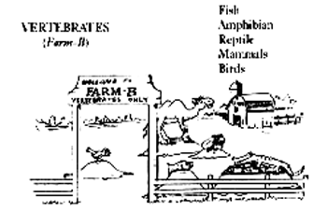

Figure 4. Mnemonic representation of the vertebrates: fish, amphibians, reptiles, mammals, and birds. (Note. From A Practical Guide for Teaching Science to Students with Special Needs in Inclusive Settings [p 158], by M. A. Mastropieri and T. E. Scruggs 1993, Austin, TX: PRO-ED.

Reprinted with permission.)

In other cases, appropriate words cannot be easily constructed from the first letters of the words to be remembered. For example, if you wished to remember the names of the planets in their order from the sun, the letters would be M-V-E-M-J-S-U-N-P, from which a word cannot be made. In these cases, an acrostic can be created, in which the first letters are reconstructed to represent the words in a sentence. In this case, the sentence could be "My very educated mother just sent us nine pizzas" (Mastropieri & Scruggs, 1994, p. 271). Again, the names of the planets must be sufficiently familiar so that students can retrieve a planet name, given only the first letter. Also, students should be sufficiently familiar with the solar system to know that the first M stands for Mercury, and not Mars.

For another example, to remember the classification taxonomy of living things, remember the sentence, "King Philip's class ordered a family of gentle spaniels." This sentence helps prompt kingdom, phylum, class, order, family, genus, and species, in order.