How To Use It:

This type of web helps to throughly summarize a topic or concept. Place the concept name in the middle and build off of it.[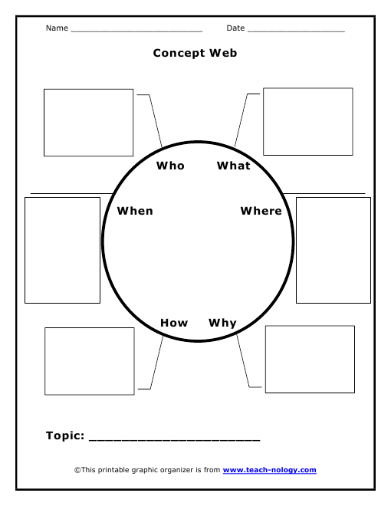](http://www.teach-nology.com/worksheets/graphic/graporg6.pdf)