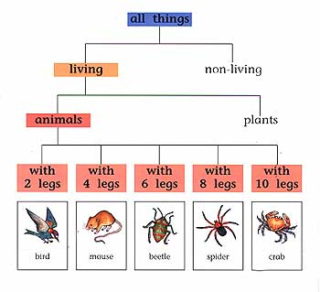

Tree diagrams are good for classification and connect ideas with a series of branches. Tree diagrams are ideal for breaking things into groups and subgroups and are especially useful for science projects, local and family history. A simpler version of the tree diagram is the wheel diagram, which has a main point at the center, with spokes coming off of it. Wheel diagrams lack a few key components of tree diagrams: categorization and ranking of those categories.

