At the top of your paper –

What does it mean to be reliable?



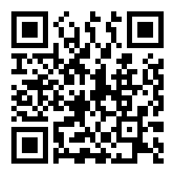

Who is this website about?

What are 2 facts found on this website?

1.

2.

What other website did you look at to determine if those facts are correct?

(IF NECESSARY) Corrected facts:

1.

2.

Is the site reliable? Yes No



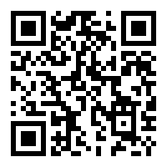



Who is this website about?

What are 2 facts found on this website?

1.

2.

What other website did you look at to determine if those facts are correct?

(IF NECESSARY) Corrected facts:

1.

2.

Is the site reliable? Yes No