**Second Step: A Violence Prevention Program**

**Grade 1: Pre/Post-test**

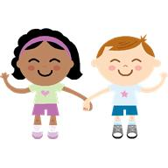

**Name_____________________________Teacher____________Date________**

1. My feelings are O.K.
2. I should keep my sad feelings to myself.
3. I can tell how my friend feels by looking at his/her face.
4. I must hit my friend when I am mad.
5. When I am mad, I can count slowly to ten to calm down.

happy apology angry

adult calm down

1. I feel ____________________when I get presents for my birthday.
2. I must make an ______________________when I hurt my friend’s feelings.
3. I must ________________________when I get angry, or I might get into trouble.
4. When someone hits me, I feel _______________________.
5. It is important to tell an ________________about my sad feelings.