Career Development: Grade 6
End-of-Course Test

Name________________________________Class_________________Date____________
Part 1: Matching. Place the number of the term on the right on the line next to its definition.
_____position for which one is employed 1. Career development
_____process of discovering our future career interests 2. Interest inventory
_____helps students identify their interests as part of the 3. career
career exploration process 4. profession
_____an occupation which demands continuous learning 5. occupation
over time 6. job
_____work related activity performed for payment
_____career requiring specialized knowledge of
academic preparation

Part 2: Order. Place in order each of the following degrees from least (1) academic training to most (4).
Bachelor’s degree______
Master’s degree_____
Associate’s degree_____
Doctoral degree_____

Part 3: Collaborative work: Careers involve working successfully with others. Study the given profiles and answer the questions that follow.

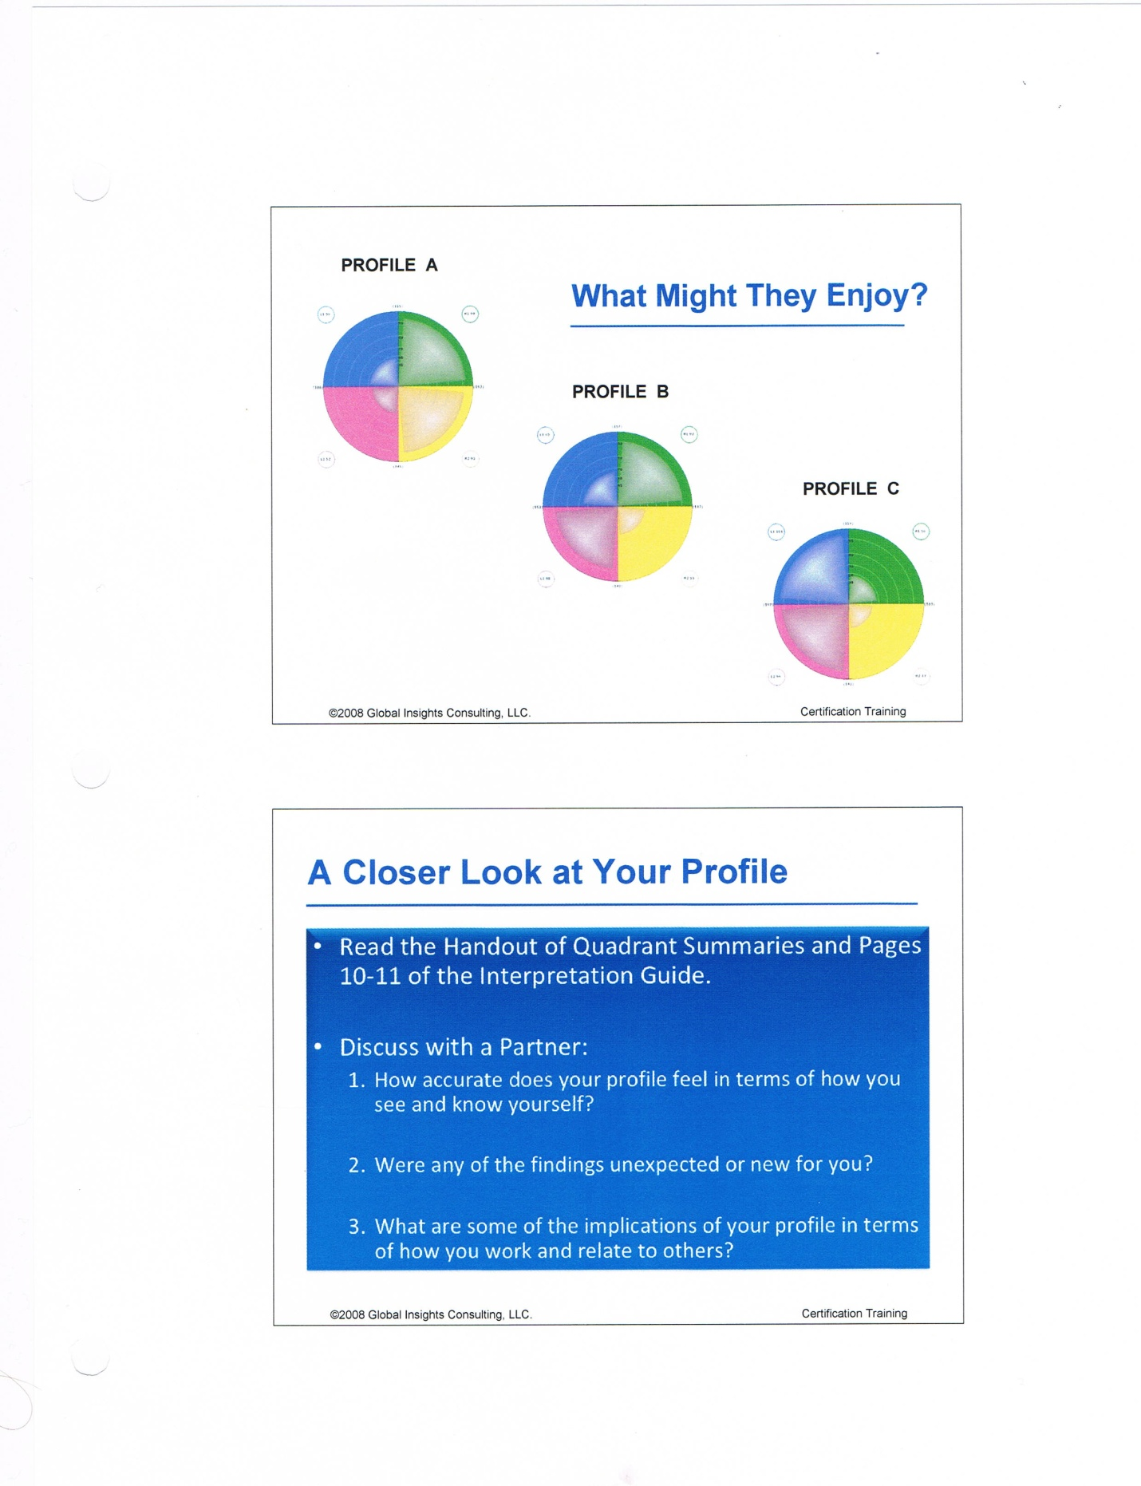
- Which of the profiles would best represent the leader of the group? Why?
________________________________________________________________________________________________________________________________________________________________________________________________________________________
- Will there be conflict in this group? If so, between which two profiles? Why?
________________________________________________________________________________________________________________________________________________________________________________________________________________________
- Which profile illustrates the one who will tend to solve conflict? Why?
__________________________________________________________________________________________________________________________________________________________________________________________________________________________________________
- In a collaborative effort, assign the tasks to each profile:
A will likely do_________________________________________________________________
B will likely do_________________________________________________________________
C will likely do_________________________________________________________________

Part 4: Open Ended Response:
Of the 16 Career Clusters explored online (Ferguson’s Career Guidance Center), which one did you find most interesting? In your response be sure to include the following and how each one influenced your career choice.
- Multiple Intelligence: Which of the nine intelligences best fit you?
- Whole Brain Creativity Assessment (NBITM): Which of the four quadrants represent your strengths?
____________________________________________________________________________________________________________________________________________________________________________________________________________________________________________________________________________________________________________________________________________________________________________________________________________________________________________________________________________________________________________________________________________________________________________________________________________________________________________________________________________________________________________________________________________________________________________________________________________________________________________________________________________________________________________________________________________________________________________________________________________________________

