
Initial Sound Assessment

Name______________________________________ Date_________________________

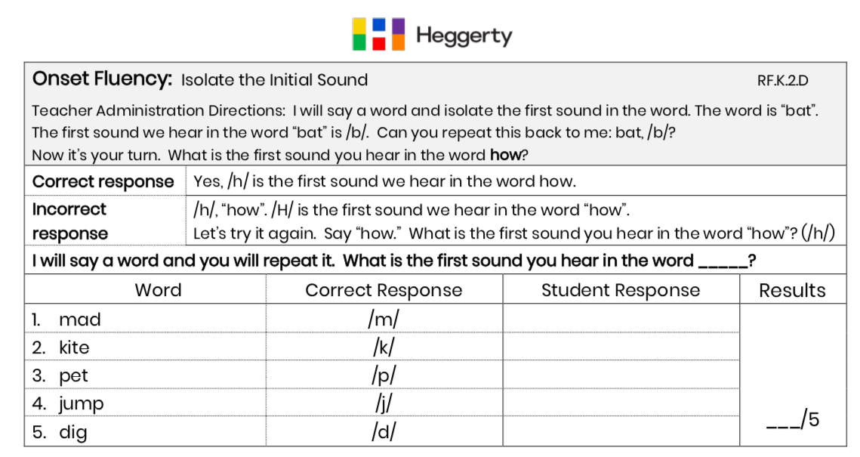

Onset Fluency Benchmarks:

Beginning: 0-2 correct

Developing: 3 correct

Proficient: 4-5 correct

