**Midyear Phoneme Segmentation Assessment**

Name____________________________________ Date______________________

**Task:** The child will listen to a word and produce each phoneme in the word separately.

**Model:** **Say**: *I am going to say a word. Then I am going to say each sound. Listen carefully for each sound. The word is* ***sat*.** *The sounds in* ***sat*** *are /s/-/a/-/t/.*

Be sure to articulate each sound separately. Do not simply stretch out the word.

**Sample: Then say**: *Listen to this word. This time you tell me the sounds in the word. Listen carefully:* ***bite****. What sounds do you hear in* ***bite****?*

Pause and wait for the child to respond. (/b/-/i/-/t/).

**Then say**: *Now listen to some more words. Tell me the sounds you hear in these words.*

Provide no additional help with the items below. Record the child’s response.

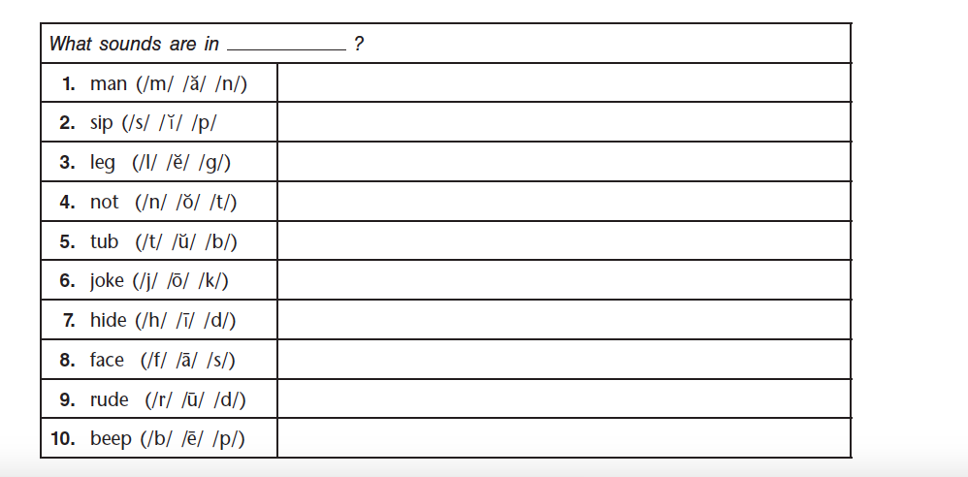

Total Score: ___________/30

**Phoneme Segmentation Benchmarks**:

**Beginning**: 0-12 correct

**Developing**: 13-23 correct

**Proficient**: 24-30 correct