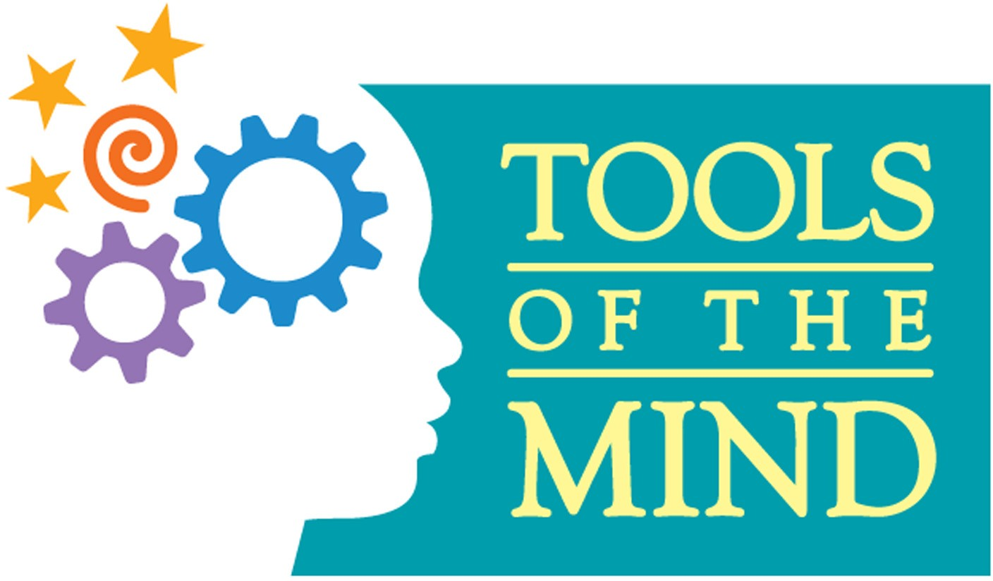

|  |  |  |  |  |  |
| --- | --- | --- | --- | --- | --- |
| **Play Theme: School** | | | | | |
| **Theme Building (Days**  **1-3)** | **Introduction to Theme: (Books/Media/Virtual Field Trips)**  **Books about School, Social/Emotional learning, Previewed YouTube videos that show roles in action, Tools eBooks** | | | **Theme Building Child Activities (prop & setting making, etc.) Props – Children can make a school bus. Children can make ID badges. Children can make a Weather Graph and Timeline calendar. Children will use learning activities materials i.e.Buddy Reading cards, Making collections materials, etc.,** | |
| **Centers** | **Roles and Role Props**  **(Tags, dress-up)** | **Scenario Framework What happens in the**  **center** | **Action Props & Role Supports** | **Story Problems – Emotional Terrain/Landscape** | **Literacy & Math Elements** |
| **Dramatic Play/**  **Cafeteria** | Cashier -cash register, money  Students – ID, lunch tray, food  Teachers/Aides –scarf, tie, dress up clothes, microphone  Cafeteria Servers – aprons, plastic gloves, tray, food  Cook – chef’s hat  Custodian – broom, mop, keys, ID, walkie talkie | Prepare food  Serve food  Use ID card to pay  Eat  Talk/Have conversations  Clean up  Recycle  Read Menu Board  Keep order (Teacher/Aide on duty)  Clean up spill or mess | Table/chairs  Trays  Empty milk cartons  Pots/Pans  Cash register  Money  Food  Dishes  Plasticware  Napkins  Menu Board (to write specials)  Trash/Sorting containers  Broom, mop  Keys Walkie talkies  Clipboards  IDs  Dress up clothes for role | Not enough food/Lunch from menu ran out  Lunch fell on the ground  Ran out of time to eat  Tables are messy and no place to sit  Burned food  Too much/Too little money | 1:1 correspondence  (count money, plates, silverware, etc)  Create a menu board  (use pictures, can change throughout)  Make signs  Sort trash  Recycle |
| **Blocks/**  **Gym** | Gym Teacher/Aides –  Teacher ID, fake whistle, headband, clipboard  Students – gym clothes  Principal/Supervisor – scarf, tie, clipboard, walkie talkie | Gym Teacher and Aide lead students in gross motor activities –  Parachute games  Beanbag games (toss)  Balance Beam activities  Circle games  Ball games – roll, catch  Numberline hopscotch  Small hoop or scooters if appropriate  Students create ramps and other structures with various blocks, can also make a balance beam or an obstacle course - can also use small pretend people to act out gross motor activities | Parachute  Bean Bags  Various blocks  Small people  Balance beam  Balls  Hoops  Scooters  Numberline hopscotch game  Walkie talkies  Clipboards  IDs  Dress up Clothes for role | Student not following directions  Student bumps knee, gets hurt  Student cuts line  Student can’t do activities i.e. can’t balance on beam  Does not recognize/identify numbers | Count steps, hops, skips  Time  Distance  Engineering (making a plan, blueprints) |
| **Science/**  **Music Room** | Music Teacher/Aides- Teacher ID, director’s stick  Students – Student ID  Principal/Supervisor – scarf, tie, clipboard, walkie talkie | Teacher uses music books, fingerplays, media, etc. to lead students in songs (singing, dancing, use of instruments, fingerplays, chants, etc)  Students participate in music activities through singing, dancing, acting out, use of instruments, sign language, etc.  Students write songs and fingerplays,etc..  Students learn Color songs, Animal songs, etc. with ASL (ex. ASL Colors Learn with Fireese)  Handbells with Color Posters (if available) | Instruments (real and student made, handbells if available)  Media (white board, CD player, phone with speaker, etc – teachers will assist students with these)  Music posters, note cards/displays  Nursery Rhyme posters or song displays  Music, Poetry, Nursery Rhyme books  Sign Language Materials  Handbells and Color posters if available  Walkie talkies  Clipboards  IDs  Dress up clothes for role | Instrument broke  Student doesn’t know how to use the instrument properly  Student doesn’t like music/can’t sing  Teacher is absent  Everybody wants the same instrument | Sort instruments  Learn to read music/musical alphabet  Counting Rhythm and Beat  Learning ASL  Rhyming through Poetry, Nursery rhymes |
| **Literacy/**  **Library** | Librarian/Aide – Teacher ID, dress up clothes, scarf, tie  Students – Student ID  Principal/Supervisor -scarf, tie, clipboard, walkie talkie | Librarian and/or Aide can read books to the students, students can also listen to books on tape, use of other media, etc.  Librarian can file/organize library cards/books  Students borrow books  Students do Buddy Reading with each other  Students can retell stories with puppets  Students can use pictures to put stories in sequential order  (Story Grammar)  Students can practice Fundations materials | Books – all types (big books, books on tape, song books, board books, picture books, etc.)  Media (white board, CD player, phone with speaker, etc – teachers will assist students with these  Puppets  Library Cards  Card Catalog  Fundations materials  Walkie talkies  Clipboards  IDs  Dress up clothes for role | Student or Librarian can’t find the books they are looking for  Student forgot to return a book  Students want the same book, prop, etc.  Student can’t remember a story for retell | Sort books, Categorize books (by author/size/topic: math, science, song books, etc.)  Buddy Reading  Story Grammar – Retell, Sequence  Write about books – (Storylab) Extensions, Favorite Part, etc.  Learning Facts  Counting books  Collections of books  Matching (card-book)  Phonemic awareness |
| **Table Toys/**  **Classroom** | Teacher/Aide – Teacher ID, dress up clothes, scarf, tie  Student – Student ID  Parent Visitor – Visitor Badge  Custodian – broom, mop, keys, ID, walkie talkie  Principal/Supervisor – scarf, tie, clipboard, walkie talkie | Teacher/Aide leads all student activities (Opening Group, Freeze Dance, Buddy Reading, Graphics Practice, Venger Drawing, SW, Storylab, Math Games, Science Eyes, etc.)  Students participate in all learning activities  Principals/Supervisors can ask questions to students about what they’re learning  Parents come in as Guest Readers  Custodian cleans up spill or mess | Materials for all Learning Activities done in this center - Timeline Calendar, Weather graph, White Board, Math games, Science Eyes, etc.  Dress up clothes for role  Pointer  Broom, mop  Keys  Walkie talkies  Clipboards  IDs  Dress up clothes for role | Student is sad  Teacher is absent  Student not listening to Teacher  Spill/mess  Guest reader doesn’t show up  Lockdown drill/Fire drill/Shelter in Place | Literacy and Math classroom activities that students can facilitate and practice with each other  (1:1 correspondence, counting, letter writing, Buddy Reading, Graphics Practice, etc.  Problem solving |
| **Art/**  **Art Room** | Art Teacher/Aide – Teacher ID, dress up clothes, scarf, tie, smock  Student – Student ID, smocks  Custodian – broom, mop, keys, ID, walkie talkie  Principal/Supervisor – scarf, tie, clipboard, walkie talkie | Art teacher leads students in art activity, drawing lesson, etc.  Aide can assist teacher or students  Students participate in art activities  Teacher/Aide/Student can plan, design, and lead art activity  Use Venger Drawing/collage  Shape Art | Paint, crayons, markers, etc.  Many kinds of paper (tissue paper, crepe paper, cardstock, etc.)  Water  Craft supplies (Pom poms, pipe cleaners, etc.)  Play dough  Model Magic  Any art supplies used in the classroom  Venger materials  Geometric shapes  Natural materials (shells, pebbles, sand, etc.)  Recycled Materials  Smocks  Easel | Paint is dried up  Mess/spill  Student wants to use different color than what’s available  Art Teacher is sick  Students arguing over materials  Students ruined someone else’s project | Colors  Books  Counting craft materials  Sorting craft materials  Various strokes  Types of textures, presentation (cubism, pointillism, etc.)  Lines/Geometry  Shapes  Venger Drawing/Collage  Collages  Colors/Mixing colors |
| **Maintenance** | Custodian – broom, mop, keys, ID  Maintenance Worker – ID, hat, clipboard, toolbelt/toolbox  Secretary – Dress up clothes, scarf, tie, phone, notepad  Principal/Supervisor – scarf, tie, clipboard, walkie talkie | Custodian writes up a work order, shows maintenance workers what needs to be fixed, can assist maintenance workers  Maintenance Worker – uses work order to make a plan, uses tools to fix broken furniture, leaky pipe, build addition, etc., paint the school, fix the school bus  Secretary - answers phone calls and makes appointments for the Maintenance Workers  Principal/Supervisor can inspect the job | Various Blocks  Various Tools  Smock/Work apron  Telephone  Clipboard  Hats  Rulers, Tape Measures  Paint Brushes  Timer | Maintenance Workers get called back because the pipe broke again  Too many work orders for one day/Job won’t get finished on time  Too many calls come in at one time  2 or 3 Maintenance workers want to do the same job at the same time  Teachers or others complain that the job wasn’t done correctly  Maintenance workers get sick  Custodian wrote an incorrect work order | Measuring  Engineering/Making a Plan  Recognizing numerals (on the telephone, on measuring tools, etc.)  Writing/Drawing a Work Order  Counting  Concept of Time  Colors/Mixing Colors  Problem Solving |
| **Office** | Secretary – Dress up clothes, scarf, tie, ID  Principal – scarf, tie, clipboard, walkie talkie, ID  Custodian – broom, mop, keys, ID  Aide – clipboard, tiger tickets/cub coupons (PBSIS), late slips, ID  Teacher – ID, scarf, tie  Student – Student ID  Parent – scarf, tie, Visitor Badge | Secretary – answers the phone and makes appointments for the teacher (guest readers, special events, meeting) and principal (special events, meeting), organizes schedules, makes announcements, works on computer making schedules, makes copies  Principal – makes announcements, works on computer making schedules, has meetings with teachers and parents  Custodian – writes work orders, cleans, assists with deliveries  Aide – gives students birthday crown and pencil, gives out PBSIS tickets when student comes to office, makes announcements, checks mailboxes, makes copies | Clipboard  Telephone  Computer  Intercom  Desk  Microphone/PA system  Walkie Talkies  Mailboxes  Copier  Sign In Book  Staff ID  Student ID  Visitor Badge  Walkie talkies  Broom  Mop  Boxes for deliveries  PBSIS tickets  Birthday Crowns  Stickers  Pencils  Late Passes | Student comes in late  A visitor comes to the office with no ID  Copier is broken  Secretary is absent  Student is upset that office forgot to announce his/her birthday  Many calls coming in at one time | Writing passes, PBSIS tickets, birthday crowns  Numeral recognition and matching  Sorting  Organizing  Counting  Calendar/Date  Time  Problem Solving |

|  |  |  |
| --- | --- | --- |
| **Centers** | **Simple Scenarios & Scripts** | **Vocabulary** |
| **Dramatic Play/Cafeteria** | “What would you like to eat?”  “What is on the menu for today?”  “What kind of fruit would you like?”  “What kind of vegetable would you like?”  “Do you have your ID?”  “Can you scan your ID?”  “What culture are we celebrating today?”  **Scenario & Script Evolution: What can happen next?** | Names of various fruits and vegetables  Cashier  Food line  Skim milk/1% milk/strawberry/ chocolate milk  Cafeteria server  Names of various foods representing all cultures |
| **Blocks/**  **Gym** | “What can we walk on?” “Which way can we go?”  “Who can race faster?”  “It’s your turn.” “It’s my turn.”  “Do you want to play with me?”  “How do you play this game?”  “How is your heart rate?”  “Which ramp will make the ball go faster?”  “Can you skip with me?” (run, jump, hop, gallop, etc.)  “Follow the Leader.”  “Simon says…”  **Scenario & Script Evolution: What can happen next?** | Pace  Hula hoop  Score  Relay  Obstacle  Heart rate  Ramp  Skip/gallop/jump/hop  Left/Right  Body parts |
| **Science/**  **Music** | “How do you take care of the instruments?”  “Let’s play together and make music.”  “Is this instrument broken?”  “What is this instrument called?”  “Can you sing/play softer? Louder?”  “How do you sign the colors of the rainbow?” “Can we sing ‘Colors with Fireese’ and practice our sign language?”  Can you match the color of the bell with the color on the poster?” “Which music note is red?”  “Let’s keep the beat of the music with our instruments.”  **Scenario & Script Evolution: What can happen next?** | String instruments  keyboard  guitar  drum  chimes  rhythm  beat  handbells  sign language (ASL)  volume  staff  notes  music alphabet |
| **Literacy/**  **Library** | “How did you organize these books?”  “What is your favorite part of the story you just read?”  “Who has the lips?” “Who has the ears?”  “Can you put these pictures in the correct sequence?”  “What happened first?” “What happened next?” What happened last?”  “How many books are in this bin?”  “Write about it” (alternate ending, sentence pattern i.e. “I see…”, etc.)  “Write/draw what you learned from that book.”  “Can you act out that story?”  “What are the important words?”  “Who wrote the book?” “Who drew the pictures?”  **Scenario & Script Evolution: What can happen next?** | Beginning  Middle  End  Author  Illustrator  Sequence  Alternate  Pattern  Main Character  Character  Setting  Plot  Story Problem |
| **Table Toys/**  **Classroom** | “Which learning activity are you going to work on today?”  “What shape is that?”  “Do you see a pattern?”  “Which mediators do you need?”  “What is the main idea?” “Who is the main character?”  “Talk it out with your partner.”  “Share your ideas.”  “What can you say to your friend if he/she made a mess?”  “How can I help you?”  “Which has more?” “Which has less?”  (You can ask various questions about the learning activities that the students choose to use.)  **Scenario & Script Evolution: What can happen next?** | Character  More  Less  Equal  Emotion words i..e. sad, happy, frustrated, annoyed, confused, ashamed, etc.  Shape words i.e. square, rhombus, triangle, hexagon, etc  Pattern  Mediator  Partner |
| **Art** | “Tell me about your project.”  “I am impressed with your color choice. Tell me about your picture.”  “What two colors make orange?” etc.  “How does the paint feel on your hands?”  “What else can you use to color your drawing?”  “What can you say to your friend who thinks his/her picture is ugly?”  “What materials can you use to create your ________?”  **Scenario & Script Evolution: What can happen next?** | Color words  Descriptive words i.e. cold, gooey, squishy, soft, rough, smooth, sharp, hard, etc.  Medium (in relation to art – the materials that are used - A **medium** refers to the materials that are used to create a work of **art**. The plural of **medium** is media. Some of the most common media are oil paints (paints that use oil to hold pigments together), tempera (pigments held together with egg yolk), marble (soft, white stone), and bronze (a metal used to cast sculptures).  Sculpture  Create  Imagination  Portrait  Collage  Texture  Stroke (painting)  Empathy – “I understand how you feel, maybe you can try again during free choice.” “I understand you think it’s ugly but I love the colors you chose.” |
| **Maintenance** | “Can you fix the copy machine?”  “The toilet is overflowing.”  “The school bus has a flat tire. What can you use to/How can you fix that?”  “The heat needs to be fixed in the library.”  “The intercom/PA isn’t working.”  “We need to build a new school. Can you draw a design for that?”  “Is that shelf level?”  **Scenario & Script Evolution: What can happen next?** | Level  Design  Build  Engineer  Architect  Maintenance  Custodian  Tool box and names of tools |
| **Office** | “The mail needs to be sorted.”  “You forgot to announce the birthdays.”  “Can you make some more late passes?”  “This group of students earned a PBSIS ticket for helping others.”  “Let’s plan an activity to celebrate an upcoming event/guest readers.”  “The student came in late and is upset.”  **Scenario & Script Evolution: What can happen next?** | Intercom  Secretary  Principal  Aide  Visitor  Earn  Sort |

