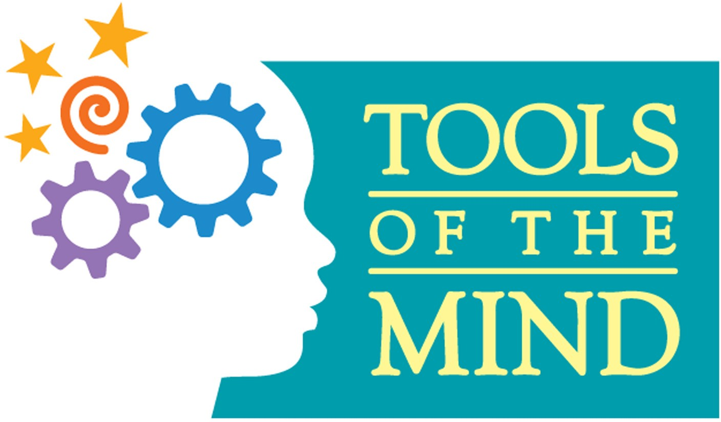

|  |  |  |  |  |  |
| --- | --- | --- | --- | --- | --- |
| **Play Theme: Community** | | | | | |
| **Theme Building (Days**  **1-3)** | **Introduction to Theme: (Books/Media/Virtual Field Trips)**  **Walk to firehouse Visit post office**  **Visit police station Read books about fire station, salon, police**  **station**  **Have police officer/fire fighter visit the classroom** | | | **Theme Building Child Activities (prop & setting making, etc.)**  **Firetruck, fire hose, blue prints, tools, hair dryers, hair sink, badges, mailbox, popcorn, tickets, movie screen** | |
| **Centers** | **Roles and Role Props**  **(Tags, dress-up)** | **Scenario Framework What happens in the**  **center** | **Action Props & Role Supports** | **Story Problems – Emotional Terrain/Landscape** | **Literacy & Math Elements** |
| **Dramatic Play/Fire Station** | Firefighter,/uniform, badge  Citizen/dress up clothes  dispatcher/headphone, uniform | Use the hose to put out fire.  Use walkie talkies to communicate.  Call for help. | Hose, fire extinguisher, trucks, pretend fire | What do you do when there is a fire.  Can’t put out the fire.  The hose isn’t long enough to reach the fire.  Can’t find the citizen.  Truck broke down. | Address  Firefighter books  Measure hose length  Count building levels  Escape plan |
| **Blocks/**  **Construction** | Construction worker, plumber, /tool belt, hard hat, vest, safety glasses  Driver/ keys  Foreman/tie, clipboard  Architect/tie, brief cases | Build structures  Materials delivered  Fix pipes  Drive construction trucks  Draw building plans | Tools  Tool belts  Cones  Trucks  Blocks  Pipes  Architect paper | What material should we use to build.  Where does this material belong.  The pipe is leaking  Someone is hurt onsite  Wrong material came in | Measure  Write a building plan  Count blocks  Sort blocks/tools  Put blocks in size order  Safety signs  Construction books |
| **Science/**  **Salon** | Hairdresser/barber-smock  Makeup artist- makeup belt  Customer- dress up clothes | Hair  Makeup  Make appointment  Dry/wash hair  Nails  Shave | Blow dryer  Pretend makeup  Nail polish  Shaving tools  Brush  Comb  Rollers  Hair ties  Mirror | Fix hair  Get makeup done  Water in the sink it to hot  Customer doesn’t like hair  Nail polish needs to be changed  Beard needs to be shaved | Books  Length of hair to be cut  Sort mustache shapes  Count rollers  Write appointments  Sort hair ties |
| **Literacy/**  **Post office** | Mail carrier- mail bag, uniform  Resident-dress up clothes  Postal worker- uniform | Deliver the mail  Sort the mail  Make/write letters  Make stamps  Sell stamps  Packages | Letter  Envelopes  Mailbox  Mailbags  Letter sorter  Stamps  Mail truck | Mail went to wrong house  Incorrect address  Can’t read address on envelope  Inclement weather to deliver mail  Mailbox is full  Letter doesn’t have a stamp | Sort mail  Write letters  Learn address  Count stamps  Make stamps  Post office books |
| **Table Toys/**  **Police station** | Police officer/uniform, badge  Citizen/dress up clothes  Dispatcher/uniform, walkie talkie | Write tickets  Enforce safety  Call for help  Talk on walkie talkies  Make finger prints | Walkie talkie  Badges  Tickets  Safety signs  Finger prints  Phone | Someone is parked in the wrong spot.  People are doing unsafe things  Citizens need help.  Called the police and waiting for them to come.  Citizen was going to fast.  Car accident | Write tickets  Use phone to learn numbers (911)  1:1 correspondence for finger prints  Write and draw safety signs |
| **Art/Movies** | Usher-vest/flashlight  Concession worker/uniform  Family members/patrons  : dress up clothes | View movie  Buy movie tickets  Buy snacks  Sell tickets  Set up film | Tickets  Snacks/snack stand  Money  Screen  Seats | Movie is not showing  Volume is to low/high  Out of snacks at the stand  Movie is sold out  Too cold in the movie theater | Count tickets/money  Write and draw movie posters  Count snacks  Write movie titles |

|  |  |  |
| --- | --- | --- |
| **Centers** | **Simple Scenarios & Scripts** | **Vocabulary** |
| **Dramatic Play/**  **Fire**  **station** | Firefighter can’t put out the fire.   * “Where is the fire.” * “Let’s get the hoses.” * “Do you need help.”   **Scenario & Script Evolution: What can happen next?** | Fire fighter  Fire extinguisher  Hose  Dispatcher  Burn  Ladder  Chief |
| **Blocks/**  **Construction site** | The building needs to be repaired.   * “Let’s get our tools.” * “Where does the material belong.” * “Make sure you are wearing your hardhat.”   **Scenario & Script Evolution: What can happen next?** | Hardhat  Construction  Leak  Saw  Hammer  Nails  Toolbelt  Pipes  Architect  Hazard |
| **Science/**  **Salon** | I don’t like the way my hair looks.   * “What do you want me to do with your hair?” * “How much hair do you want cut off?” * “Do you need to shave?”   **Scenario & Script Evolution: What can happen next?** | Blow dryer  Blush  Eye shadow  Lipstick  Nail polish  Razor  Mustache  Length  Thick/thin |
| **Literacy/**  **Post office** | Where do we deliver the mail to.   * “Can you read this?” * “Let’s deliver the mail.” * “The mailbox is full.”   **Scenario & Script Evolution: What can happen next?** | Postal  Deliver  Envelope  Mail carrier  Stamp  Address  Location  City  State  Street |
| **Table Toys/**  **Police** | Someone is breaking the law.   * “The people need help.” * “What number do we dial to call the police?” * “Write a ticket for that car.”   **Scenario & Script Evolution: What can happen next?** | Law  Ticket  Safety  Citizen  Enforce  Speeding  Accident |
| **Art/movies** | Movie is not working correctly.   * “What movie is playing today?” * “Let’s go get a snack.” * “How much are the tickets?”   **Scenario & Script Evolution: What can happen next?** | Tickets  Usher  Film  Volume  Screen  Audience  Concession  Isle |

