Name: ___________________________ Algebra I
Class Color: ___________ Date: _____________ MP3 Assessment

Solve the following equations:

- 4(3x – 1) + 13 = 5x + 2

- 7(2 + x) = 5(x + 6)

Solve the following inequalities and draw the number line to match your answer:

- 4x + 8 ≤ - 48

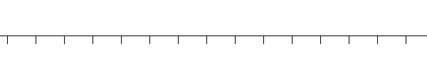

- 2(x – 2) > 3(x + 4)

Solve for the given variable:

- Solve for x.

- Find the slope of the line that passes through the points (-5, 4) and (6, -3)

- Put the following in slope-intercept form and then find the slope and the y-intercept.

-2x + y – 8 = 0 Slope: _____________

y-intercept: __________

- Find the slope and the y-intercept given the following the table:
Slope: ______________

y – intercept: _________
x | y
-4 | 8
-2 | 6
0 | 4
2 | 2

- Find f(-3) if f(x) = 3x + 5

- Simplify: (3x²y⁵)(7x³y⁴)

- Simplify: 9x³y⁵
3x²y

- Simplify: (3x⁵y³z²)³

- Simplify: 3⁻²

- (5x³ + 4x² – 8x) + (3x³ – 10x² + 3x)

- -2a²b(4a³b² – 3a²b²)

- Multiply: 3x(2x² + 3x – 4)

- Multiply: (3x – 5)(6x + 8)

- Multiply: (2x + 3y)(2x – 3y)

- Factor Completely: x² – 2x – 15
a. (x + 3)(x – 5) b. (x + 3)(x + 5) c. (x – 3)(x – 5) d. (x + 2)(x – 7)

- Which inequality represents the shaded portion of the graph?
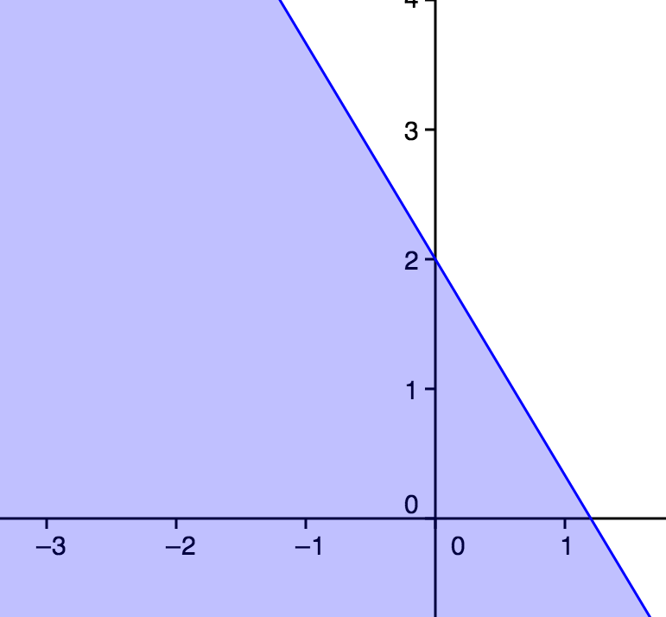
- 6y < -5x + 1
- y <$−\frac{5}{3}$x + 2
- y <x + 2
- 3y < -5x + 6
- y <$\frac{5}{3}$x + 1
- Write an equation that represents a line parallel to the line y = -5x + 1

- Graph the following line and be sure to show at least 2 points on that line.
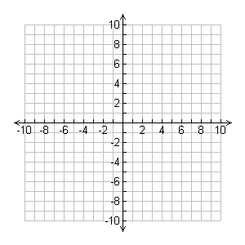

- Solve the system of linear equations by graphing: y = 4x – 1
y = 3x - 2
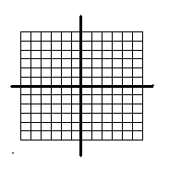

- Which equation represents a line that intersects at exactly one point?

- Which description best compares the graphs given by the equations 6x – y = -3 and x – 6y = 42

- parallel
- coinciding
- perpendicular
- intersecting but not perpendicular

- Determine which point is a solution to the linear inequality, -2x + 4y > 16

- (2, 3) c. (0, 4) e. (4, 0)
- (-6, 2) d. (10, 8)

- Which equation represents a line parallel to the y axis?

- y = 3x+2
- y = -5x – 1
- y = 4
- x = -4
- x = 0

- Evaluate -2x²+12 when x = -3

- 0
- 6
- 30
- -30
- -6

Part III Open Ended

Julie has $800 in her bank account. She wants to have at least $500 in her account in the next 3
months. She spends $45 per week for gas, food, and other items.

- Write an inequality to represent her situation.

- How many full weeks can she go before she goes below $500 in her account?

- If she were not make another deposit into this account and she were to continue with her current expenses, how many full weeks does she have before her account is depleted?

Standards:

- HSA-CED.A.1, A.3, HSA-REI.B.3
- HSA-CED.A.1, A.3, HSA-REI.B.3
- HSA-CED.A.1, A.3, HSA-REI.B.3
- HSA-CED.A.2, A.4, HSA-REI.B.3
- HSA-CED.A.2, A.4, HSA-REI.B.3
- HSA-CED.A.4
- HSA-CED.A.1, A.3, HAS-REI.B.3
- HSA-CED.A.2, HAS-REI.D.10
- HSA-CED.A.2, A.4, HAS-REI.D.10
- HSA-CED.A.2, HSA-REI.D.10,HSF-IF.C.9
- HSF-IF.A.1, A.2, HSF-IF.B.4
- HSA-SSE.A.1, A.2, B.3
- HSA-SSE.A.1, A.2, B.3
- HSA-SSE.A.1, A.2, B.3
- HSA-SSE.A.1, A.2, B.3
- HSA-APR.A.1
- HSA-APR.A.1
- HSA-APR.A.1
- HSA-APR.A.1
- HSA-SSE.B.3a
- HSA-SSE.B.3a
- HSA-SSE.B.3a
- HSA-SSE.B.3a
- HSA-REI.D.10, HSA-CED.A.2, HSF-IF.B.4, B.6
- HSA-REI.D.11, HSA-CED.A.2, A.3, HSF-IF.B.4, B.6

OE
HSA-REI.A.1, HSA-CED.A.1, A.3, HSA-REI.B.3

