Name: _________________ Algebra 1 Date: __________Pd: _____ MP2 Exam

Multiple Choice:

1. What is the solution of -2(3x – 4) = -2x + 2 ?

a.  b.  c. 2 d. 24

1. Evaluate -2x2 + 12 when x = -3
2. 0 b. 6 c. 30 d. -30 e. -6
3. The cost to manufacture *x* pairs of sunglasses can be represented by a function, *C(x)*

If it costs $398 to manufacture 4 pairs of sunglasses, which of the following is true?

Select the correct equation.

1. C(4) = 99.50
2. C(398) = 4
3. C(4) = 398
4. C(99.50) = 1
5. A local theater sells admission tickets for $9.00 on Thursday nights. At capacity, the theater holds 100 customers. The function *M(n)* = 9n represents the amount of money the theater takes in on Thursday nights, where *n* is the number of customers. What is the **domain** of *M(n)* in this context?
6. All whole numbers
7. All non-negative rational numbers
8. All non-negative integers that are multiples of 9
9. All non-negative integers less than or equal to 100

5. The formula for finding the perimeter, ***P***, of a rectangle with length ***l*** and width ***w*** is given:

Solve for the length, ***l***

P = 2l + 2w

1.  b. 

c.  d. 

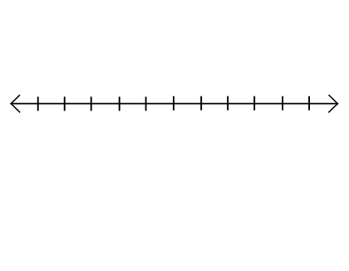**Short Constructed Response**

6. Solve for ***x*** then **graph** the solution:



 7. Solve and graph: 

Is this a conjunction or a disjunction? __________________________

Write the solution in interval notation: __________________________

8. Write the inequality for the graph below.

Inequality: ______________________________

Is this a conjunction or a disjunction? __________________________

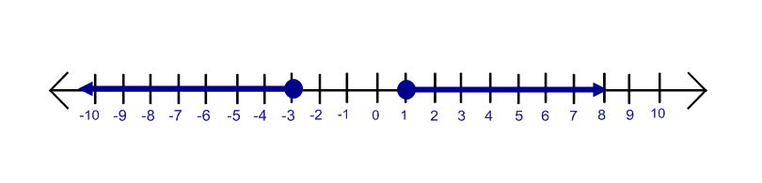

9. Solve the algebraic proportion for the given variable:



10. The Triangle Inequality Theorem states that the sum of the lengths of any two sides of a triangle is greater than the third side. If a triangle has side lengths of 15 cm and 21 cm, what are possible lengths of the third side?

What is the upper limit? __________________

What is the lower limit? __________________

Write the inequality ___________________

Write the interval notation _________________

Write the set notation ___________________

11. Solve the following absolute value:



12. Solve the absolute value equation and check your solutions for erroneous answers.



13. Find the inverse of the equation: y = -4x – 8

14. Given the function f(x) = 4 – 2x, find f(3r – 1)

15. Solve the following inequality:



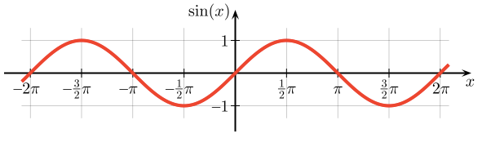

16. Is this graph, ***y = sin(x)*,** a function?

Explain your reasoning.

Domain: ___________

Range: ____________

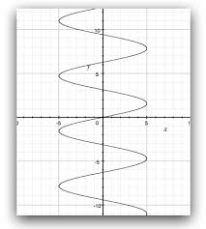17. Is this graph, ***x = 5sin(y)***, a function?

Explain your reasoning.

Domain: ___________

Range: ____________

Extended Constructed Response:

18. Julie has $800 in her bank account. She wants to have at least $500 in her account in

the next 3 months. She spends $45 per week for gas, food, and other items.

* Write an inequality to represent her situation.
* How many full weeks can she go before she goes below $500 in her account?
* If she were not make another deposit into this account and she were to continue with her current expenses, how many full weeks does she have before her account is depleted?

19. Sheila is taking medicine to help fight an infection. The function f(x) = 12(0.82)x models the amount of a 12-mg dose of antibiotic left in her bloodstream after *x* hours.

a. What does f(5) represent? Explain your reasoning.

b. How many mg are left in her bloodstream after 2 hours? Express your answer as a decimal rounded to the nearest hundredth.

c. How many mg are left in her bloodstream after 30 minutes? Express your answer as a decimal rounded to the nearest hundredth.

20. Tell how many solutions for the following situations:



1. Where c > 0
2. Where c = 0
3. Where c < 0

NJ Student Learning Standards:

**MA.9-12.A-CED.A.1** - [Standard] - Create equations and inequalities in one variable and use them to solve problems.

**MA.9-12.A- CED.A.2** - [Standard] - Create equations in two or more variables to represent relationships between quantities; graph equations on coordinate axes with labels and scales.

**MA.9-12.A -CED.A.4** - [Standard] - Rearrange formulas to highlight a quantity of interest, using the same reasoning as in solving equations.

**MA.9-12. A-SSE.A.1a** - Interpret parts of an expression, such as terms, factors, and coefficients.

**MA.9-12.A-SSE.A.1b** - Interpret complicated expressions by viewing one or more of their parts as a single entity.

**MA.9-12.A-REI.A.1** - [Standard] - Explain each step in solving a simple equation as following from the equality of numbers asserted at the previous step, starting from the assumption that the original equation has a solution. Construct a viable argument to justify a solution method.

**MA.9-12.A-REI.B.3** - [Standard] - Solve linear equations and inequalities in one variable, including equations with coefficients represented by letters.

**MA.9-12.F-IF.B.4** - [Standard] - For a function that models a relationship between two quantities, interpret key features of graphs and tables in terms of the quantities, and sketch graphs showing key features given a verbal description of the relationship.

**MA.9-12.F-LE.A.1b** - Recognize situations in which one quantity changes at a constant rate per unit interval relative to another.

**MA.9-12.F-LE.A.2** - [Standard] - Construct linear and exponential functions, including arithmetic and geometric sequences, given a graph, a description of a relationship, or two input-output pairs (include reading these from a table).

**MA.9-12.F-IF.B.6** - [Standard] - Calculate and interpret the average rate of change of a function (presented symbolically or as a table) over a specified interval. Estimate the rate of change from a graph.

**MA.9-12.F-IF.C.7** - [Standard] - Graph functions expressed symbolically and show key features of the graph, by hand in simple cases and using technology for more complicated cases.

**MA.9-12.N-Q.A.2** - [Standard] - Define appropriate quantities for the purpose of descriptive modeling.