Name _______________________________ Period_____________

Programming in Python – MPA4

_______ 1. What color would be defined by (0, 0, 0)?

a. black

b. white

c. grey

d. red

_______ 2. The technique used to illustrate movement by displaying successive images is called?

a. program

b. pygame

c. animation

d. streaming

_______ 3. What is a group of statements that exists within a program for the purpose of performing a specific task?

a. function

b. subtask

c. recursion

d. subprogram

_______ 4. The coordinates (0, 0) is also called, the screens _________.

a. basis

b. origin

c. center point

d. axis

_______ 5. What function allows us to resize a crab object on the screen?

a. pygame.transform.flip(mouse)

b. pygame.transform.spin(mouse)

c. pygame.transform.scale(mouse)

d. pygame.transform.rotate(mouse)

_______ 6. A bounding box of an object is made up of the objects _______________.

a. width and height

b. x and y

c. x_change and y_change

d. radius

_______ 7. Where will the center of this ellipse be?

pygame.draw.ellipse(screen, BLACK, [1, 1, 5, 5], 1)

a. (3, 3)

b. (2, 2)

c. (1, 1)

d. (1, 3)

_______ 8. A method of surface which creates a rectangular object in the dimensions of itself.

a. getwrecked()

b. get_rect()

c. rect_ get()

d. get_rectangle()

_______ 9. Each individual image of an animation is sometimes called a _____________.

a. transparency

b. gel

c. cel

d. cartoon

_______ 10. What is the most common type of file used when playing music?

a. .wav

b. .mp3

c. .mid

d. all of the above

_______ 11. This is the event from pygame triggered when the user moves the mouse?

a. MOUSEMOVE

b. MOUSEMOTION

c. MOUSEX, MOUSEY

d. MOUSEHOVER

_______ 12. What will happen if you change the 20 to 30, in this code? clock.tick(20)

a. game will go faster

b. game will go slower

c. the number is too small to tell the difference

d. clock starts at 30 instead of 20

_______ 13. This event is generated when the user closes the window.

a. END

b. CLOSE

c. QUIT

d. DELETE

_______ 14. When something is triggered in a pygame code, it is called this?

a. occurrence

b. module

c. import

d. event

_______ 15. A timers event is called a

a. tick

b. tock

c. tac

d. millisecond

_______ 16. To hide the mouse from being displayed from the screen during runtime of a program use ____.

a. pygame.mouse.delete()

b. pygame.mouse.remove ()

c. pygame.mouse.set_visible()

d. pygame.mouse.clear()

_______ 17. Each location in multiple image picture is commonly called a(n) _______________.

a. rect

b. frame

c. pos

d. pixel

_______ 18. Everytime through the game loop is called an ______________

a. iteration

b. annotation

c. concatenation

d. round

_______ 19. What is a library?

a. a py file

b. any code that has not been written by the developer

c. a collection of functions and/or classes that can be implemented into a project.

d. a part of a program that the users can interface with during run time.

_______ 20. If the screen width and height are both 400 pixels, and a rectangle is drawn starting

at (400, 200), where will it display?

a. top left

b. middle left

c. middle right

d. It won’t display

_______ 21. In computer graphics, as x coordinate decreases and y coordinates decreases in value, a point will move:

a. up and to the left

b. down and to the right

c. up and to the right

d. down and to the left

_______ 22. What color would be defined by (0, 255, 0)?

a. red

b. blue

c. green

d. black

_______ 23. FPS stands for

a. frames per second

b. flips per second

c. fast paced sprites

d. frames per sprites

_______ 24. In a bouncing rectangle program, if rect_change_x is negative and rect_change_y is positive, which way will the rectangle travel?

a. up and right

b. up

c. down

d. down and left

_______ 25. This in the unit of measure when moving an image on the screen?

a. inch

b. render

c. tweener

d. pixel

_______ 26. This loads the pygame module into the current program.

a. input

b. quit

c. import

d. init

_______ 27. This draws content of one Surface object onto another Surface object

a. blit

b. draw

c. create

d. .put()

_______ 28. When code detects the intersections of two or more objects, it is called?

a. collision

b. bounding

c. impact

d. fender bender

_______29. This is the event that is triggered when the any key on the keyboard is released.

a. K_UP

b. KEYUP

c. K_DOWN

d. KEYDOWN

_______ 30. The function header begins with the keyword _______________ followed by the name of the function.

a. funct

b. dim

c. return

d. def

_______ 31. This is a series of images combined into a larger image

a. image diagram

b. image matrix

c. bitmap

d. sprite sheet

_______ 32. To _______ a function, you write the name of the function with any values it will need in parentheses.

a. call

b. define

c. assign

d. import.

_______33. If a box is drawn starting at (x,y) coordinate (0,0), where will it be on the screen?

a. center

b. upper left

c. lower left

d. lower right

_______ 34. The approach called __________________ is taking a large task and dividing it into several smaller tasks that are easily performed.

a. top-scale

b. hierarchy development

c. code and retrieve

d. divide and conquer

_______ 35. Which of the following codes will get the current mouse position and returns the position as a list of two numbers

a. pos = pygame.mouse.get_pos()

b. pos = pygame.mouse.get_loc()

c. pos = pygame.mouse.get_location()

d. pos = pygame.mouse.get_position()

_______ 36. What is a benefit of creating a library?

a. it makes the code smaller

b. libraries are something to be avoided by developers

c. it makes the code run faster.

d. it provides an easy way for developers to share code between projects and other developers.

_______ 37. To quick change the direction that a sprite is facing, you would use _____________

a. pygame.display.flip()

b. pygame.transform.flip()

c. pygame.flip()

d. pygame.image.flip()

_______ 38. In pygame the acceptable image file type(s) is/are _____________________

a. .jpg

b. .bmp

c. .png

d. all are acceptable

_______ 39. Mouse event 2 represents what action?

a. right button

b. left button

c. scroll wheel moved up

d. scroll button

_______ 40. The get_rect functions retrieves how many values?

a. 1

b. 2

c. 3

d. 4

_______ 41. This is commonly used to clear the screen.

a. screen.fill()

b. screen.init()

c. screen.quit()

d. screen.clear()

_______ 42. What color would be defined by (200, 200, 200)

a. black

b. dark gray

c. white

d. light gray

_______ 43. What sequence is commonly used when breaking up an sprite image for animation

a. string

b. tuple

c. list

d. dictionary

_______ 44. The _______________ function is used when checking to see if the mouse pointer is within the bounds of an image.

a. getpospostion()

b. collidepoint()

c. colliderect()

d. xyposition()

_______ 45. When creating a text object, this must be created before you can display it on the screen.

a. render

b. blit

c. print

d. random

_______ 46. A coding system using the digits 0 and 1 to represent a letter, digit, or other character in a computer or other electronic device.

a. binary

b. assembly

c. unicode

d. english

Part Two: Welcome to Code Country

47. What is the frame size for the Owens sprite below, if the image is 480 x 200? ______________________

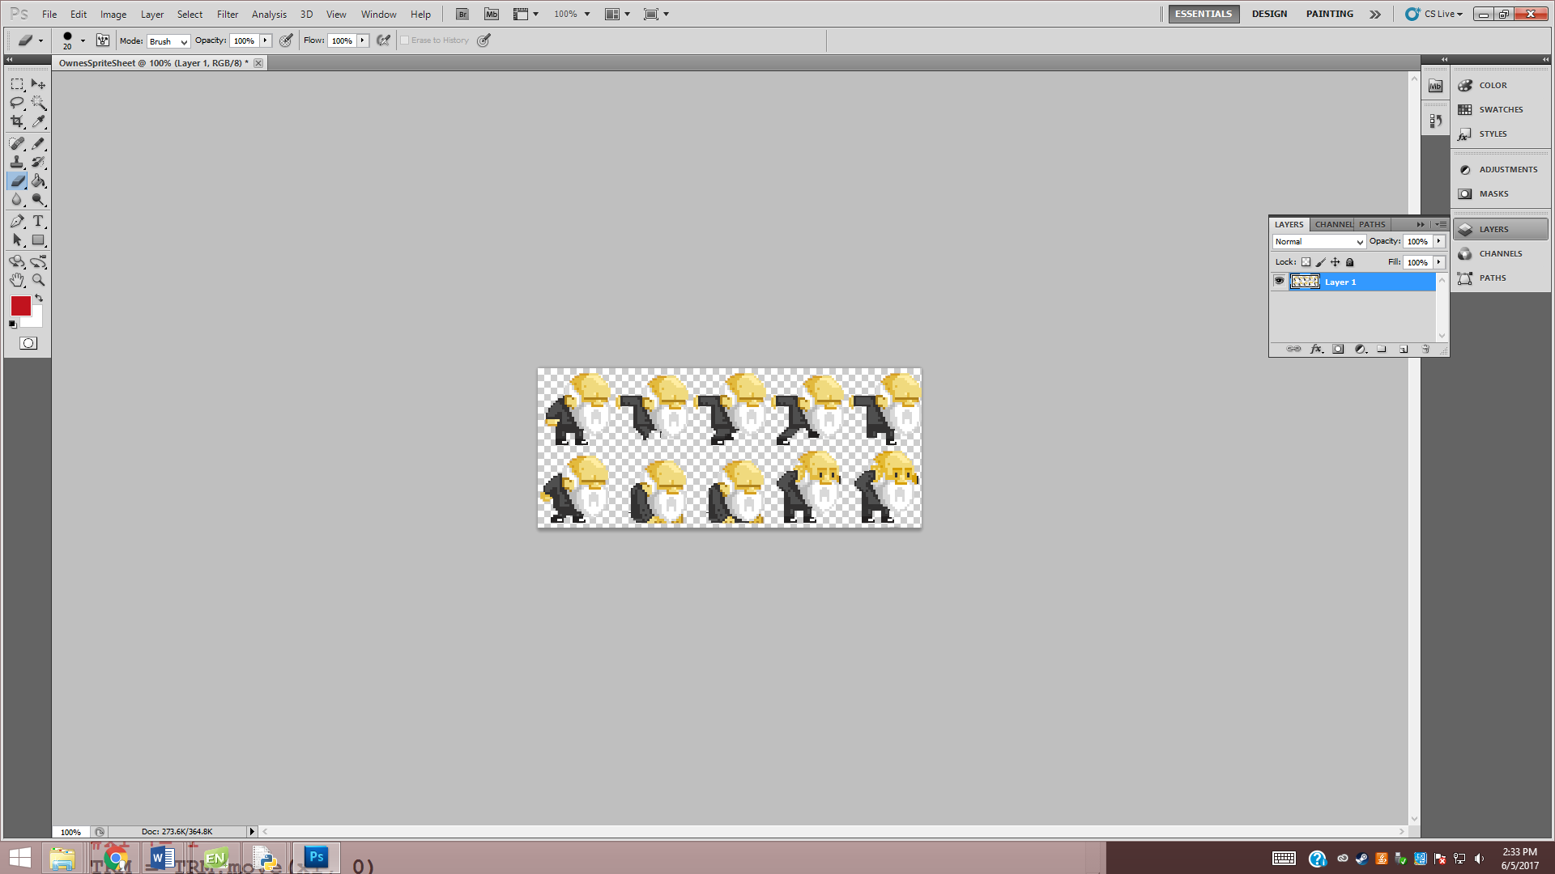

48. What is the size of the scissors image below if the frame size is 50 x 50? _______________________

49. framecount = (framecount + 1) % ________________________

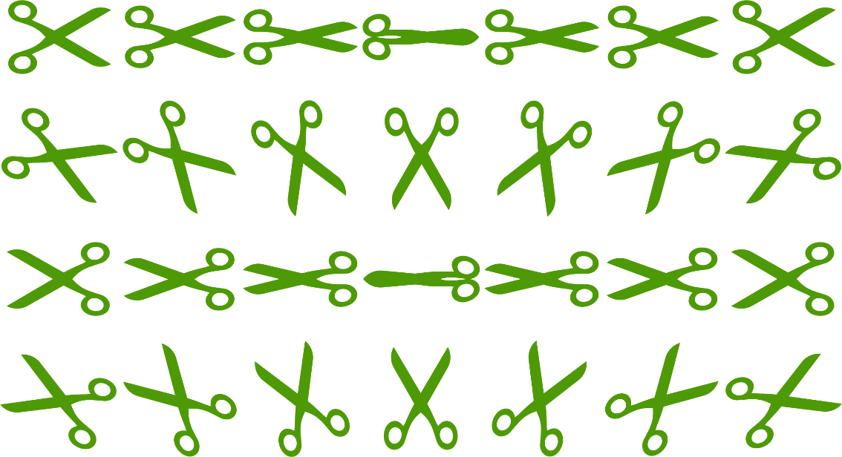

50. Write the code that would create the list for the scissors image.