Name _______________________________ Period_____________

Programming in Python – MPA3

_______ 1. What color would be defined by (0, 0, 0)?

a. black

b. white

c. grey

d. red

_______ 2. A group of statements that exists within a program for the purpose of performing a specific task is called a(n) ______________.

a. function

b. subtask

c. recursion

d. subprogram

_______ 3. The coordinates (0, 0) is also called, the screens _________.

a. basis

b. axis

c. center point

d. origin

_______ 4. A bounding box of an object is made up of the objects _______________.

a. width and height

b. x and y

c. x_change and y_change

d. radius

_______ 5. Where will the center of this ellipse be?

pygame.draw.ellipse(screen, BLACK, [1, 1, 3, 3], 1)

a. (3, 3)

b. (2, 2)

c. (1, 1)

d. (1, 3)

_______ 6. What is the most common type of file used when playing music?

a. .wav

b. .mp3

c. .mid

d. all of the above

_______ 7. This is the event from pygame triggered when the user moves the mouse?

a. MOUSEMOVE

b. MOUSEMOTION

c. MOUSEX, MOUSEY

d. MOUSEHOVER

_______ 8. The method ____________ takes in an x, y coordinate pair, and checks if that pair exists inside the area of a shape.

a. Hitrect

b. Mousepoint

c. Collidepoint

d. Hitpoint

_______ 9. When something is triggered in a pygame code, it is called this?

a. occurrence

b. module

c. import

d. event

_______ 10. The part of the program that looks closest to the front of the screen is ________________

a the background

b. the foreground

c. the top index

d. incorrect, because there is no depth on a computer screen.

_______ 11. __________ is the rapid display of images in a specific order that give the illusion of movement.

a. animation

b. movement

c. collision

d. simulation

_______ 12. Each location in multiple image picture is commonly called a(n) _______________.

a. rect

b. pos

c. frame

d. pixel

_______ 13. Everytime through the game loop is called a(n) ______________

a. iteration

b. annotation

c. concatenation

d. round

_______ 14. What color would be defined by (0, 0, 255)?

a. red

b. blue

c. green

d. random color

_______ 15. If the screen width and height are both 400 pixels, and a rectangle is drawn starting at (0,400), where will it display?

a. upper left

b. lower right

c. center

d. It won’t display

_______ 16. In computer graphics, as x coordinate increases and y coordinates decreases in value, a point will move:

a. up and to the left

b. down and to the right

c. up and to the right

d. down and to the left

_______ 17. This event is generated when the user closes the window.

a. END

b. CLOSE

c. QUIT

d. DELETE

_______ 18. FPS stands for

a. frames per second

b. flips per second

c. fast paced sprites

d. frames per sprites

_______ 19. ______________ is the speed at which an animation is played,

a. sprite clock

b. frame rate

c. image tick

d. MPG rate

_______ 20. This loads the pygame module into the current program.

a. input

b. quit

c. import

d. init

_______ 21. This draws content of one Surface object onto another Surface object

a. blit

b. draw

c. create

d. put

_______ 22. When code detects the intersections of two or more objects, it is called?

a. collision

b. bounding

c. impact

d. fender bender

_______23. This is the event that is triggered when a key on the keyboard is released.

a. K_UP

b. KEYUP

c. K_DOWN

d. KEYDOWN

_______ 24. What function allows us to resize a crab picture object on the screen?

a. pygame.transform.resize(crab)

b. pygame.transform.spin(crab)

c. pygame.transform.scale(crab)

d. pygame.transform.rotate(crab)

_______ 25. This is a series of images combined into a larger image

a. image diagram

b. cel matrix

c. bitmap

d. sprite map

_______ 26. A method of surface which creates a rectangular object in the dimensions of itself.

a. getwrecked()

b. get_rect()

c. rect_get()

d. get_rectangle()

_______ 27. If a box is drawn starting at (x,y) coordinate (0,0), where will it be on the screen?

a. center

b. upper left

c. lower left

d. lower right

_______ 28. The part of the program that looks closest to the back of the screen is the________________

a the background

b. the foreground

c. the top index

d. incorrect, because there is no depth on a computer screen.

_______ 29. Which of the following codes will get the current mouse position and returns the position as a list of two numbers

a. pos = pygame.mouse.get_pos()

b. pos = pygame.mouse.get_location()

c. pos = pygame.mouse.get_loc()

d. pos = pygame.mouse.get_position()

_______ 30. What color would be defined by (155, 155, 155)

a. black

b. gray

c. white

d. seniors sunburn

_______ 31. In pygame the acceptable image file type(s) is/are _____________________

a. .jpg

b. .bmp

c. .png

d. all are acceptable

_______ 32. Mouse event 3 represents what action?

a. right button

b. left button

c. scroll wheel moved up

d. middle button

_______ 33. The code used to retrieve and store an images size is?

a. get_box()

b. get_size()

c. get_rect()

d. get_area()

_______ 34. This is commonly used to clear the screen.

a. screen.clear()

b. screen.init()

c. screen.quit()

d. screen.fill()

_______ 35. A clock event is called a

a. tick

b. tock

c. tac

d. millisecond

_______ 36. This function gets the state of the mouse buttons?

a. mouse_pressed()

b. mouse_down()

c. get_pressed()

d. get_mouse()

_______ 37. When dividing up a sprite map, you would use a __________ sequence

a. string

b. tuple

c. list

d. dictionary

_______ 38. Images are made up of dots called __________.

a. pixels

b. twips

c. sprites

d. specks

_______ 39. A music object method which plays a music is called ______________.

a. music.play()

b. music.mixer.play()

c. pygame.music.mixer.play()

d. pygame.mixer.play()

_______ 40. This is generated when a mouse button is released in the window.

a. MOUSEPRESSED

b. MOUSEBUTTONUP

c. MOUSEBUTTONPRESSED

d. MOUSEBUTTONDOWN

_______ 41. Mouse event 2 represents what action?

a. right button

b. middle scroll button

c. scroll wheel moved up

d. scroll wheel moved down

_______ 42. What code will draw a line from x, y coordinates (0, 0) to (100, 100)?

a. pygame.draw.line(GREEN, screen, 0, 0, 100, 100, 5)

b. pygame.draw.line(screen, GREEN, 0, 0, 100, 100, 5)

c. pygame.draw.line(screen, GREEN, [0,0,100,100], 5)

d. pygame.draw.line(screen, GREEN, [0, 0], [100, 100], 5)

_______ 43. What does this code do?

pygame.display.flip()

a. flips the screen from top to bottom.

b. flips the screen from left to right.

c. clears the screen.

d. displays everything that has been drawn so far.

_______ 44. What does the following code mean?

Pygame.init()

a. declares an integer variable called pygame

b. installs the pygame library

c. initializes the pygame module

d. states that Pygame is inside

_______ 45. What is the main program loop?

a. It runs once for the entire game.

b. It processes user input, updates objects, and draws the screen each frame of the game.

c. It loops once for each level of the game.

d. It loops once for each life that the player has.

Part Two: Welcome to code country

Finish the code that will animate the globe.png with a size of 600 by 800.

Create a font and text saying “The Earth” and then show it on the screen.

Change the background to display a random color every time it completes a rotation.

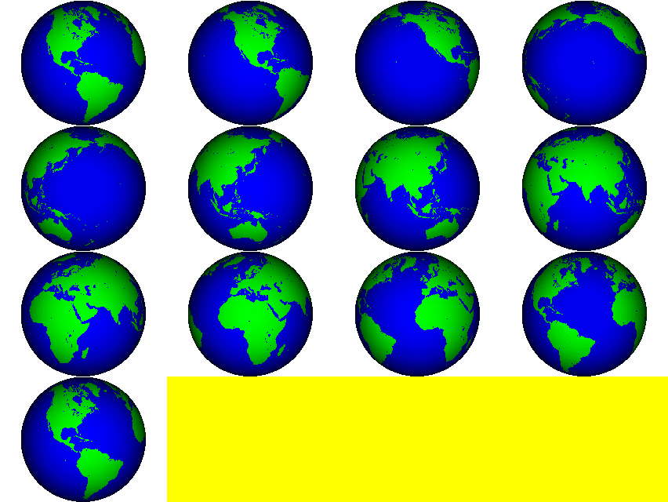import pygame

pygame.init()

done = False

framecount = _______________

globe = pygame.image.load(________________________________)

screen = pygame.display.set_mode((600,600))

clock = pygame.time.Clock()

globe_frames = ____________________________

globeW, globeH = __________________________________

fw = ______________________________

fh = ______________________________

while not done:

for event in pygame.event.get():

if event.type == pygame.QUIT:

done = True

pygame.display.flip()

clock.tick(10)

pygame.quit()