AP Calculus AB name: _________________________________

**Revolutionary Volume Lighting** date: __________________________________

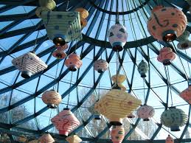

A new company, RVLV (Revolutionary Volume Lighting Visions) has opened for business to sell updated versions of tea lanterns. They contacted me because they know I have amazing AP Calculus students that have their fingers on the pulse of not only mathematics, but on the aesthetics of modern lighting.

They want to create tea lanterns that have a hollow core, but are completely filled around with a honeycombed-style amount of paper. They have asked for prototypes of fresh new modern designs with specs for the volume of material they need to purchase, so that they can make their design decisions for their line of products.

Your boss (and I think you know who I mean), has written up a list of tasks for you to complete so that we can be paid.

circumference: 8”

height: 4.25”

1. The hollow core will be of the shown dimensions, so create a prototype out of scratch paper (do not tape into a cylinder yet).

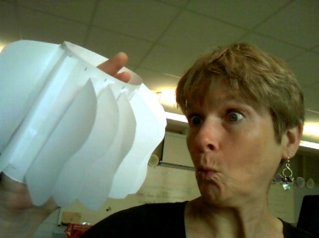

1. You will explore creating **one** shape that will be repeatedly taped around the cylinder (eventually) to be your prototype of a potentially final version that has these shapes ALL the way around. Do some brainstorming on any solid 2-dimensional shape you want to create. Look at me for inspiration!
2. 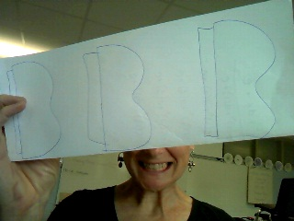Now take two 8.5” x 11” sheets of paper, and fold them each “hotdog” style. You will have room to mess up because ultimately you want to cut out 13 identical shapes. Settle on ONE shape (don’t forget a thin tab to fold over for taping), and then cut ONE shape out and use it to trace all other shapes (13 total since we need 12 plus one for other purposes).
3. Now make your cylinder and tape 12 of your shapes equally around the outside (use a ruler to be precise …. Shoddy Work is Sad Work …. Be creative).
4. But wait! It’s not all fun and games. To get paid, we need to provide the company with specs which include the volume of the PPP, pretty perimeter portion. Now if only there was a way to calculate this volume of revolution ….. hmmmmm.

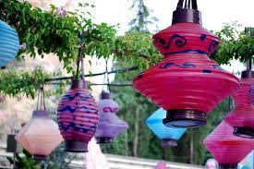

1. 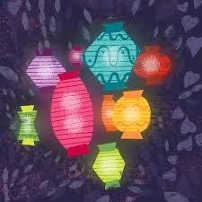On a piece of graph paper, draw axes to create a 1st quadrant and trace out your shape in the appropriate place. You ultimately want the equation of your curve, so don’t forget about the cylinder radius.

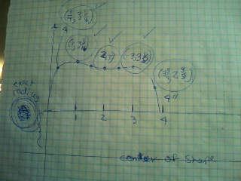

**Exact Radius of Cylinder.**

1. You are going to use the inch side of your ruler to create a scale on your axes. You will need the exact radius of the cylinder. What is it _______. What is the degree of your polynomial? ___________. Let’s call that number “n”. Then you need to EXACTLY measure to the nearest 16th of an inch, “n+1” points on your graph. Write them down here.
2. Go to this link and follow their instructions to use regression to get an equation of your curve: [http://www.xuru.org/rt/PR.asp#CopyPaste](http://www.xuru.org/rt/PR.asp" \l "CopyPaste) . Write the equation down here:
3. Go to desmos.com and type in two equations: 1. Yours from above, and 2. Y = exact radius.



1. Ooh, and aaah and adjust as needed to make sure the desmos graph looks like your #6 graph.
2. Use your calcul-us-ator skills to find the volume of revolution of your prototype to send to our client. Show set up and work here:
3. We will hang up our version 2 prototypes around school. Go forth and be awesome.