Name: ____________________________________________ Date: ________ Period: _____

THE ROAD TO CIVIL WAR

Directions: For the next week and a half, we will be examining events throughout the 1850s that pushed the nation ever closer to an explosive civil war. Each day as a warm up, you will recap the previous day’s event in the space below.

Pit Stop #1: COMPROMISE OF 1850
Who was involved? | Where did it happen? | Why did it happen? | What was decided?

Pit Stop #2: ABOLITION MOVEMENTS IN THE NORTH
a. What caused Northerners to become more invested in abolitionism in the 1850s?

b. Give 2 examples of abolitionist efforts that garnered enormous attention from the North.

c. Why would interest in the abolitionist movement move the nation closer to civil war?

Pit Stop #3: BLEEDING KANSAS
a. Define the Kansas-Nebraska Act:
b. Define popular sovereignty:
c. Complete the chart on Bleeding Kansas:
Who was involved? | What happened? | When did it happen? | Where did it happen? | Why did it happen?

d. What is the image below depicting? What happened in that event?
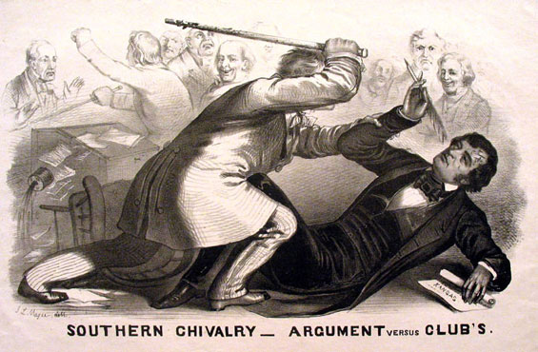
Pit Stop #4: RISE OF THE REPUBLICANS
a. Provide the basic platforms of the political parties below
Whig Party | Know-Nothing Party | Free Soil Party | Democratic Party

b. Why did the Whig Party break up in the early 1850s?
c. What did the new Republican Party stand for?

Pit Stop #5: DRED SCOTT V. SANFORD (1857)
a. Provide background on the case. Why did it go to the Supreme Court?

b. What did the Supreme Court rule in the Dred Scott case?

c. Why did this case push the United States closer to civil war?

d. Interpret this quote by Roger Taney: “The enslaved African race were not intended to be included [in the Declaration of Independence], and formed no part of the people who framed and adopted this declaration…”

Pit Stop #6: LINCOLN-DOUGLASS DEBATES
- In the chart below, describe the arguments made by both Abraham Lincoln and Stephen Douglas in their 1858 campaigns for the Illinois senate seat.
Lincoln | Douglas
Pit Stop #7: JOHN BROWN’S RAID ON HARPERS FERRY, 1859
- Describe John Brown and his mission.
- How did John Brown carry out his attack?
- Was the raid successful? Explain.
- How did the Raid on Harpers Ferry push the United States closer to war?

Final Destination: Election of 1860 and SECESSION!


