Name: _____________________________________ Date: ____________ Period: ________
HUMANS OF NEW YORK: JACOB RIIS
Directions: Study the photographs taken by Jacob Riis at the turn of the 20th century. For each photograph, write a 2-3 sentence caption about what you see and what you think the people in the photograph would say if they were interviewed. Try to use the style of the “Humans of New York” blog posts. See the samples below. For each photograph, use the details and context clues to help you start your story, but you can add in some details of your own to make it more creative!
Humans of New York Samples:
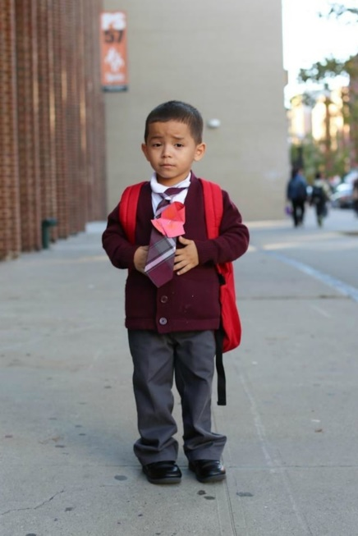
“What do you want to be when you grow up?”
“Fireman.”
“Why do you want to be a fireman?”
“I said Ironman!”

I’m going to find a job. Nobody is going to force me into retirement at 61. I moved to New York at the age of 35 with nothing but $1000 and a cat. I’ve reinvented myself once. And I can do it again.’

‘If you could give one piece of advice to a large group of people, what would it be?’
‘When a wave comes, go deep.’
‘I think I’m going to need an explanation for that one.’
‘There’s three things you can do when life sends a wave at you. You can run from it, but then it’s going to catch up and knock you down. You can also fall back on your ego and try to stand your ground, but then it’s still going to clobber you. Or you can use it as an opportunity to go deep, and transform yourself to match the circumstances. And that’s how you get through the wave.’
Jacob Riis Photographs
- $1 a Month to Sleep Here
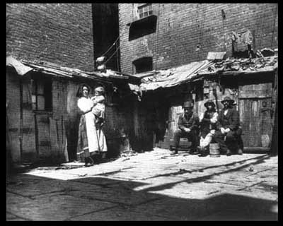
_____________________________________________________________________
_____________________________________________________________________
_____________________________________________________________________
- A Makeshift Bed
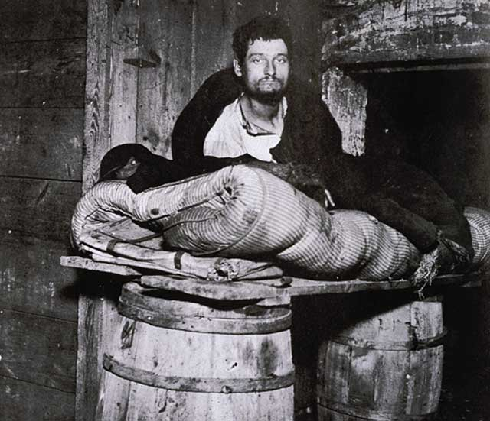
_____________________________________________________________________
_____________________________________________________________________
_____________________________________________________________________
- Five Cents a Spot

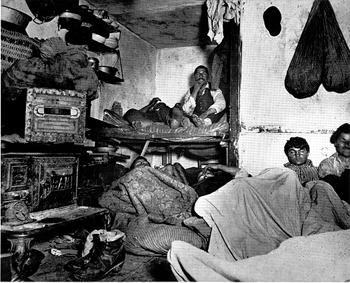
_____________________________________________________________________
_____________________________________________________________________
_____________________________________________________________________
- Child Labor
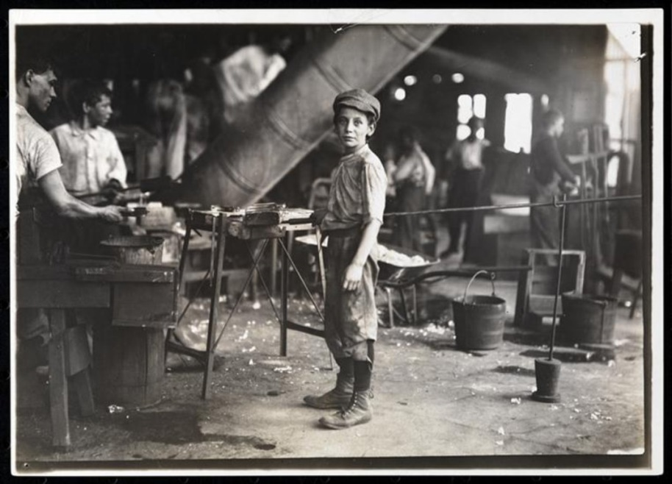

_____________________________________________________________________
_____________________________________________________________________
_____________________________________________________________________
- Children Rolling Dice





