Vertical Integration: An arrangement in which the entire supply chain of a company is owned by that company.
Horizontal Integration: The process of a company increasing production of goods or services at the same location of the supply chain. This process can lead to a monopoly.
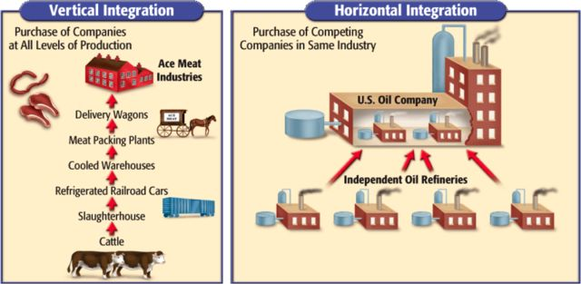

Your task: You will choose an industry that interests you to illustrate horizontal and vertical integration. Examples: chocolate factory, clothing chain, amusement park. You will then create a poster with your group illustrating both horizontal and vertical integration for this industry. Think about other brands that offer this product and what factors of production are needed to produce it. Use the sample image as guidance. Make your poster as detailed as possible!

