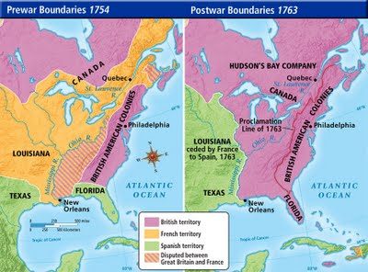
Name: _______________________________________________________________
French and Indian War Map Analysis
Directions: Use the map to answer the following questions:
1. How did British territory change after the French and Indian War?
2. How did French territory change after the French and Indian War?
3. How did Spanish territory change after the French and Indian War?
4. Which European country controlled the most land in North America before the French and Indian War? Which European country controlled the most land in North America after the French and Indian War?

5. Which European country controlled the Mississippi River before the French and Indian War? Which European country controlled the Mississippi River after the French and Indian War?
6. Spain was given control of the port of New Orleans in a secret treaty with the French in 1762. Why do you think this was such an important Spanish territorial gain?

