Was Andrew Carnegie a Titan of Industry or a Robber Baron?

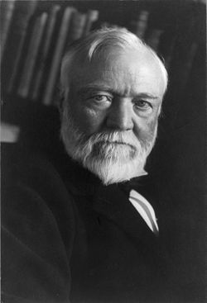

Document A
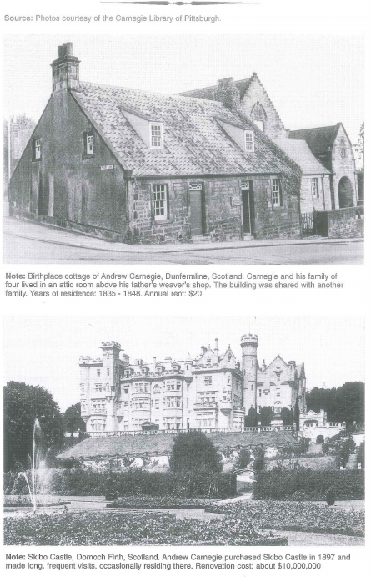

Document A Questions:
- When did Andrew Carnegie live in the Dunfermline cottage? Skibo castle?

- In what country were both homes located?

- What was the Carnegie rent at Dunfermline? The fix up coast of Skibo?

- Does the document help you decide if Carnegie was a titan of industry or a robber baron? Explain.

Document B
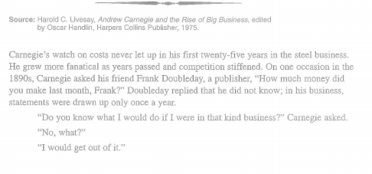
Document B Questions:
- In the business world of steel making, what would be two examples of costs?

- What were Carnegie’s ideas about costs?

- Does this document help explain why Carnegie was a successful businessman?

- Does the document help you decide if Carnegie was a titan of industry or a robber baron? Explain.

Document C
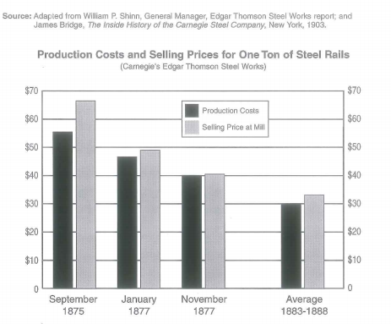

Document C Questions:
- Over time, what happened to the cost of producing a ton of steel in Carnegie’s Edgar Thompson steel works?

- Over time, what happened to the price at which Carnegie sold his steel?

- Who benefitted from the lower costs and the lower prices?

- How might this document help explain why Carnegie was a Titan of Industry or a Robber Baron?
Document D
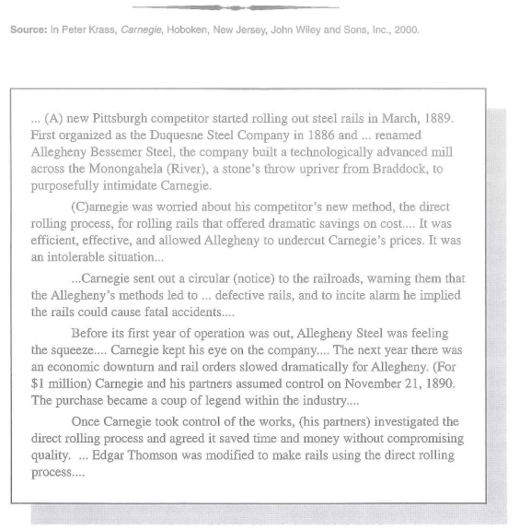
Document D Questions:
- Why was Andrew Carnegie worried about the Allegheny Bessemer Steel Company?

- How did Carnegie manage to acquire Allegheny Steel?

- How might this document help explain why Carnegie was a Titan of Industry or a Robber Baron?

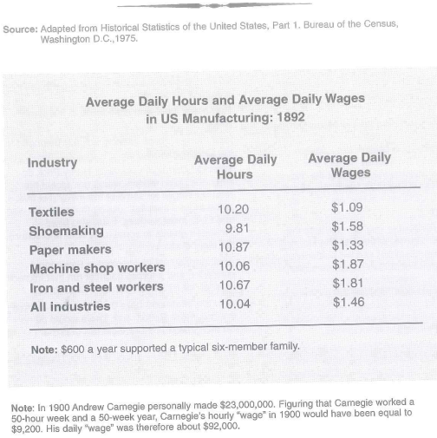
Document E

Document E Questions:
- In 1900, how much did Andrew Carnegie earn in one day?

- How does the average wage of steel workers compare to the wages of other professions?

- How might this document help explain why Carnegie was a Titan of Industry or a Robber Baron?
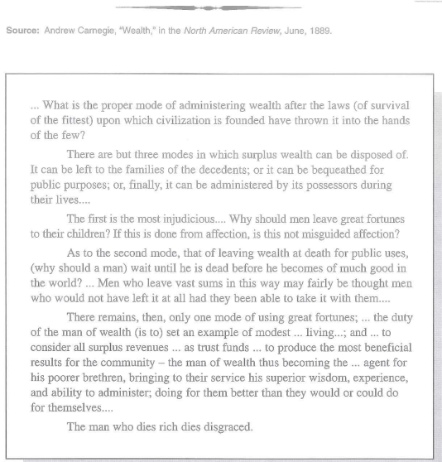
Document F

Document F Questions:
- According to Carnegie, what “throws” wealth into the hands of the few?

- What does Carnegie believe should be done with this wealth?

- How might this document help explain why Carnegie was a Titan of Industry or a Robber Baron?

Document G
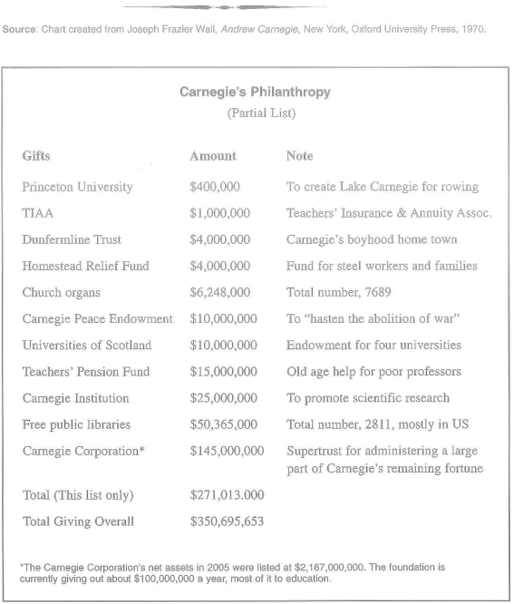
Document G Questions:
- How much money did Andrew Carnegie give away during his lifetime?

- Is the Carnegie Foundation still active? Is that important in deciding if Carnegie was a Titan of Industry or a Robber Baron?
Document H
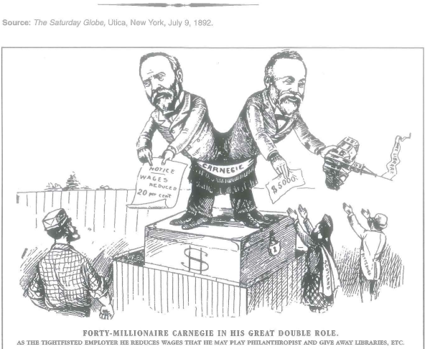

Document H Questions:
- Who are the two figures standing on the cash box?

- What is the cartoonist saying about Andrew Carnegie?

- How might this document help explain why Carnegie was a Titan of Industry or a Robber Baron?

Document I

